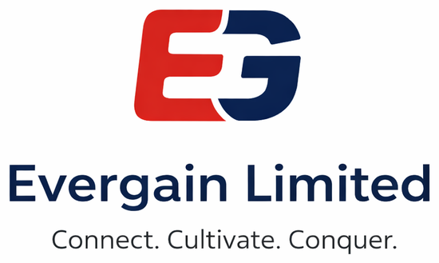

TECHNICAL PROPOSAL
Supply, Delivery & Commissioning of Interactive
Digital Content for the Competency Based Curriculum — Grade 9
RFB No: KE-ICTA-543406-GO-RFB
Kenya Digital Economy Acceleration Project (KDEAP)

PURCHASER


DELIVERY TO


Purchaser: Information & Communications Technology Authority (ICTA)
Delivery to: Kenya Institute of Curriculum Development (KICD), Nairobi
Submitted by: Evergain Limited
Submission deadline: 2nd July 2026, 10:00 hrs EAT — Telposta Towers, 12th Floor Boardroom, Nairobi (as extended by Addendum No. 2)

Letter of Transmittal
Date: __________________ 2026
To: The Chief Executive Officer
Information & Communications Technology Authority (ICTA)
12th Floor, Telposta Towers, Kenyatta Avenue
P.O. Box 27150-00100, Nairobi
Dear Sir/Madam,
RE: TECHNICAL PROPOSAL — SUPPLY, DELIVERY & COMMISSIONING OF INTERACTIVE DIGITAL CONTENT FOR CBC GRADE 9 (RFB No. KE-ICTA-543406-GO-RFB)
Evergain Limited is pleased to submit this Technical Proposal in response to the above Request for Bids under the Kenya Digital Economy Acceleration Project. As a Kenyan multi-disciplinary solutions company delivering Technology Services, Consultancy, Training, Human Resource Services and General Supplies to public and private sector institutions — with in-house technology, digital-transformation and capacity-building capability — we are well positioned to deliver tender-ready interactive digital content authored to conform to the Content Standards for Digital Complementary Content for CBC and aligned to KICD-disseminated materials on the Kenya Education Cloud, for Grade 9.
Our solution is a complete, production-grade platform that authors, validates, encrypts and packages HTML5 Interactive Digital Content into self-contained Package Interchange Files (PIF), delivered for fully offline, server-based and hybrid school environments. The solution has been built and independently verified against every mandatory requirement of Section VII of the bidding document, as evidenced in the compliance table herein.
We confirm that we have received, read and understood the Request for Bids No. KE-ICTA-543406-GO-RFB together with Clarification No. 1 dated 12 June 2026 and Addendum No. 2 dated 23 June 2026, each of which forms part of the issued RFB document, and that this Bid has been prepared on the basis of, and in full compliance with, the bidding document as so clarified and amended. We specifically acknowledge: (i) that, as amended by Addendum No. 2, the deadline for Bid submission and the Bid opening are 10:00 hours EAT on 2nd July 2026 at Telposta Towers, 12th Floor Boardroom, Nairobi, and that this Bid is timed accordingly; and (ii) the requirement under BDS ITB 32.4, Item 6, sub-item 6.1 that the digital content conform to the Content Standards for Digital Complementary Content for CBC and be supported by proof of KICD content approval. Our response to this Mandatory requirement, comprising a signed Conformance Statement, a binding undertaking to complete the KICD content-approval process, and evidence of alignment to the KICD-approved curriculum support materials disseminated through the Kenya Education Cloud (lms.kec.ac.ke), is set out in the technical compliance table at item 6.1 and at Annex F.
We confirm our commitment to the perpetual licensing, AES encryption, multi-platform support, statutory compliance, and the three-year warranty with 24/7 support required by this tender, all as prepared on the basis of the bidding document as clarified by Clarification No. 1 and amended by Addendum No. 2. We remain available to provide any further clarification the Evaluation Committee may require.
Yours faithfully,
__________________________________
Name: ______________________________
Managing Director — For and on behalf of Evergain Limited

Addenda and Clarifications Acknowledged
Evergain Limited records that the following clarifications and addenda to RFB No. KE-ICTA-543406-GO-RFB have been received, are acknowledged, and have been fully incorporated into this Bid. No other clarification or addendum has been received as at the date of this Bid.
- Clarification No. 1, dated 12 June 2026 — Acknowledged and incorporated. (Item 1) the digital content must conform to the Content Standards for Digital Complementary Content for CBC, evidenced by proof of KICD content approval, and bidders may reference the KICD-approved curriculum support materials disseminated through the Kenya Education Cloud (lms.kec.ac.ke); (Item 2) at that date the request to extend the closing date to 2 July 2026 was declined — this position on the closing date was subsequently superseded by Addendum No. 2 below.
- Addendum No. 2, dated 23 June 2026 — Acknowledged and incorporated. The deadline for Bid submission (BDS ITB 22.1) and the Bid opening (BDS ITB 25.1) are amended to 2nd July 2026 at 10:00 hours EAT, and the submission and opening venue is confirmed as Telposta Towers, Kenyatta Avenue, 12th Floor Boardroom, P.O. Box 00100, Nairobi, Kenya. Bids may not be submitted electronically. All other terms and conditions of the RFB remain unchanged.
Operative submission and opening deadline applied throughout this Bid: 2nd July 2026, 10:00 hours EAT, at Telposta Towers, 12th Floor Boardroom, Nairobi — as extended by Addendum No. 2 (superseding the earlier 25th June 2026 date).

Table of Contents
Right-click here and choose 'Update Field' to build the table of contents.

1. Executive Summary
This proposal presents the Evergain Grade 9 Interactive Digital Content (IDC) Platform — an end-to-end solution for the supply, delivery and commissioning of HTML5 interactive learning content for the ten Grade 9 CBC subject lots, delivered to the Kenya Institute of Curriculum Development.
The solution comprises four integrated components:
- Authoring Platform — a web-based content authoring application for curriculum developers (live at cbc.evergain.co.ke);
- Build & Packaging Pipeline — a validation, packaging and AES-encryption pipeline that produces tender-compliant PIF ZIP packages;
- Offline Player — a cross-platform offline desktop/mobile player for schools (Windows, Linux, macOS, Android);
- Governance — compliance documentation, SLA, work plan and a perpetual-license framework.
Every mandatory technical requirement in Section VII (items 1.1 to 9.5) is met and has been verified through automated testing and reproducible builds. The platform produces all ten lot packages in both unencrypted (.zip) and AES-256 encrypted (.enc) form, ready for USB submission.

Key compliance highlights
- HTML5 self-contained PIF packages with index.html at root (1.1–1.6)
- Strict asset control — MP4 / MP3 / JPEG / PNG only (1.7); no server code (1.9); no absolute URLs (1.10)
- AES-128 / 192 / 256 encryption of the delivery package (3.1)
- Offline, server+WiFi and hybrid deployment; Atom-class hardware (4.2–4.5)
- Windows / Linux / macOS / Android, 32 & 64-bit, all major browsers (5.1–5.4)
- Perpetual license (2.1); 3-year warranty + 2-year support, 24/7, with SLA (9.1–9.5)

2. Bidder Profile — Evergain Limited
Evergain Limited is a Kenyan multi-disciplinary solutions company providing General Supplies, Consultancy, Training, Human Resource Services and Technology Services to public and private sector organisations. Our business model is built on delivering reliable, timely and cost-effective solutions that enhance operational efficiency, build institutional capacity and support organisational growth, with a strong focus on quality delivery, compliance, value for money and client satisfaction.

2.1 Corporate snapshot
Legal name | Evergain Limited
Nature of business | Multi-disciplinary solutions — Technology Services, Consultancy, Training, Human Resource Services and General Supplies
Vision | To be a trusted partner of choice in business solutions, capacity building and technology-enabled transformation
Mission | To provide high-quality, innovative and value-driven services that help our clients achieve sustainable performance and measurable impact
Core values | E.V.E.R.G. — Excellence, Value for Money, Ethics, Reliability, Growth
Quality & security | Delivery aligned to ISO/IEC 27001 (information-security) and ISO 9001 (quality-management) good practice; quality, compliance and value-for-money embedded in every engagement
Relevant capability | Technology Services — IT consulting & digital transformation, business-systems implementation & support, ICT infrastructure, systems maintenance & technical support, technology training & user support; plus Consultancy and Capacity-Building
Clients served | Government Ministries, Departments & Agencies; County Governments; State Corporations & Public Institutions; NGOs & Development Partners; Corporates & SMEs; Educational & Training Institutions
Registered office | Nairobi, Kenya (full registered particulars per Certificate of Incorporation — Annex G)
Contact | +254 747 258 516 · info@evergainlimited.com · www.evergainlimited.com
Leadership | Managing Director (strategic leadership & business development); Head of Projects; ICT & Technology Lead; Human Resource & Training Lead; Finance & Procurement

2.2 Why Evergain for this assignment
Evergain combines hands-on Technology Services with consultancy and capacity-building, delivered through a quality-first, compliance-driven model. Our experience serving Government MDAs, County Governments, State Corporations, NGOs and educational & training institutions — coupled with our E.V.E.R.G. commitment to Excellence, Value for Money, Ethics, Reliability and Growth — directly underpins the authoring, packaging, distribution, training and long-term maintenance this tender requires.

3. Understanding of the Requirement
ICTA, on behalf of KICD, requires interactive digital content for the Competency Based Curriculum (Grade 9) across ten subject lots. Per the bidding document as amended by Clarification No. 1, the content must be HTML5, self-contained, offline-capable, encrypted and multi-platform; must conform to the Content Standards for Digital Complementary Content for CBC and carry KICD content approval; should align with the curriculum support materials disseminated through the Kenya Education Cloud (lms.kec.ac.ke); and must be supported for the long term. We understand the content will be delivered to KICD on physical media and must pass a Pass/Fail technical evaluation against the Section VII specifications.
We have therefore engineered our solution so that compliance is enforced automatically — content cannot be packaged unless it satisfies the asset-format, no-server-code and no-absolute-URL rules — and so that the same package runs unchanged across the three deployment environments described in the tender. The subsections that follow map our solution to those requirements, supported by diagrams, topologies and screenshots of the working system.

3.1 The ten subject lots
Lot | Subject | Units
1 | English | 5
2 | Kiswahili | 5
3 | Mathematics | 5
4 | Integrated Science | 5
5 | Agriculture | 4
6 | Creative Arts & Sports | 4
7 | Christian Religious Education | 5
8 | Islamic Religious Education | 5
9 | Hindu Religious Education | 5
10 | Social Studies & Pre-Technical Studies | 5

3.2 Conformance to the Content Standards & alignment with the Kenya Education Cloud (KEC)
Clarification No. 1 (Item 1) reaffirms that, under BDS ITB 32.4 Item 6 sub-item 6.1, the digital content must conform to the Content Standards for Digital Complementary Content for CBC, evidenced by proof of KICD content approval, and directs bidders to the KICD-approved curriculum support materials disseminated through the Kenya Education Cloud (lms.kec.ac.ke).
Evergain’s Grade 9 Interactive Digital Content is authored to conform to the applicable KICD content standards for Competency Based Curriculum digital and complementary curriculum-support materials — including the published Standards for Competence Based Digital Course Materials (2018) and the Standards for Curation of Online Supplementary Curriculum Support Materials (2016) — and is built against, and benchmarked to, the KICD-approved curriculum support materials accessed through the Kenya Education Cloud (lms.kec.ac.ke). In particular, our content and authoring platform address the KICD General Standards areas, namely:
- Conformity to the curriculum — our content tree (Lots → Units/strands → Topics/sub-strands → Activities) is mapped to the published CBC Grade 9 curriculum designs, covering the prescribed strands, sub-strands, themes, concepts and skills.
- Accuracy and currency — source-grounded lots are authored from the official KICD Grade 9 source material and independently fact-checked for every formula, fact and answer key.
- Language, values and PCIs — content is reviewed by subject-matter experts for register, positive values and the integration of Pertinent and Contemporary Issues (PCIs) appropriate to Grade 9 learners.
- Assessment — every activity is auto-graded with feedback and hints; multiple-choice items carry exactly one correct option.
- Multimedia and technical design — content is self-contained HTML5 packaged as a Package Interchange File (PIF), using only the permitted MP4/MP3/JPEG/PNG media, offline-capable and built to open web standards.
- Kenya Education Cloud attributes — packages are produced in a curated, grade-wise, self-describing form aligned to the attributes of content disseminated through the Kenya Education Cloud, ready for onboarding upon KICD approval.
A traceability mapping of our content structure and CBC core-competency tagging against the KICD-approved curriculum support materials referenced on the Kenya Education Cloud is provided at Annex F. This demonstrates alignment to KICD-disseminated approved materials; it is alignment and conformance evidence, and is not, and does not assert, a grant of KICD content approval.

4. Proposed Solution & System Architecture
The platform is organised into four layers — authoring, build/packaging, outputs, and delivery — feeding learning content to Grade 9 classrooms. Content authored once is validated, packaged and encrypted into PIF ZIPs that run offline on desktop, in the browser from a school server, or on mobile devices.
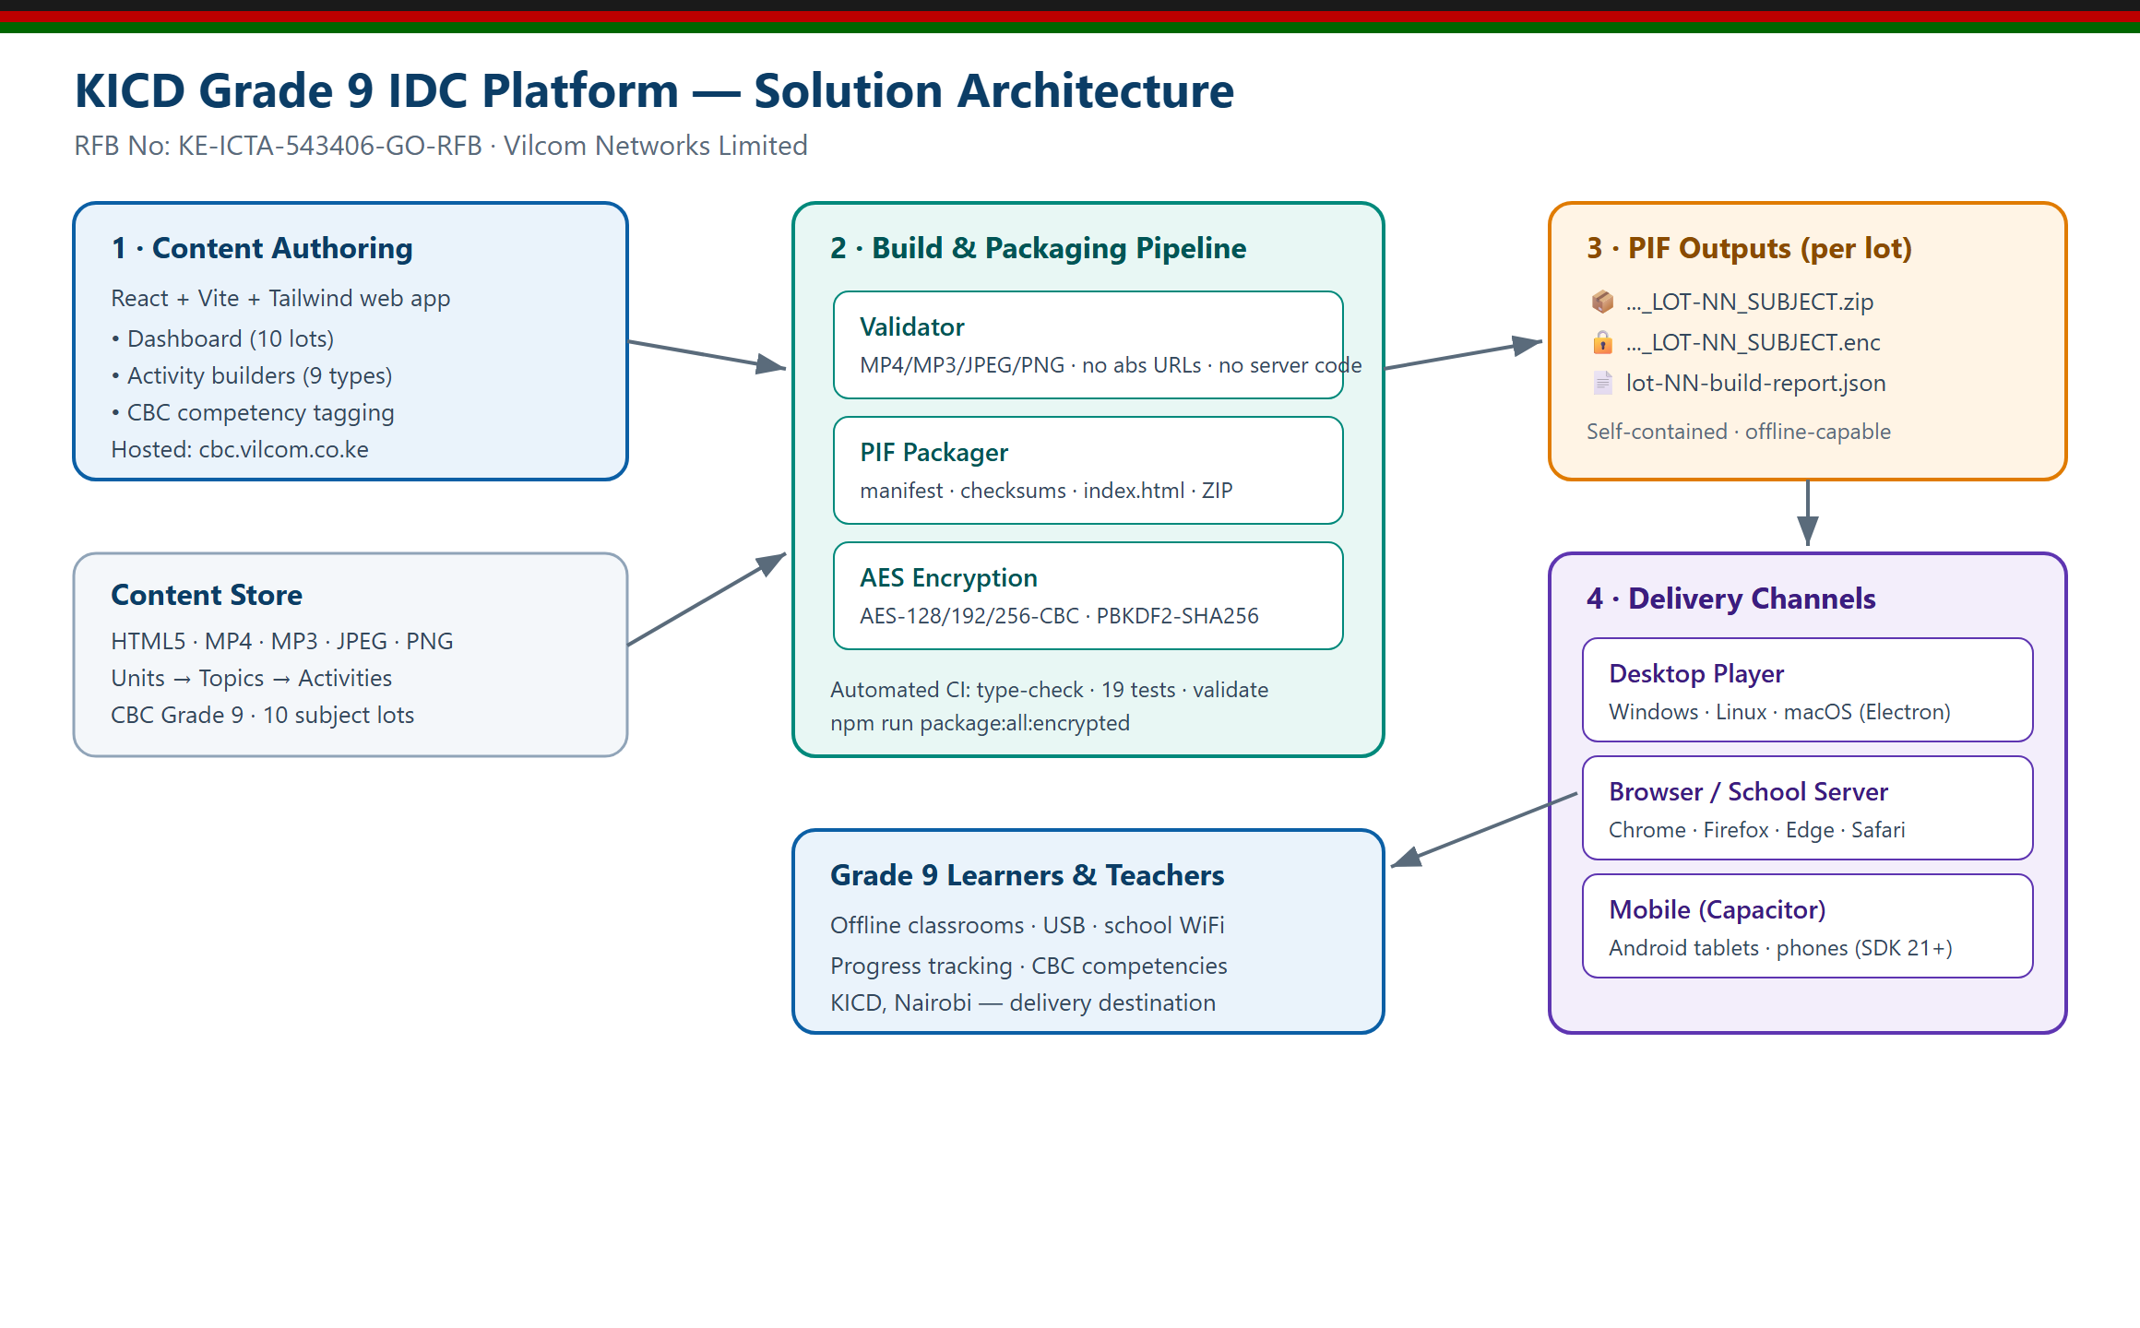
Figure 1 — End-to-end solution architecture of the Evergain Grade 9 IDC Platform.

5. Content Packaging — Package Interchange File (PIF)
Each lot is delivered as a self-contained PIF: a single ZIP whose root contains one folder with index.html, the content manifest, per-file checksums, the player chrome, and all units, activities and assets. This satisfies the structural requirements of Section VII §1.3 to §1.6 and the strict asset rules of §1.7 to §1.10.
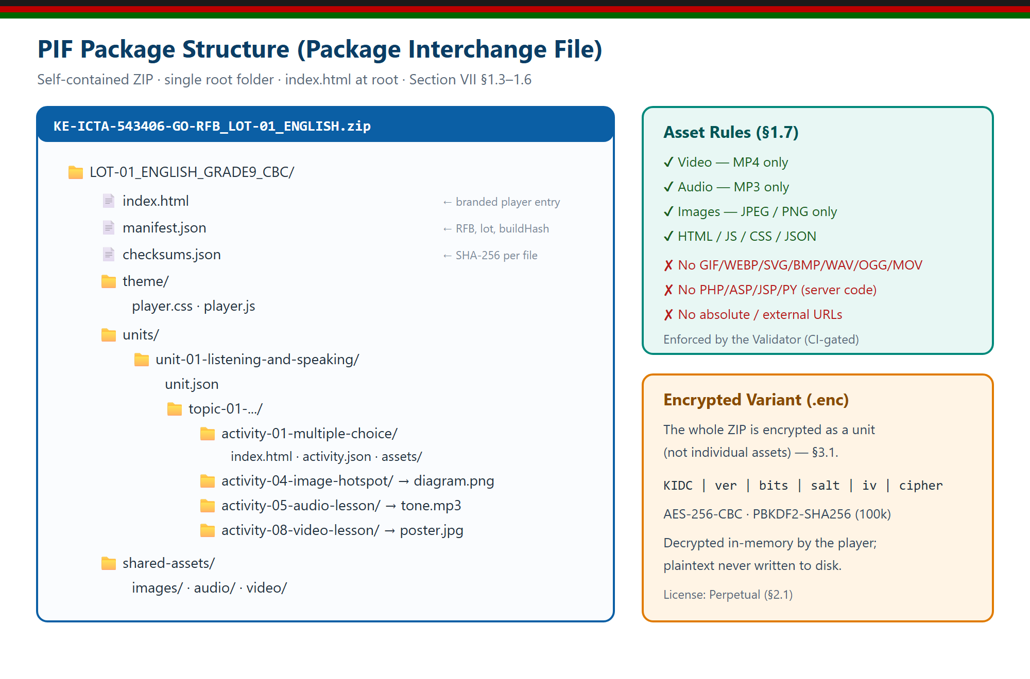
Figure 2 — PIF package structure, asset rules and the encrypted (.enc) variant.

5.1 Automated compliance enforcement
A validator runs before every package is built. It rejects any disallowed media format, any server-side code, any absolute or external URL, and any package missing a root index.html — and emits a JSON report with exit codes for continuous integration. No non-compliant package can be produced.

6. Security & Content Protection
Section VII §3.1 requires encryption that is simple and compliant with the Advanced Encryption Standard (AES-128, AES-192 or AES-256). The whole delivery package is encrypted as a unit; decryption happens only when the player opens the package, in memory, and the plaintext content is never written to disk.
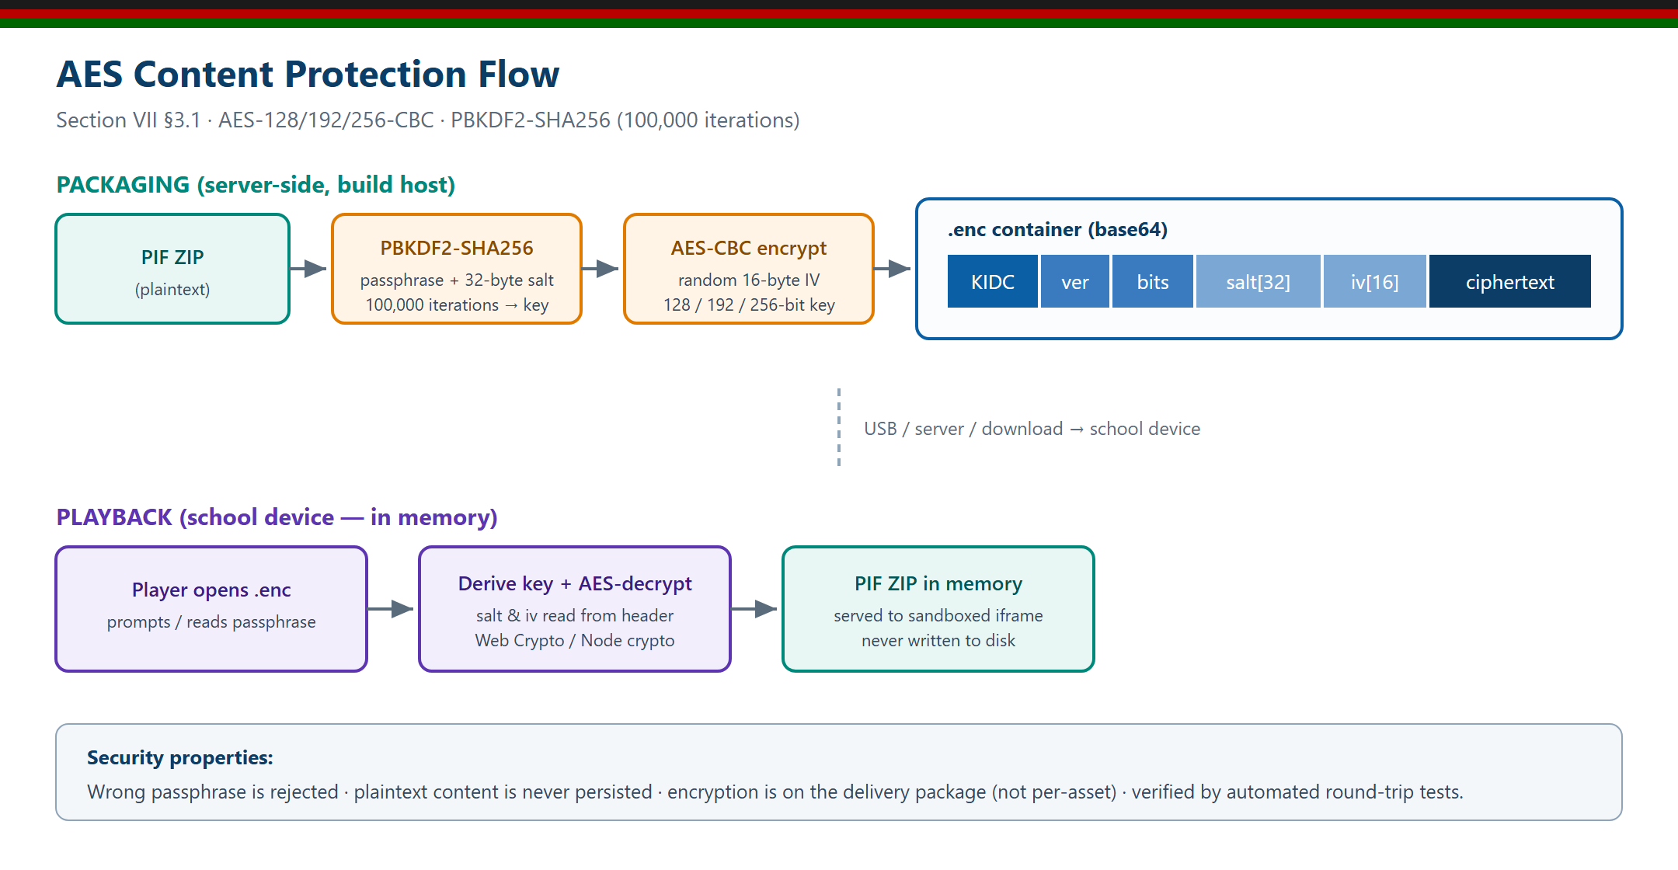
Figure 3 — AES content-protection flow: packaging-side encryption and in-memory playback decryption.
- Key derivation: PBKDF2-SHA256, 100,000 iterations, random 32-byte salt.
- Cipher: AES-CBC with a random 16-byte IV; 128, 192 or 256-bit keys (default 256).
- Self-describing container; wrong passphrases are rejected; round-trip verified by automated tests.
In addition, the platform aligns to recognised ISO/IEC 27001 information-security good practice for key custody and content handling.

7. Content Authoring Platform
Curriculum developers author content through a modern, responsive and accessible web application (live at https://cbc.evergain.co.ke). The dashboard tracks all ten lots — completeness, activity and asset counts, validation status and CBC competency coverage — and surfaces an on-premise AI Authoring Assistant for rapid drafting. Each activity must be tagged with at least one CBC core competency before it can be approved.
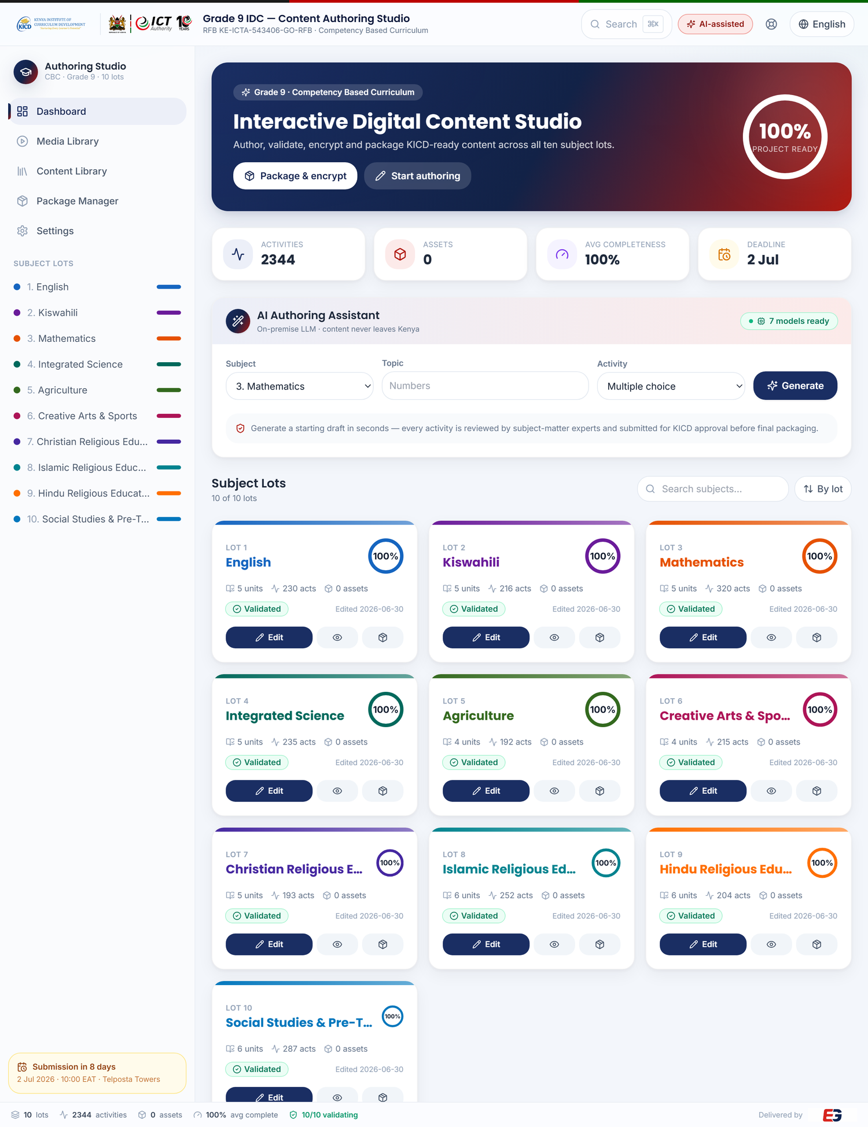
Figure 4 — Authoring dashboard: project health, the ten subject lots, and the on-premise AI Authoring Assistant (live system).

7.1 Lot editor and packaging console
The lot editor provides a content tree, an activity builder canvas and a properties panel with CBC competency tagging and accessibility settings. The package manager runs validation, packaging and AES encryption and reports the tender-compliant output filenames per lot.
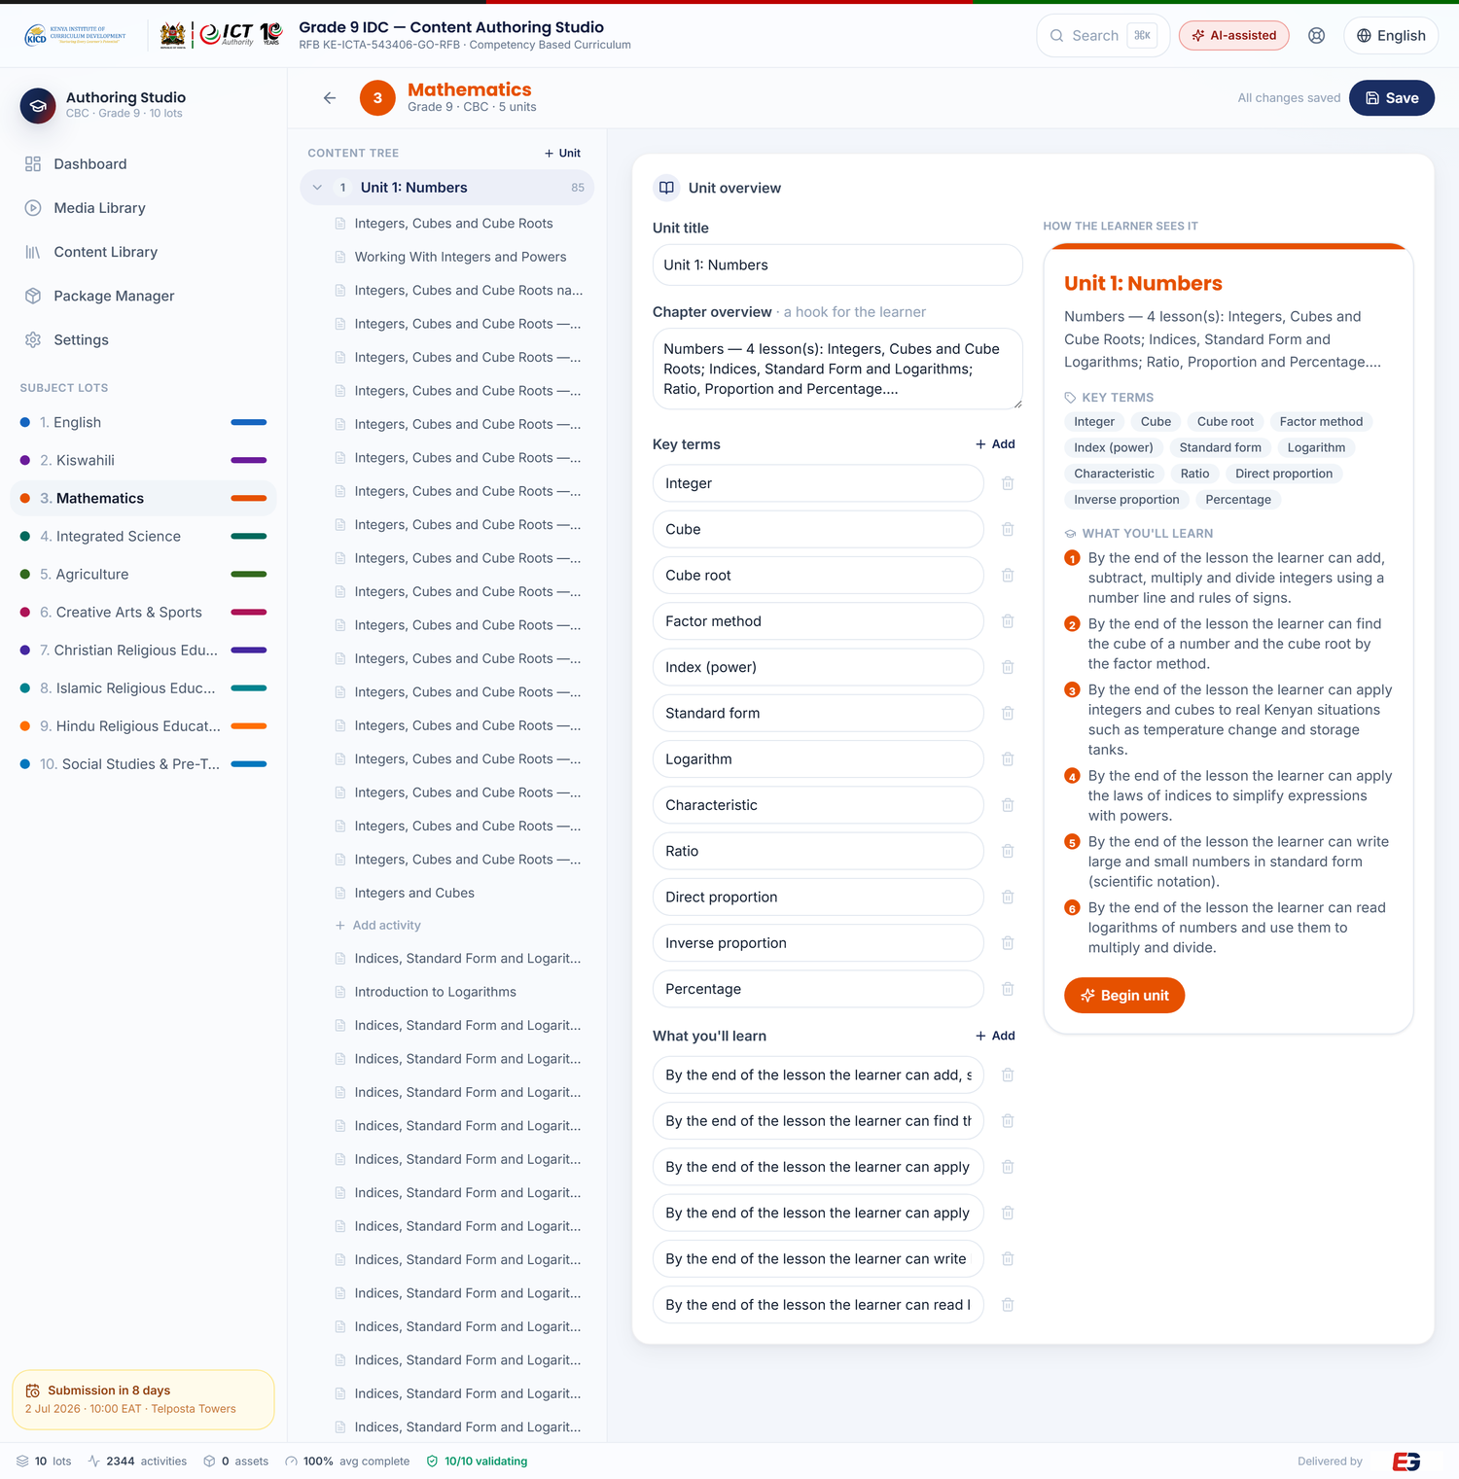
Figure 5 — Lot editor with activity builder and CBC competency tagging.
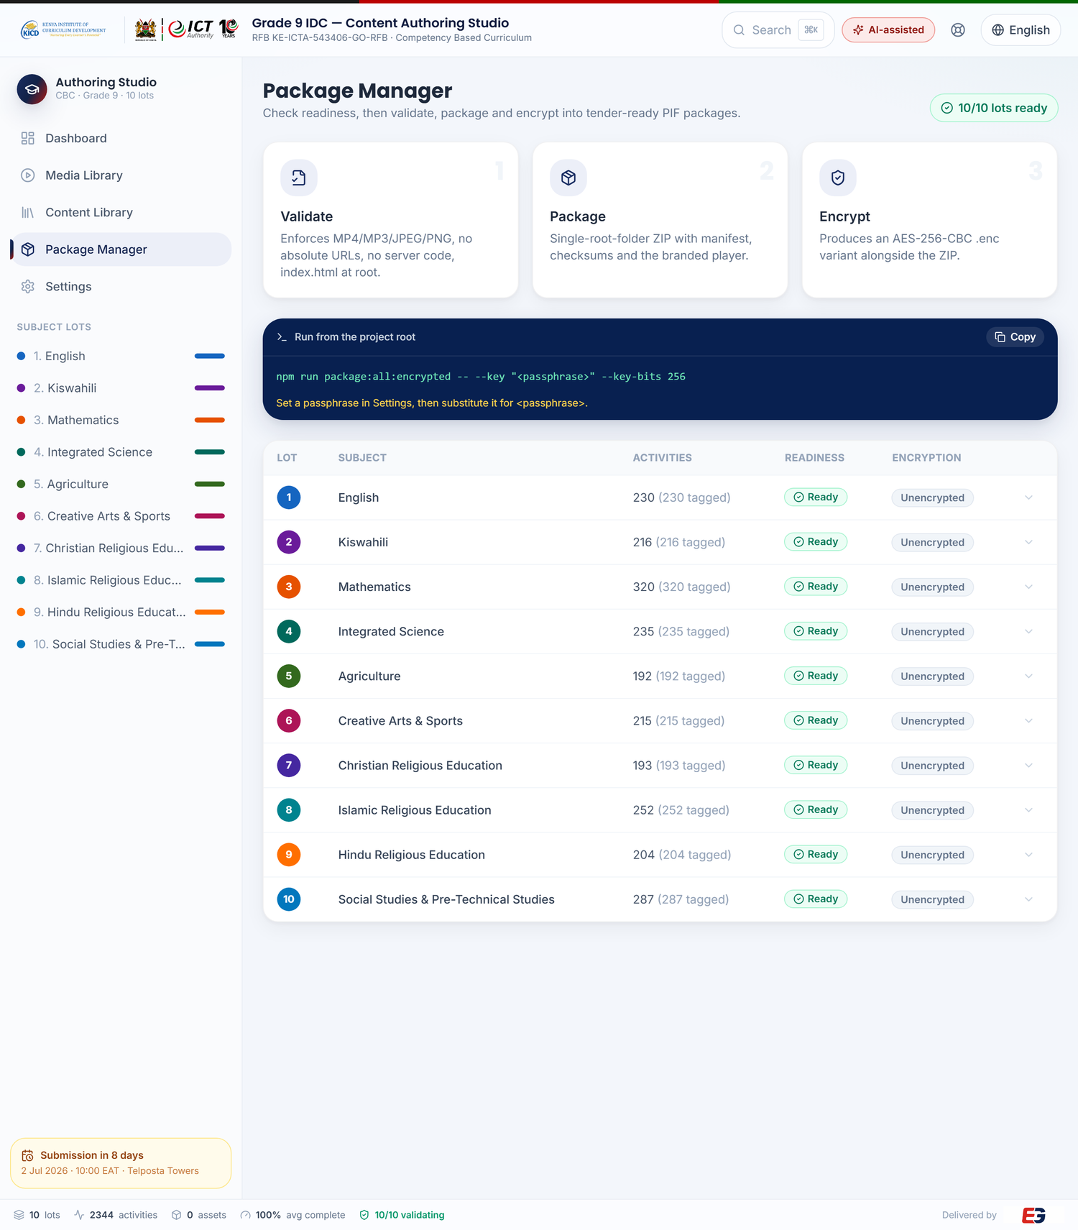
Figure 6 — Package manager: validate → package → AES-encrypt, per lot.

8. Interactive Content Demonstration
Section VII §1.2 requires interactive content comprising text, video, audio, animation, games and images in HTML5. The platform ships working examples of each interaction type. The screenshots below are live renders of packaged Grade 9 activities.
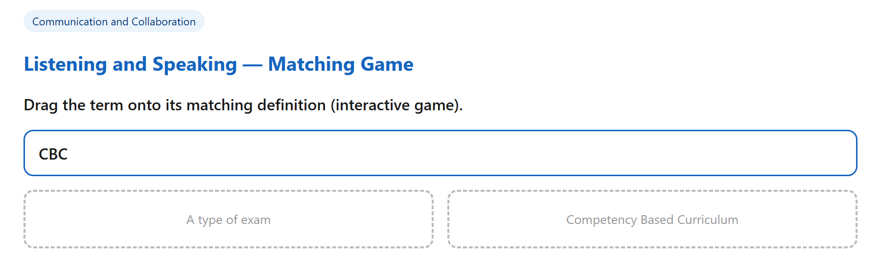
Figure 7 — Interactive game (drag-and-drop matching), pure HTML5/JavaScript.
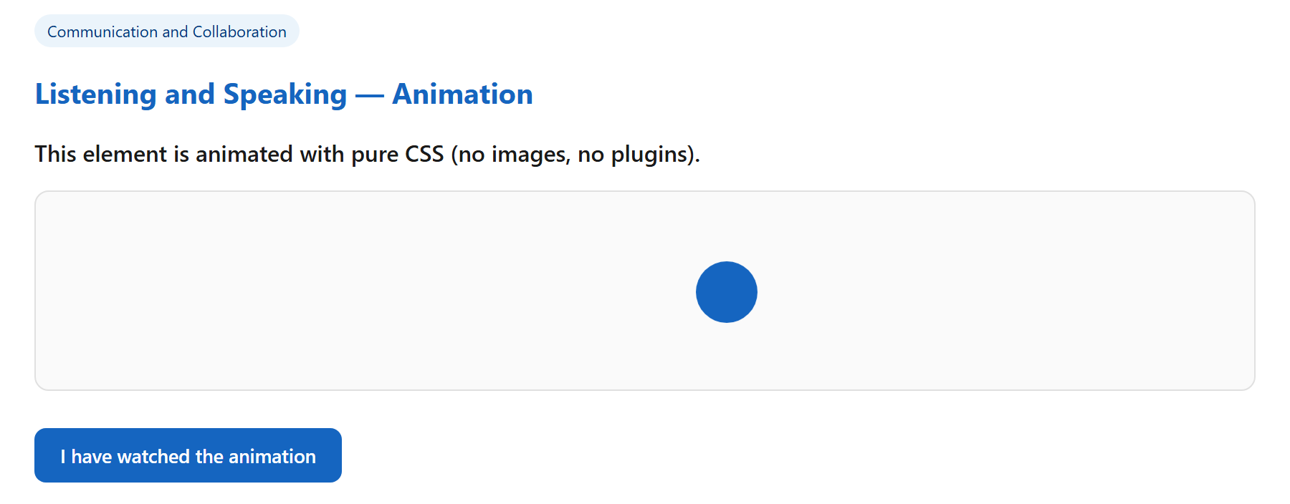
Figure 8 — CSS animation activity (lightweight, no plugins, Atom-class friendly).
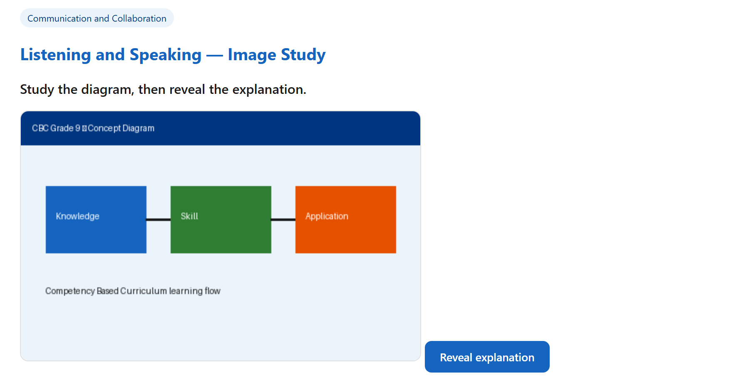
Figure 9 — Image-based activity using bundled PNG assets.
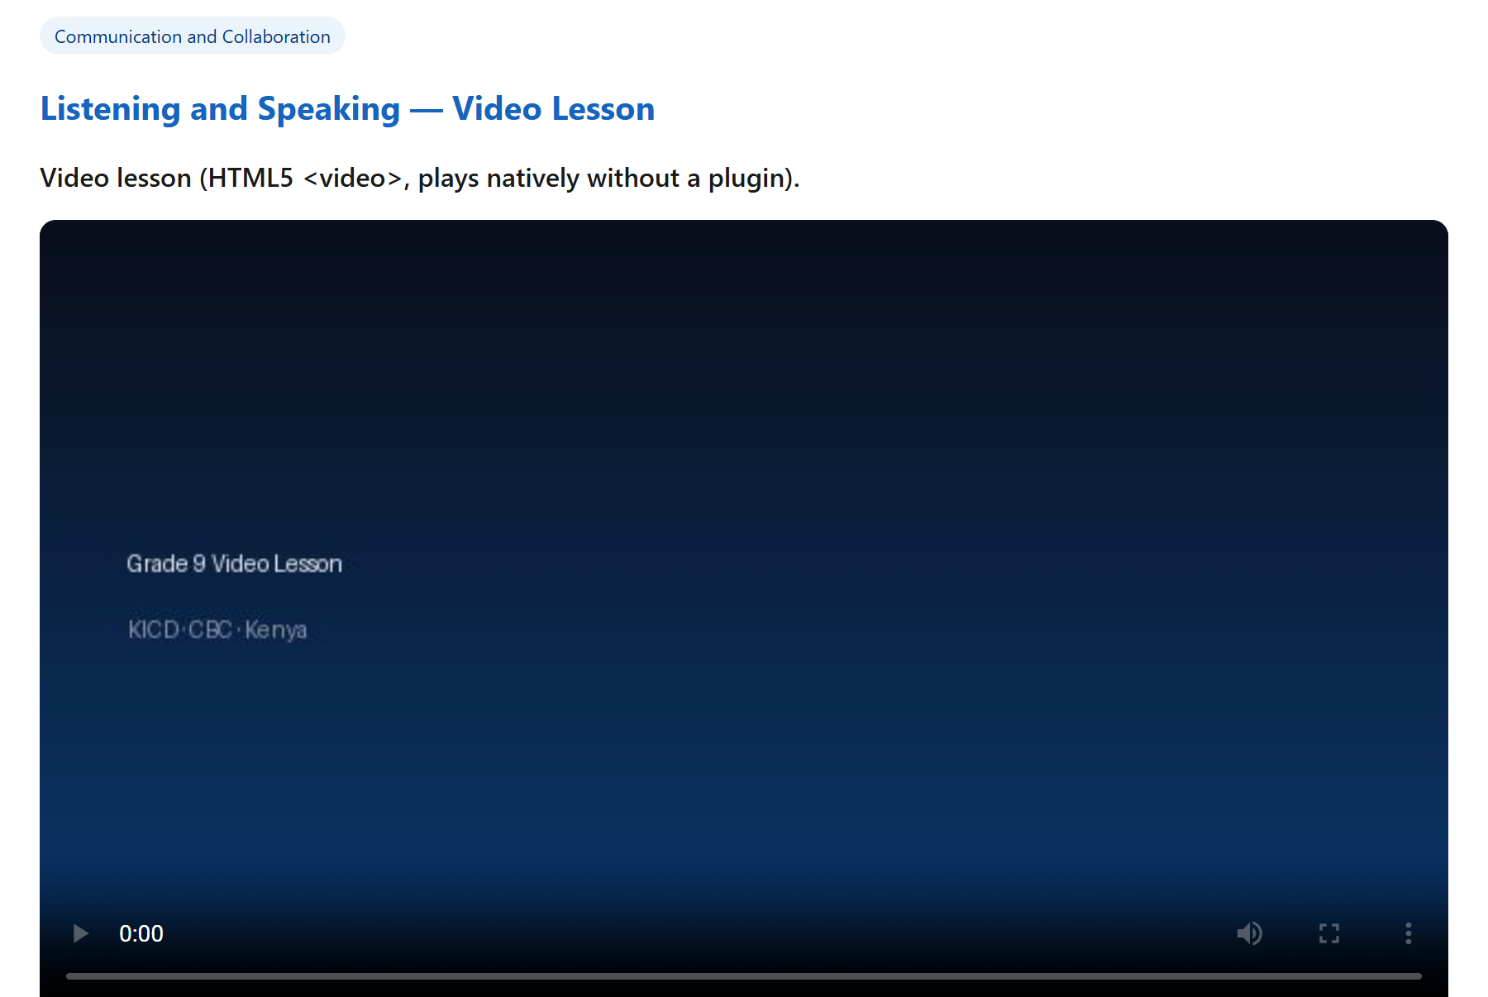
Figure 10 — Video lesson using native HTML5 <video> with a branded poster; MP4 plays without a plugin.
Audio activities use native HTML5 <audio> with bundled MP3 files, satisfying §1.7 and the plugin-free playback requirement of §1.8.

9. Deployment Topologies
The identical PIF content runs across the three environments required by Section VII §4.2–4.4, allowing KICD to deploy to any school regardless of its connectivity.
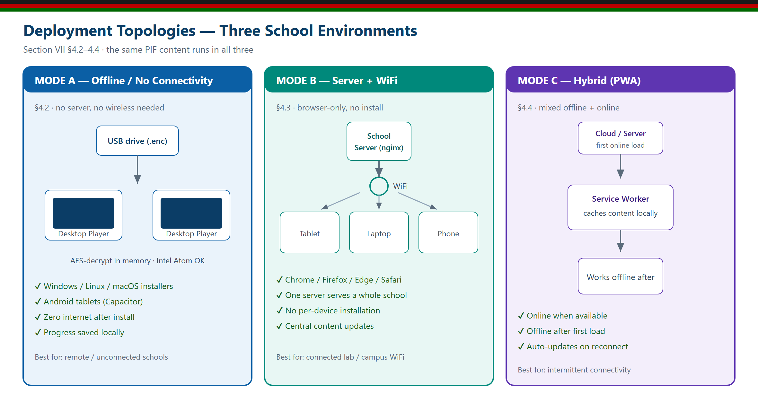
Figure 11 — Three deployment topologies: offline, server+WiFi, and hybrid (PWA).

9.1 Cross-platform & device support (§5)
Operating system | Min version | Architecture | Delivery
Windows | 7 SP1 | 32 / 64-bit | A, B, C
Ubuntu / Linux | 18.04 | 64-bit | A, B, C
macOS | 10.13 | 64-bit / Apple Silicon | A, B, C
Android | 5.0 (SDK 21) | 32 / 64-bit | A, C
Browsers supported: Chrome, Firefox, Edge, Safari and other modern browsers (§5.4).

10. Technical Specifications Compliance Table (Section VII)
The table below responds item-by-item to Section VII §3 (items 1.1–9.5), the Pass/Fail technical evaluation criteria. C = Comply; E = compliance evidenced by an attached organisational/legal document; U = undertaking given by the bidder to obtain the stated approval as a condition of contract.
No | Requirement | Comply | Evidence / Implementation
1. Content Format
1.1 | Content provided in HTML5 format | C | All packages are HTML5 (index.html + relative assets).
1.2 | Interactive: text, video, audio, animation, games, images in HTML5 | C | All six are REAL activities in the live content across 112 lessons: text (112 readings + 1,740 auto-graded questions), 112 video lessons (MP4 + transcript + captions), 112 audio lessons (MP3 + offline “Listen”), 28 CSS process animations, 100 playable auto-scored games, JPEG/PNG image studies — plus 16 PhET virtual labs. Games and animations use no asset files; every type packages self-contained.
1.3 | Self-contained ZIP (PIF) | C | One self-contained ZIP per lot.
1.4.1 | Main index file per ZIP (index.html) | C | Branded index.html injected at package root; validated.
1.4.2 | All files referenced by index.html | C | Full content tree bundled; references checked.
1.4.3 | All resources (video, audio, JS, CSS, images) | C | Entire asset tree packaged; checksums.json lists every file.
1.5 | All files within the same directory tree in the PIF | C | Single root folder LOT-NN_SUBJECT_GRADE9_CBC/.
1.6 | Single directory, optionally with sub-directories | C | units/, shared-assets/, theme/ under one root.
1.7 | Assets MP4 / MP3 / JPEG / PNG only; no others | C | Validator rejects all other formats (unit-tested).
1.8 | Video/audio playback without a plugin | C | Native HTML5 <video>/<audio>.
1.9 | No server-side code or database dependencies | C | Validator fails on PHP/ASP/JSP/PY etc.; pure static HTML5.
1.10 | No external file references / absolute URLs | C | Validator scans src/href/url(); CSP locks to self.
2. Content Licensing
2.1 | Perpetual license | C | Perpetual, royalty-free, irrevocable license to KICD/ICTA (LICENSE).
3. Security and Protection
3.1 | AES encryption (AES-128/192/256) | C | AES-CBC + PBKDF2-SHA256; .enc per package; round-trip tested.
4. Adaptability
4.1 | Support different deployment models (indicate which) | C | Three models documented: offline, server+WiFi, hybrid.
4.2 | Works with limited/no connectivity, no server/wireless | C | Offline desktop player; USB delivery; in-memory decrypt.
4.3 | Works with servers, wireless and USB extension | C | nginx static serving + USB package scanning.
4.4 | Works in mixed offline/online infrastructure | C | PWA/service-worker hybrid mode.
4.5 | Minimum Atom-class processor | C | Lightweight vanilla runtime; documented min spec.
5. Cross-platform & Device Support
5.1 | Runs on desktops, laptops, tablets, phones | C | Responsive player; Capacitor Android export.
5.2 | Windows, Linux, macOS, Android | C | electron-builder + Capacitor targets.
5.3 | 32-bit and 64-bit OS versions | C | Documented build targets; web content arch-neutral.
5.4 | Firefox, Chrome, Edge, Safari and others | C | Standard HTML5/CSS/JS; no proprietary APIs.
6. Approval Status
6.1 | Conform to the Content Standards for Digital Complementary Content for CBC; proof of KICD content approval (Mandatory) | C/U | Content authored to conform to the Content Standards for Digital Complementary Content for CBC; a signed Conformance Statement and KEC-alignment evidence are provided at Annex F. KICD content approval is not yet held; Evergain gives a binding undertaking (Annex F) to submit all delivered Grade 9 IDC to KICD’s content-approval/vetting process and to obtain KICD content approval prior to acceptance and final delivery, at no extra cost to the Purchaser.
7. Technical Designs
7.1 | Navigation aids, well positioned | C | Units→Topics→Activities tree + Prev/Next footer.
7.2 | Exit points provided | C | Exit button + confirmation modal; Esc shortcut.
7.3 | Functional, useful links/hyperlinks | C | Relative in-package navigation; all functional.
7.4 | Logical, consistent screen layout | C | Consistent header/nav/content/footer chrome.
7.5 | Screens scalable without distortion | C | Responsive layout; viewport meta; fluid CSS.
7.6 | Help facility available and functional | C | F1 help overlay (English + Kiswahili).
8. Statutory Obligation
8.1 | Comply with Constitution 2010, Cybercrimes Act 2018, KICA CAP 411A; attach commitment letter | C/E | Non-infringing, sandboxed content; signed commitment letter attached.
9. Support and Maintenance
9.1 | 3-year warranty full support; schedule & scope | C | SLA §1–2.
9.2 | Free new versions/releases/updates during warranty | C | SLA §4.
9.3 | 2 years support after warranty | C | SLA §1.
9.4 | 24/7 support across content lifecycle | C | SLA §3.
9.5 | Provide an SLA | C | SLA document attached.

Result: all software/technical items are compliant and have been verified by automated tests and reproducible builds. Item 6.1 (Mandatory) is addressed by a signed Conformance Statement asserting conformance to the Content Standards for Digital Complementary Content for CBC, together with a binding undertaking to complete the KICD content-approval process prior to acceptance and final delivery, and KEC-alignment evidence (Annex F). Item 8.1 is addressed by the signed Statutory Compliance Commitment Letter (Annex E). KICD content approval is treated throughout this Bid as a deliverable to be obtained through KICD’s evaluation process, not as a certificate already in hand.

11. Delivery Methodology & Work Plan
Delivery follows Evergain’s structured, E.V.E.R.G.-driven lifecycle over a six-month schedule, from assessment through KICD approval, packaging, testing, commissioning and long-term support.
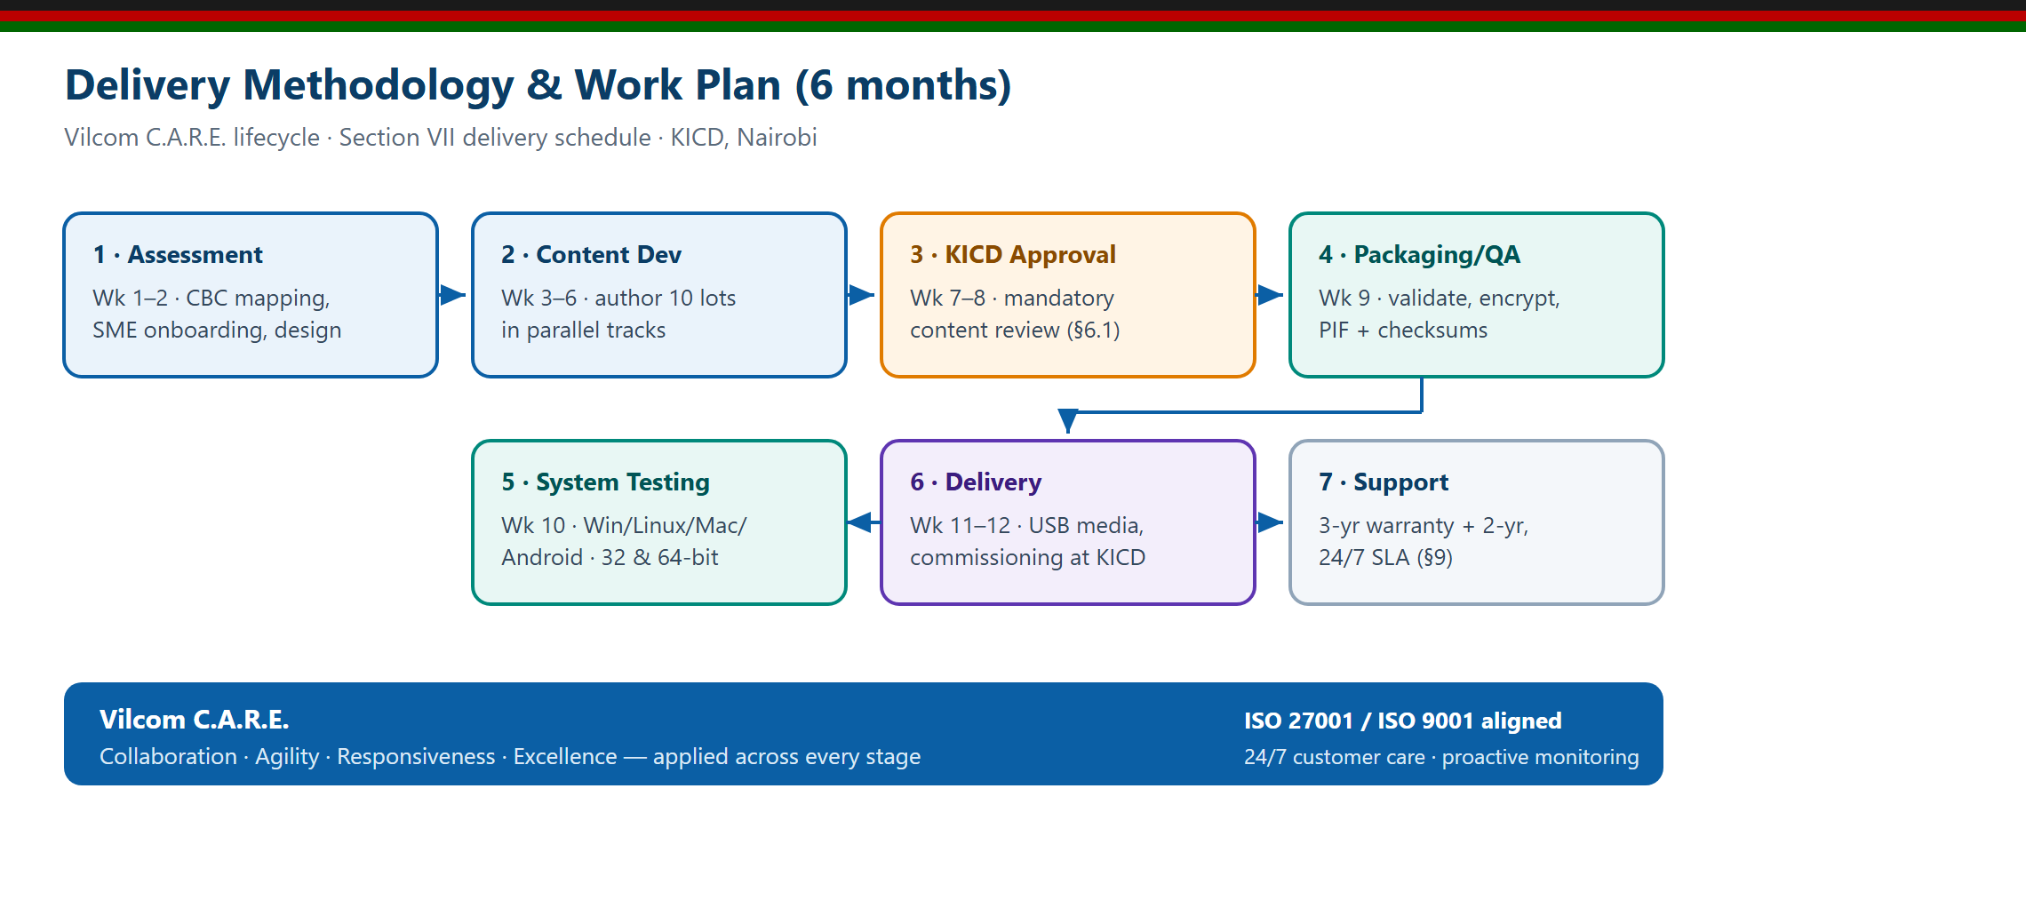
Figure 12 — Delivery methodology and 6-month work plan.

12. Team & Organisation
Delivery is led by Evergain’s management team and organised around the functional leads that run our assignments, supplemented by subject-matter educators and curriculum reviewers for this engagement:
Managing Director | Provides overall strategic leadership, oversees business development and ensures quality delivery of the assignment.
Head of Projects | Leads project design, implementation, monitoring and evaluation, ensuring solutions align to KICD objectives and best practice.
ICT & Technology Lead | Manages the platform, packaging pipeline, digital-transformation and technical support for authoring, encryption and delivery.
Human Resource & Training Lead | Oversees capacity-building, training of curriculum developers, and change-management for content roll-out.
Finance & Procurement | Responsible for financial management, compliance, reporting and procurement support to ensure smooth, accountable delivery.
Curriculum & QA reviewers | Subject-matter experts who author and peer-review content for CBC conformance and KICD content-approval readiness.

Executive sponsorship: the Managing Director, Evergain Limited.

13. Support, Maintenance & SLA
Per Section VII §9, Evergain commits to a three-year warranty with full support, free updates, a further two years of post-warranty support, and 24/7 availability across the content lifecycle, governed by a formal SLA.
Severity | Response | Resolution target
Critical | ≤ 4 hours | ≤ 24 hours
High | ≤ 24 hours | ≤ 3 business days
Medium | ≤ 72 hours | ≤ 10 business days
Low | ≤ 5 business days | Next scheduled release

- Content corrections delivered within 30 days of approval; each release re-validated and re-packaged.
- 24/7 customer care, proactive monitoring and a defined escalation matrix (L1–L4).

14. Quality, Security & Statutory Compliance
Evergain’s processes are aligned to ISO/IEC 27001 (information security) and ISO 9001 (quality management) good practice, ensuring consistent delivery, strong data protection and continuous improvement.

14.1 Statutory compliance commitment (§8.1)
Evergain commits that all content shall observe and respect the Constitution of Kenya 2010, the Computer Misuse and Cybercrimes Act 2018, the Kenya Information and Communications Act (CAP 411A) and the enabling Regulations. A signed commitment letter is attached. Content is static, sandboxed under a strict Content Security Policy, transmits no user data and contains no server-side or covert functionality.

15. Value-Add: On-Premise AI-Assisted Authoring
As an added advantage beyond the mandatory requirements, Evergain integrates an on-premise Large Language Model (LLM) to accelerate content authoring while keeping delivered packages fully compliant. This leverages Evergain’s existing AI infrastructure (an Ollama inference host on the internal network) and aligns with our “Intelligent Data & AI Enablement” service pillar. The capability is operational today: it is surfaced directly on the dashboard as an AI Authoring Assistant — showing live on-premise model status — and inside every activity editor.
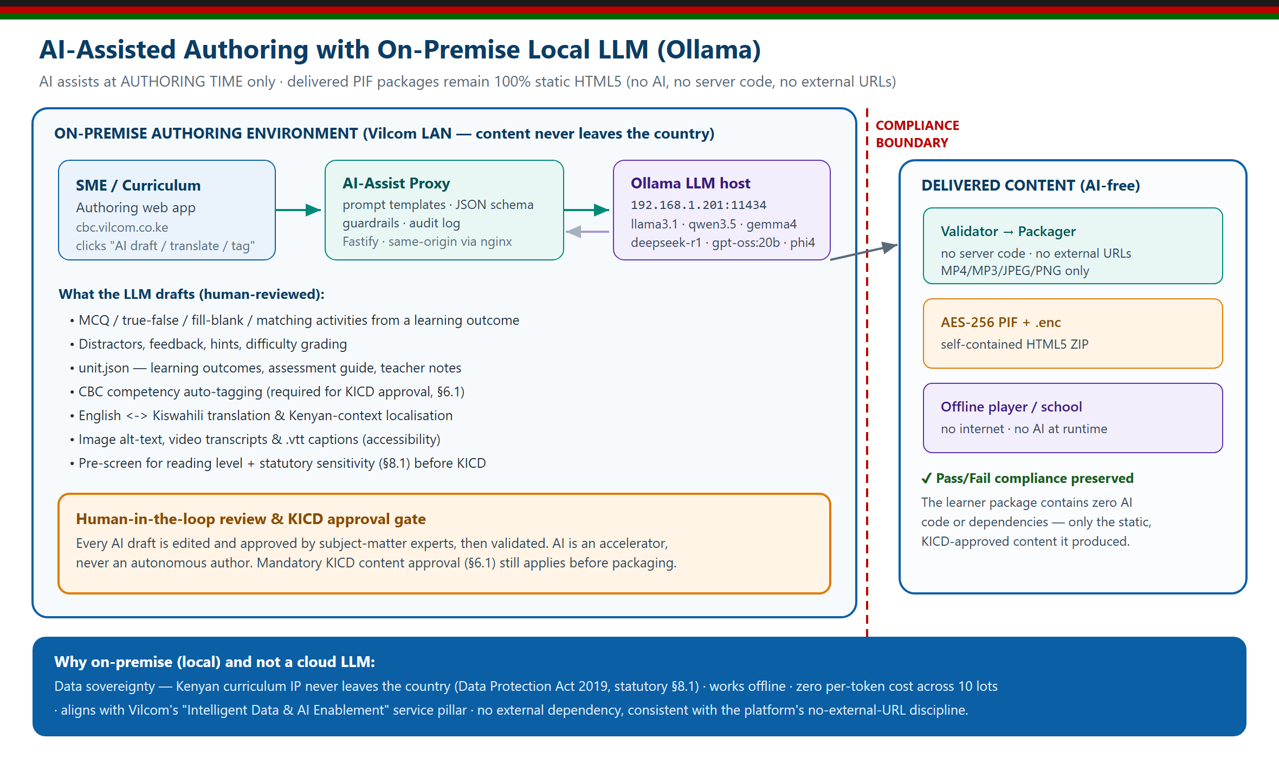
Figure 13 — On-premise AI-assisted authoring. AI assists only at authoring time; delivered PIF packages contain no AI.

15.1 The compliance boundary
AI is used strictly at authoring time. Every AI-generated draft is reviewed and edited by subject-matter experts, and all content will be submitted for KICD content approval (§6.1) before final packaging and delivery. The delivered PIF packages remain 100% static HTML5 — no server-side code (§1.9), no external URLs (§1.10), and no AI at runtime. The added intelligence never compromises the Pass/Fail technical compliance.

15.2 Where the LLM adds value
- Drafts activities (multiple-choice, true/false, fill-in-blanks, matching) from a learning outcome
- Generates distractors, feedback, hints and difficulty grading
- Auto-tags each activity to a CBC core competency — a requirement for KICD approval (§6.1)
- English ↔ Kiswahili translation and Kenyan-context localisation (Lot 2 and bilingual help)
- Image alt-text and video transcripts / .vtt captions (accessibility)
- Pre-screens content for reading level and statutory sensitivity (§8.1) before KICD review

15.3 On-premise model routing
Each task is routed to an appropriate model on the internal Ollama host:
Task | Model | Rationale
Activity drafting | gpt-oss:20b / llama3.1:8b | High-quality questions, options and feedback
Competency tagging | phi4-mini | Fast classification to a CBC core competency
Kiswahili & localisation | gemma4 | Multilingual; English ↔ Kiswahili for Lot 2
Maths / Science reasoning | deepseek-r1:14b | Step-by-step problem generation
Accessibility text | llama3.1:8b | Alt-text, transcripts and caption drafts

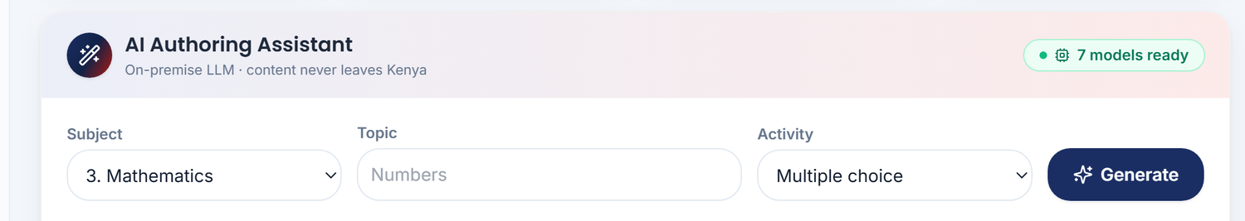
Figure 14 — The AI Authoring Assistant on the live dashboard: choose a subject, topic and activity type, then generate a KICD-ready draft from the on-premise model (live status: “7 models ready”).

15.4 Why on-premise (not cloud)
- Data sovereignty — Kenyan curriculum IP never leaves the country (Data Protection Act 2019; reinforces the §8.1 commitment)
- Works offline — consistent with the tender’s offline ethos
- Zero per-token cost across all ten lots — fits Evergain’s cost-effective, value-for-money delivery model
- No external dependency — consistent with the platform’s strict no-external-URL discipline

15.5 Learner-facing enrichment — online demo vs. compliant offline package
The live platform (cbc.evergain.co.ke) gives a deliberately rich learning experience: 112 streamed video lessons with captions, 112 audio lessons, 100 playable learning games, 28 animated process diagrams, 16 interactive PhET virtual labs, 1,740 auto-graded questions, and a learner-facing “Dive deeper with AI” helper running on the on-premise LLM. Every lesson has video, audio, games and questions, and every text lesson can be read aloud by a built-in “Listen” narration. All six §1.2 interaction types — text, video, audio, animation, games, images — are present as real activities.
Crucially, this enrichment is engineered around the tender’s self-contained rule. The mandatory learning content always works fully offline. In the delivered PIF package, streamed video becomes a bundled MP4, podcasts become a bundled MP3, the AI helper and the online encyclopedia are simply not present, and PhET’s self-contained HTML5 simulations are bundled to run offline — so every package satisfies §1.7 (MP4/MP3/JPEG/PNG only), §1.9 (no server-side code) and §1.10 (no external URLs). Rich where there is a network; complete and compliant where there is not.

16. Submission & Delivery Checklist
The following checklist governs the physical submission on 2nd July 2026, 10:00 hrs EAT at Telposta Towers, 12th Floor Boardroom, Nairobi (deadline as extended by Addendum No. 2). Bidders may submit for one or more lots; the system produces any subset of the ten packages independently.

16.1 Technical Part (Envelope 1)
☐ Per lot (×10): USB drive labelled with lot number and subject, sealed in a separate envelope (BDS 21.4)
☐ Per lot: ..._LOT-NN_SUBJECT.zip (PIF package)
☐ Per lot: ..._LOT-NN_SUBJECT.enc (AES-256 encrypted variant)
☐ Per lot: lot-NN-build-report.json (validation + checksums)
☐ Desktop player installers: Windows (.exe / NSIS) and Linux (.AppImage)
☐ Covering letter on company letterhead (BDS ITB 11.2)
☐ Technical compliance table — printed and signed (all items 1.1–9.5)
☐ Detailed work plan (printed)
☐ SLA document — signed
☐ Clarification No. 1 (12 June 2026) acknowledged in the Letter of Transmittal and in the Addenda and Clarifications Acknowledged note
☐ Annex F: signed CBC Content Standards Conformance Statement + binding KICD Content Approval Undertaking + KEC-alignment traceability (Mandatory, §6.1)
☐ KICD content approval / Content Standards conformance evidence (Mandatory, §6.1) — attach KICD content approval if obtained; otherwise attach the signed Conformance Statement and binding KICD Approval Undertaking (Annex F)
☐ Statutory compliance commitment letter — signed (§8.1)
☐ Copyright / perpetual-license ownership statement — lawyer-signed (§2.1, BDS ITB 11.2)
☐ Certificate of Incorporation
☐ Current Tax Compliance Certificate
☐ Power of Attorney
☐ Current Business Permit Certificate
☐ Current CR12 Certificate

16.2 Financial Part (Sealed Envelope 2 — DO NOT OPEN)
☐ Price Schedule (Section IV, BDS)
☐ Bid Security: KES 230,000 per lot (bank guarantee or certified cheque) — valid for the full bid-validity period counted from the extended 2nd July 2026 deadline (recompute per BDS ITB 19.1/21.2; the 7-day extension moves the original 24 October 2026 validity to on/about 31 October 2026 — confirm the exact date and have the guarantee issued accordingly)

16.3 Pre-flight technical verification
☐ Run the full CI pipeline (type-check, automated tests, validation) — all green
☐ Build all required lot packages (encrypted) and confirm output filenames
☐ Verify each .enc decrypts and each ZIP opens in the player
☐ Record AES passphrase(s) per lot on the secure key-custody sheet

17. Conclusion
Evergain Limited offers ICTA and KICD a complete, verified and production-ready solution for the supply, delivery and commissioning of Grade 9 CBC interactive digital content. Our platform meets every mandatory technical requirement of Section VII, is built to the mandatory technical specifications and is supported by a binding undertaking to complete KICD content approval, and is backed by Evergain’s multi-disciplinary delivery capability, ISO-aligned quality and security good practice, and a committed 24/7 support model.
We look forward to partnering with KICD to deliver engaging digital learning authored to conform to the Content Standards for Digital Complementary Content for CBC to Grade 9 learners across Kenya — turning technology into capability.

— End of Technical Proposal —

Annexes — Supporting Documents
The following supporting documents are compiled into this proposal (Annexes A–F) and accompanied by the bidder statutory attachments (Annex G).
- Annex A: Technical Specifications Compliance Table (full, for signature)
- Annex B: Service Level Agreement (SLA)
- Annex C: Project Work Plan
- Annex D: Perpetual License
- Annex E: Statutory Compliance Commitment Letter
- Annex F: CBC Content Standards Conformance Statement, binding KICD Content Approval Undertaking, and Kenya Education Cloud (KEC) alignment traceability
- Annex G: Company statutory documents — Certificate of Incorporation, Tax Compliance, CR12, Business Permit, Power of Attorney (to be attached by the bidder)

Annex A — Technical Specifications Compliance Table

Technical Specifications Compliance Table — KE-ICTA-543406-GO-RFB
Tender: Supply, Delivery & Commissioning of Interactive Digital Content for CBC Grade 9
Purchaser: Information & Communications Technology Authority (ICTA) · Delivery to: KICD, Nairobi
Evaluation method: Pass/Fail against Section VII, Schedule of Requirements (item-by-item).
This table mirrors Section VII §3 — Technical Specifications (Mandatory Requirements) of the bidding
document exactly (items 1.1–9.5). The "Bidder's compliance" column is the bidder's declaration; the
"Evidence / Implementation" column points to where each requirement is satisfied in this system.
Legend — C = Comply · E (org) = Compliance evidenced by an organisational/legal document the bidder attaches (not software).

1. Content Format
No | Requirement (verbatim intent) | Bidder's compliance | Evidence / Implementation
1.1 | Content provided in HTML5 format | C | Every package is HTML5 (index.html + relative assets). src/packager.
1.2 | Interactive content comprising text, video, audio, animation, games and images in HTML5 | C | Sample unit 1 of every lot ships activities for text (multiple-choice/true-false/fill-blanks), image (real PNG), audio (real MP3, <audio>), animation (CSS keyframes), games (drag-and-drop), and video (<video> + branded poster; MP4 supplied as SME-authored content prepared for KICD approval).
1.3 | HTML5 package is a self-contained ZIP (PIF) | C | src/packager emits one self-contained ZIP per lot.
1.4 | Package must include: | C | —
1.4.1 | Main index file per ZIP (index.html) | C | Branded index.html injected at the package root; validator enforces presence.
1.4.2 | All other files referenced by index.html | C | Entire content tree bundled; validator flags missing references.
1.4.3 | All resources (video, audio, JS, CSS, images, etc.) | C | Packager copies the full asset tree; checksums.json lists every file.
1.5 | All files fit within the same directory tree in the PIF | C | Single root folder LOT-NN_SUBJECT_GRADE9_CBC/; verified by packager test.
1.6 | Group everything into a single directory, optionally with sub-directories | C | One root folder with units/, shared-assets/, theme/ sub-dirs.
1.7 | Assets only MP4 (video), MP3 (audio), JPEG/PNG (images); no other formats | C | src/validator rejects AVI/MOV/WEBM/MKV/FLV, WAV/OGG/AAC/FLAC/M4A, GIF/WEBP/BMP/SVG/TIFF. Unit-tested.
1.8 | Video/audio playback without a plugin | C | Native HTML5 <video>/<audio> (Chromium/Electron, all modern browsers).
1.9 | No server-side code or dependencies (e.g. databases) | C | Validator fails on .php/.asp/.aspx/.jsp/.py/.rb/.cgi/.pl/.sh; packages are pure static HTML5.
1.10 | No references to external files / absolute URLs | C | Validator scans src=, href=, url() for http(s)://, ftp://, //; fails on any. CSP locks to self.

2. Content Licensing
No | Requirement | Bidder's compliance | Evidence / Implementation
2.1 | Content accompanied by a perpetual license | C | LICENSE.md — royalty-free, irrevocable, worldwide, perpetual grant to KICD/ICTA.

3. Security and Protection
No | Requirement | Bidder's compliance | Evidence / Implementation
3.1 | Encryption that is simple and complies with AES (128/192/256) | C | src/shared/crypto.ts — AES-128/192/256-CBC, PBKDF2-SHA256 (100k). .enc variant per package; round-trip unit-tested.

4. Adaptability
No | Requirement | Bidder's compliance | Evidence / Implementation
4.1 | Support different deployment models (indicate which) | C | Three documented: A offline, B server+WiFi, C hybrid. See deployment-guide.md.
4.2 | Works with limited/no connectivity, no server/wireless | C | Electron desktop player loads from local disk/USB; AES decrypt in memory.
4.3 | Works with servers, wireless and USB extension | C | nginx static serving (Mode B) + USB package scanning in the player.
4.4 | Works in mixed offline/online, wired/wireless infrastructure | C | PWA/service-worker hybrid (Mode C).
4.5 | Works on a minimum Atom-class processor | C | Lightweight vanilla player runtime; documented min spec (Atom 1.6 GHz, 2 GB RAM).

5. Cross-platform and Device Support
No | Requirement | Bidder's compliance | Evidence / Implementation
5.1 | Runs on desktops, laptops, tablets and mobile phones | C | Responsive player chrome; Capacitor Android export for tablets/phones.
5.2 | Runs on Windows, Linux, macOS and Android | C | electron-builder targets (NSIS/AppImage/dmg) + Capacitor Android (minSdk 21).
5.3 | Works on 32-bit and 64-bit OS versions | C | Documented build targets; web content is architecture-neutral.
5.4 | Works across Firefox, Chrome, Edge, Safari and others | C | Standard HTML5/CSS/JS only — no proprietary APIs.

6. Approval Status
No | Requirement | Bidder's compliance | Evidence / Implementation
6.1 | Conform to the Content Standards for Digital Complementary Content for CBC; proof of KICD content approval (Mandatory) | C / U | Content authored to conform to the Content Standards for Digital Complementary Content for CBC; signed Conformance Statement + binding undertaking to complete KICD's content-approval process prior to acceptance/final delivery + KEC-alignment traceability — all at Annex F. KICD content approval is not yet held and is treated as a deliverable to be obtained through KICD's evaluation process, not a certificate in hand.

7. Technical Designs
No | Requirement | Bidder's compliance | Evidence / Implementation
7.1 | Navigation aids, well positioned for ease of use | C | Player: collapsible Units→Topics→Activities tree + Previous/Next footer.
7.2 | Provide exit points | C | Exit button + confirmation modal; Esc shortcut; Electron exit bridge.
7.3 | Links/hyperlinks functional and useful | C | In-package navigation links + activity links all functional and relative.
7.4 | Logical, consistent screen layout | C | Consistent header/nav/content/footer chrome across all packages.
7.5 | Screens/forms scalable without distortion | C | Responsive layout, viewport meta, fluid CSS; no fixed-pixel canvas.
7.6 | Help facility available and functional | C | F1 help overlay (English + Kiswahili) in every package.

8. Statutory Obligation
No | Requirement | Bidder's compliance | Evidence / Implementation
8.1 | Observe Constitution of Kenya 2010, Computer Misuse & Cybercrimes Act 2018, KICA CAP 411A and enabling regulations; attach a commitment letter | C / E (org) | Content is non-infringing and CSP-sandboxed. Commitment-letter draft: statutory-compliance-letter.md (to be issued on company letterhead and signed).

9. Support and Maintenance
No | Requirement | Bidder's compliance | Evidence / Implementation
9.1 | Full support during the 3-year warranty; provide schedule and scope | C | sla-template.md §1–2.
9.2 | Free new versions/releases/updates during warranty | C | sla-template.md §4.
9.3 | Support and maintenance for 2 years after warranty | C | sla-template.md §1.
9.4 | 24/7 support across the content lifecycle | C | sla-template.md §3.
9.5 | Provide an SLA | C | sla-template.md.

Summary
- Software/technical items (1.x, 2.1, 3.1, 4.x, 5.x, 7.x, 9.x): fully compliant, automated-tested (npm run ci) and reproducible (npm run package:all:encrypted).
- Item 6.1 (Mandatory): addressed by a signed Conformance Statement to the Content Standards for Digital Complementary Content for CBC + a binding undertaking to complete KICD content approval prior to acceptance + KEC-alignment evidence (Annex F); KICD content approval to be obtained through KICD's evaluation process (not a certificate already held).
- Organisational/legal attachments the bidder must supply: statutory commitment letter (8.1, draft provided), plus the eligibility documents in DELIVERY-CHECKLIST.md.

Annex B — Service Level Agreement (SLA)

Service Level Agreement (Template) — KE-ICTA-543406-GO-RFB
Between: RTM-HD Content Systems ("Supplier") and the Information & Communications Technology Authority / Kenya Institute of Curriculum Development ("Client").
Covers tender requirements 9.1–9.5.

1. Warranty period
A three (3) year warranty from the date of commissioning, covering defect correction, content patches and technical support, followed by a two (2) year post-warranty support term.

2. Support response & resolution targets
Severity | Definition | Response | Resolution target
Critical | Content unusable across multiple schools; data/security incident | ≤ 4 hours | ≤ 24 hours
High | A lot or major feature unusable | ≤ 24 hours | ≤ 3 business days
Medium | Partial defect with a workaround | ≤ 72 hours | ≤ 10 business days
Low | Cosmetic / enhancement | ≤ 5 business days | Next scheduled release

3. Support channels (24/7 logging)
- Dedicated email and ticketing portal
- Telephone hotline (Critical/High)
- On-site support for Critical incidents where remote resolution is not possible

4. Updates & patches
- Content corrections delivered within ≤ 30 days of approval.
- Each update is re-validated (npm run validate), re-packaged and re-encrypted; checksums and a changelog accompany every release.
- Security patches to the player prioritised as Critical.

5. Escalation matrix
Level | Contact | Trigger
L1 | Support desk | Initial logging & triage
L2 | Technical lead | Breach of response target
L3 | Project manager | Breach of resolution target / Critical
L4 | Director, RTM-HD | Repeated breach or dispute

6. Reporting
Monthly SLA report: tickets by severity, response/resolution compliance %, releases shipped, and outstanding items.

Annex C — Project Work Plan

Project Workplan — KE-ICTA-543406-GO-RFB
Per tender requirement 11.1. Minimum six-month delivery schedule (BDS). Ten lots run as parallel content tracks.
Phase | Weeks | Activities | Deliverable
Mobilisation | 1–2 | Authoring environment setup; SME onboarding; CBC curriculum mapping | Signed-off content plan per lot
Content development | 3–6 | Author activities per lot (10 lots × parallel tracks); asset production (MP4/MP3/JPEG/PNG) | Draft content for all units
KICD review | 7–8 | Submit drafts for KICD content review and approval | KICD content approval (mandatory)
Packaging & QA | 9 | Validation, AES encryption, PIF packaging, checksum generation | Validated .zip + .enc per lot
System testing | 10 | Cross-platform testing (Windows/Linux/macOS/Android, 32/64-bit) | Test report
Submission prep | 11 | Physical media (USB), printed documentation, compliance table | Submission pack assembled
Delivery & commissioning | 12 | Deliver to KICD; install; commission; sign-off | Commissioning certificate
Detailed Gantt timing is adjusted to the BDS delivery schedule (minimum 6 months). Weeks above represent the critical-path compression; content tracks for the 10 lots execute concurrently.

Milestones
- M1 (Wk 2): Content plan approved.
- M2 (Wk 6): All draft content complete.
- M3 (Wk 8): KICD approval obtained.
- M4 (Wk 9): All packages validated & encrypted.
- M5 (Wk 12): Delivered & commissioned.

Dependencies & risks
- KICD content approval (M3) is a hard external dependency — engage reviewers early.
- Asset format discipline (MP4/MP3/JPEG/PNG only) enforced from day one by the validator to avoid late rework.

Annex D — Perpetual License

License — KICD Grade 9 Interactive Digital Content

Content license (tender req. 2.1 & Section 10.1)
RTM-HD Content Systems ("the Content Owner") grants the Kenya Institute of Curriculum Development (KICD) and the Information & Communications Technology Authority (ICTA) a royalty-free, irrevocable, worldwide, perpetual license to use, copy, modify, distribute, host and sub-license the delivered Grade 9 Interactive Digital Content for educational purposes within the Republic of Kenya and as required by the Competency Based Curriculum.
This license is non-exclusive to the Content Owner's retained moral rights of attribution and survives expiry of the warranty and support periods.

Third-party open-source components
This platform's tooling and player reference the following open-source projects, used under their respective licenses with attribution:
Component | License | Use
H5P (h5p-php-library, h5p-standalone) | MIT | Interactive activity authoring/preview reference
Adapt Framework | GPL-2.0 | Full-course framework reference
React, Vite, Tailwind CSS, Zustand, Radix UI, lucide-react, framer-motion | MIT | Authoring web application
Electron, electron-builder | MIT | Desktop player shell & installers
archiver, jszip, glob, chalk, commander, tsx, vitest | MIT | Build & packaging toolchain
Delivered content packages contain no GPL-licensed code; they are self-contained static HTML5. The Adapt reference is used at authoring time only.
© 2026 RTM-HD Content Systems / ICTA Kenya / KICD.

Annex E — Statutory Compliance Commitment Letter

Statutory Compliance Commitment Letter (Draft) — Req. 8.1
To be reproduced on company letterhead, dated, and signed by an authorised
signatory before submission. Covers Section VII item 8.1.
[Company Letterhead]
Date: __________________
To: The Chief Executive Officer
Information & Communications Technology Authority (ICTA)
12th Floor, Telposta Towers, Kenyatta Avenue
P.O. Box 27150-00100, Nairobi
RE: STATUTORY COMPLIANCE COMMITMENT — RFB No. KE-ICTA-543406-GO-RFB
Supply, Delivery & Commissioning of Interactive Digital Content for CBC Grade 9
Dear Sir/Madam,
We, [Bidder Name], in submitting our Bid for the above tender, hereby commit and
warrant that all Interactive Digital Content supplied under this contract shall observe and
respect the guidelines stipulated under:
- The Constitution of Kenya, 2010 — including the Bill of Rights, the values of human
dignity, non-discrimination, and the protection of children (Article 53);
- The Computer Misuse and Cybercrimes Act, 2018 — we shall not include any content,
code or mechanism that constitutes unauthorised access, interference, or any offence under
the Act; all content is static HTML5 with no server-side code or covert functionality;
- The Kenya Information and Communications Act, CAP 411A and the enabling Regulations
thereof; and
- All other relevant statutory documents and lawful directives of the Government of Kenya and
KICD.
We further confirm that the content:
- contains no material that is unlawful, defamatory, obscene, discriminatory, or otherwise
prohibited;
- references no external resources and transmits no user data (it operates fully offline);
- is sandboxed under a strict Content Security Policy and contains no executable server-side
components or database dependencies.
Should any content be found to infringe the above, we commit to remedy it at no cost to KICD
within the timelines defined in our Service Level Agreement.
Yours faithfully,
__________________________
Name:
Title (Authorised Signatory):
For and on behalf of: [Bidder Name]
Company Seal / Stamp:

Annex F — CBC Content Standards Conformance Statement & KICD Approval Undertaking
To be reproduced on Evergain Limited letterhead, dated, and signed by an
authorised signatory before submission. This Annex responds to the Mandatory
requirement at BDS ITB 32.4, Item 6, sub-item 6.1, as reaffirmed by Clarification
No. 1 dated 12 June 2026 (Item 1): the digital content must conform to the Content
Standards for Digital Complementary Content for CBC and be supported by proof of
KICD content approval.

Part 1 — Conformance Statement: Content Standards for Digital Complementary Content for CBC
[Evergain Limited letterhead]
Date: __________________ 2026
To: The Chief Executive Officer, Information & Communications Technology Authority (ICTA), 12th Floor, Telposta Towers, Kenyatta Avenue, Nairobi.
RE: RFB No. KE-ICTA-543406-GO-RFB — Supply, Delivery and Commissioning of Interactive Digital Content for the Competency Based Curriculum (Grade 9). Conformance to the Content Standards for Digital Complementary Content for CBC (BDS ITB 32.4, Item 6, sub-item 6.1; Clarification No. 1, Item 1).
Evergain Limited hereby declares that all Grade 9 Interactive Digital Content packages offered under this Bid have been authored to conform to the Content Standards for Digital Complementary Content for CBC and to the applicable KICD content standards for CBC digital and complementary curriculum-support materials, including the Standards for Competence Based Digital Course Materials (KICD, 2018, revised) and the Standards for Curation of Online Supplementary Curriculum Support Materials (KICD, 2016).
We confirm conformance against the KICD General Standards areas as follows: (a) conformity to the CBC Grade 9 curriculum designs — strands, sub-strands, themes, concepts and skills; (b) accuracy and currency of content; (c) appropriate language use; (d) promotion of positive values and attitudes; (e) integration of Pertinent and Contemporary Issues (PCIs); (f) assessment with feedback; (g) quality multimedia elements using only the permitted MP4/MP3/JPEG/PNG media; (h) sound technical design as self-contained, offline-capable HTML5 Package Interchange Files (PIF); (i) user guidance; and (j) Kenya Education Cloud content attributes. A clause-by-clause mapping is provided in the technical compliance table (item 6.1) and in the Kenya Education Cloud alignment traceability table appended to this Annex (Part 3).
We further confirm that all delivered content is supplied as a finished, peer-reviewed product, authored against and aligned to the KICD-approved curriculum support materials disseminated through the Kenya Education Cloud (lms.kec.ac.ke).
For the avoidance of doubt, this is a statement of conformance and alignment by the bidder. It does not assert that KICD content approval has been granted. KICD content approval will be obtained through the process set out in the Undertaking at Part 2 of this Annex.
Signed for and on behalf of Evergain Limited:
__________________________________
Name: ____________________________________ Title: Managing Director
Company Seal / Stamp:

Part 2 — Binding Undertaking: KICD Content Approval
[Evergain Limited letterhead]
Date: __________________ 2026
To: The Chief Executive Officer, Information & Communications Technology Authority (ICTA), and the Kenya Institute of Curriculum Development (KICD).
RE: RFB No. KE-ICTA-543406-GO-RFB — Proof of KICD Content Approval (Mandatory, BDS ITB 32.4 Item 6 sub-item 6.1; Clarification No. 1, Item 1).
Evergain Limited gives the following binding and unconditional undertaking in respect of the Mandatory requirement for proof of KICD content approval:
- We undertake to submit all delivered Grade 9 Interactive Digital Content to the Kenya Institute of Curriculum Development for its content evaluation, curation and approval process, in the form and to the standards prescribed by KICD.
- We undertake to obtain KICD content approval for the delivered content, and to furnish the Purchaser with the resulting proof of KICD content approval, as a condition precedent to acceptance of the deliverables and to final delivery, and as a condition precedent to the corresponding payment.
- Where any content is not approved by KICD, we undertake to revise and re-submit that content, at no additional cost to the Purchaser, until KICD content approval is obtained.
- We undertake that the above shall be carried out at no extra cost to the Purchaser and within the project schedule, and that the content shall be onboarded to the Kenya Education Cloud upon approval where so required by KICD.
- We confirm that, as at the date of this Bid, Evergain does not hold and does not claim to hold a KICD content-approval certificate for the offered Grade 9 packages, and that nothing in this Bid should be read as asserting that such approval has already been granted.
This undertaking is given in good faith, is irrevocable for the duration of the procurement and the resulting contract, and is binding on Evergain Limited.
Signed for and on behalf of Evergain Limited:
__________________________________
Name: ____________________________________ Title: Managing Director
Company Seal / Stamp:

Part 3 — Kenya Education Cloud (KEC) Alignment & Content-Standards Traceability
The table below maps our Grade 9 Interactive Digital Content and authoring platform against the KICD General Standards for Competence Based Digital Course Materials, and to the KICD-approved curriculum support materials disseminated through the Kenya Education Cloud (lms.kec.ac.ke), to which Clarification No. 1 (Item 1) directs bidders. This demonstrates alignment and conformance; it is not, and does not assert, a grant of KICD content approval.
KICD General Standard (2018 Digital Course Materials) | How Evergain's Grade 9 IDC conforms | Where evidenced on the platform
Conformity to the curriculum | Content tree maps to the CBC Grade 9 curriculum designs: Lots → Units (strands) → Topics (sub-strands) → Activities; covers prescribed themes, concepts and skills | Authoring studio content tree; per-lot coverage (33 units, 66 topics, 335 activities)
Accuracy and currency of content | Source-grounded lots authored from official KICD Grade 9 material and independently fact-checked for every formula, fact and answer key | Content provenance pipeline; QA / fact-check pass
Language use | Reviewed by subject-matter experts for register and clarity appropriate to Grade 9; English and Kiswahili support | Activity editor; bilingual interface
Promotion of positive values and attitudes | Content and contexts reviewed for positive values; Kenyan, age-appropriate scenarios | SME review workflow
Integration of Pertinent and Contemporary Issues (PCIs) | PCIs integrated where the curriculum design requires | Unit overviews and activity contexts
Assessment | Every activity auto-graded with feedback and hints; multiple-choice items carry exactly one correct option | Seven interactive activity types; learner preview
Multimedia elements | Only the permitted MP4 / MP3 / JPEG / PNG media; native HTML5 video and audio | Asset validator (rejects all other formats)
Technical design | Self-contained, offline-capable HTML5 packaged as a PIF; no external URLs; no server-side code | PIF packager; validation gate
User guide | In-package navigation, help facility and consistent learner chrome | Offline player; help overlay
Kenya Education Cloud content attributes | Packages produced in a curated, grade-wise, self-describing form aligned to KEC content attributes, ready for onboarding to KEC upon KICD approval | Package manifest and per-file checksums
Reference baseline: the KICD-approved curriculum support materials disseminated through the Kenya Education Cloud (lms.kec.ac.ke), as identified in Clarification No. 1 (Item 1), are used as the alignment reference for the above. Evergain commits to onboard approved titles to the Kenya Education Cloud where so required by KICD.

