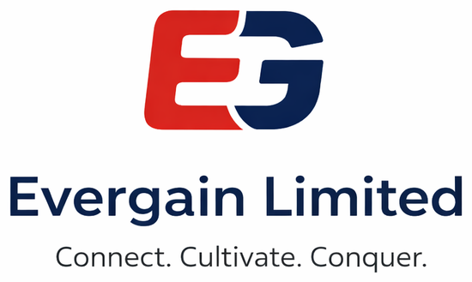

PLATFORM OVERVIEW & TECHNICAL SHOWCASE
Evergain Grade 9 Interactive
Digital Content Studio
A working, end-to-end platform that authors, validates, encrypts and
packages KICD-aligned HTML5 interactive content for all ten Grade 9 lots.
Live at cbc.evergain.co.ke

Submitted with the Technical Proposal for
RFB No: KE-ICTA-543406-GO-RFB
Supply, Delivery & Commissioning of Interactive Digital Content for CBC Grade 9

PURCHASER | DELIVERY TO
 | 

Submitted by: Evergain Limited
Platform: cbc.evergain.co.ke — live, HTTPS, on-premise AI
Document: Platform Overview & Technical Showcase (Annex to the Technical Proposal)

Table of Contents
Right-click here and choose 'Update Field' to build the table of contents.

1. What This Document Shows
This document is a visual tour of the Evergain Grade 9 Interactive Digital Content (IDC) Studio — the working platform we built for this tender, live at cbc.evergain.co.ke. Where the Technical Proposal maps our solution to each requirement of Section VII, this companion document shows the platform itself: the screens curriculum developers use, the interactive activities a learner experiences, the architecture and deployment topologies, and how content is authored, fact-checked, packaged and encrypted.
Everything pictured here is real and running. The screenshots are captured from the live system; the activities shown are rendered from actual KICD-aligned Grade 9 content authored on the platform.

1.1 The platform at a glance
10 | 112 | 2,344 | 1,740 | 100%
SUBJECT LOTS | LESSONS | INTERACTIVE  ACTIVITIES | ASSESSMENT  QUESTIONS | OFFLINE-  CAPABLE

A single platform takes content from a blank page to a tender-ready, AES-encrypted PIF package:
- Author — a modern web studio where curriculum developers author units, topics and interactive activities, with a live learner preview.
- Assist — an on-premise AI assistant drafts a starting activity in seconds; all content stays in Kenya and is reviewed by subject-matter experts and prepared for submission to KICD for content approval.
- Validate — every package is checked against the asset rules (MP4/MP3/JPEG/PNG only, no external URLs, no server code) before it can ship.
- Package & encrypt — content is wrapped into a self-contained HTML5 PIF ZIP and an AES-256 encrypted .enc variant for delivery on physical media.
- Deliver — learners study fully offline on a laptop, tablet or phone, with instant feedback and progress tracking.

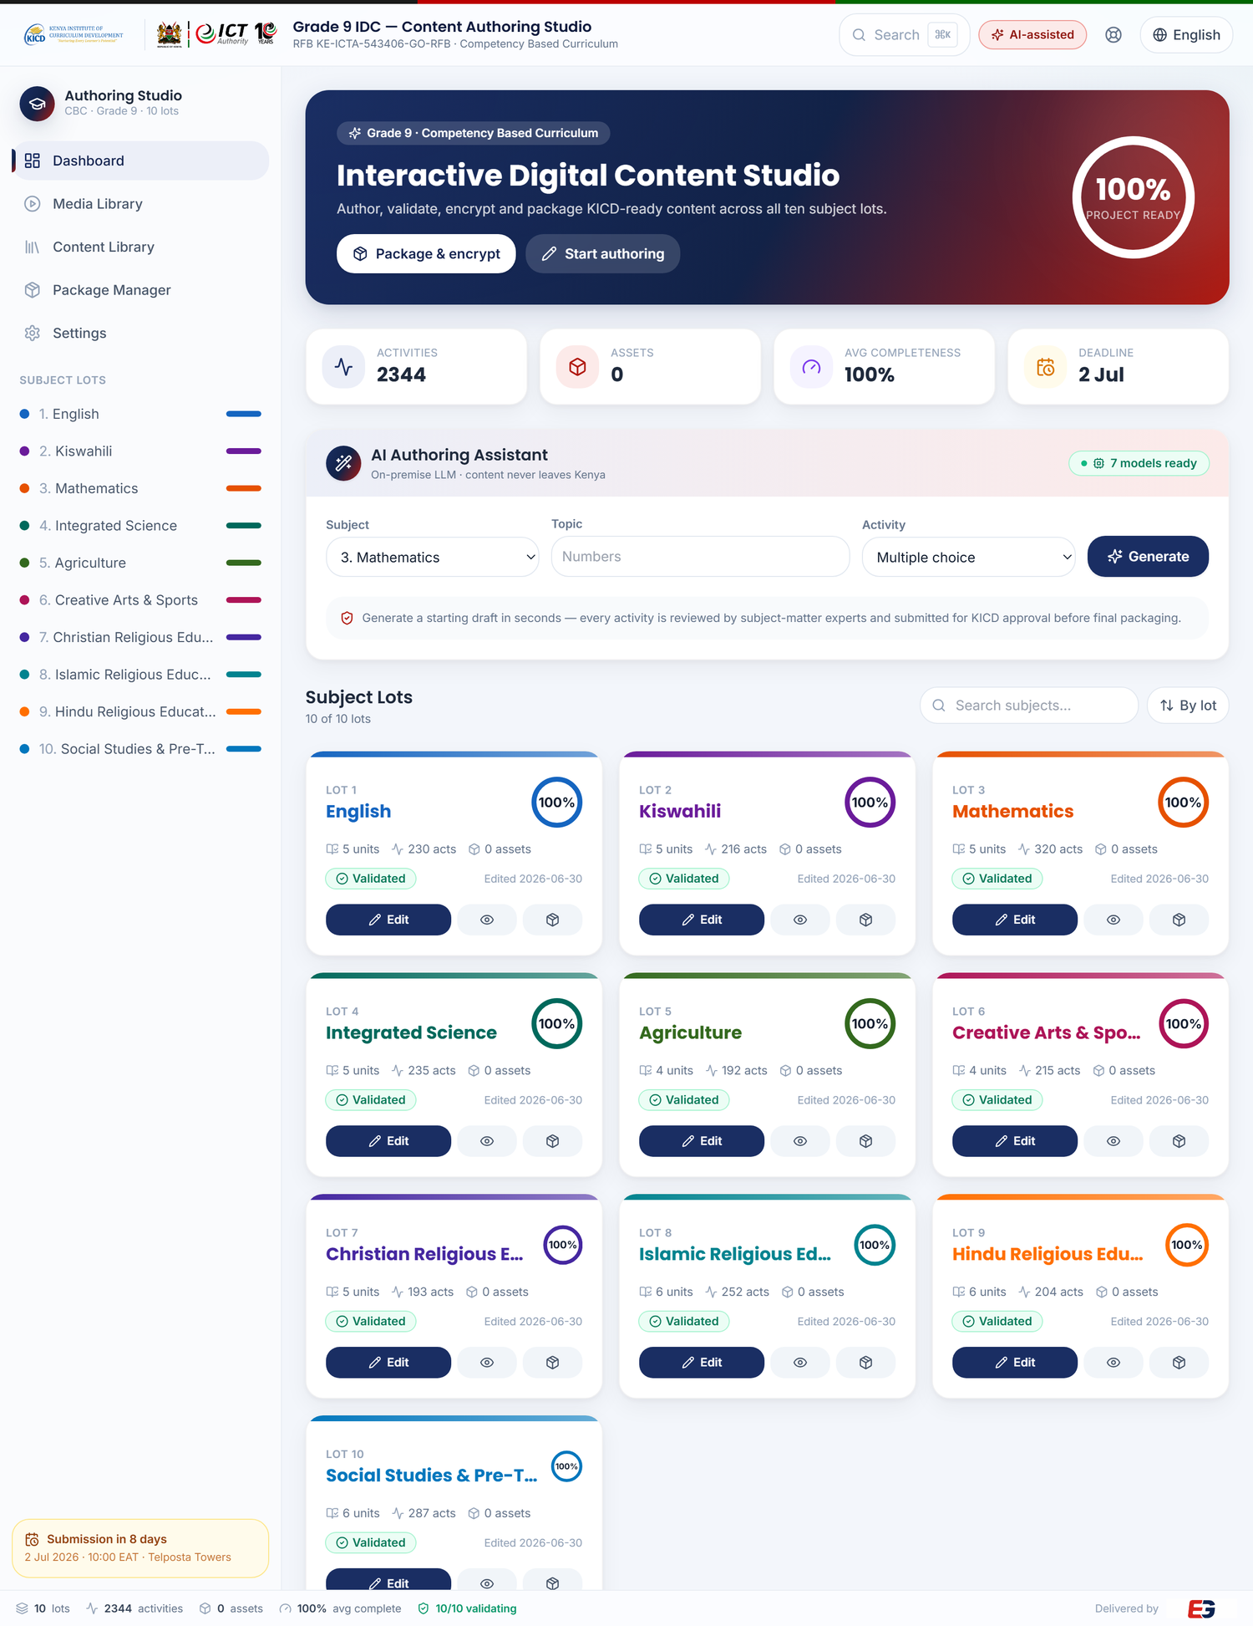
Figure 1 — The Content Authoring Studio dashboard (cbc.evergain.co.ke): live progress across all ten lots, the on-premise AI assistant, and per-subject content cards.

2. System Architecture
The platform is organised into four cooperating layers — authoring, build & packaging, outputs, and delivery. Content is authored once in the web studio, validated and packaged into a self-contained PIF, encrypted, and then runs unchanged across offline desktop, school-server and mobile environments. There is no run-time dependency on the internet for the learner.
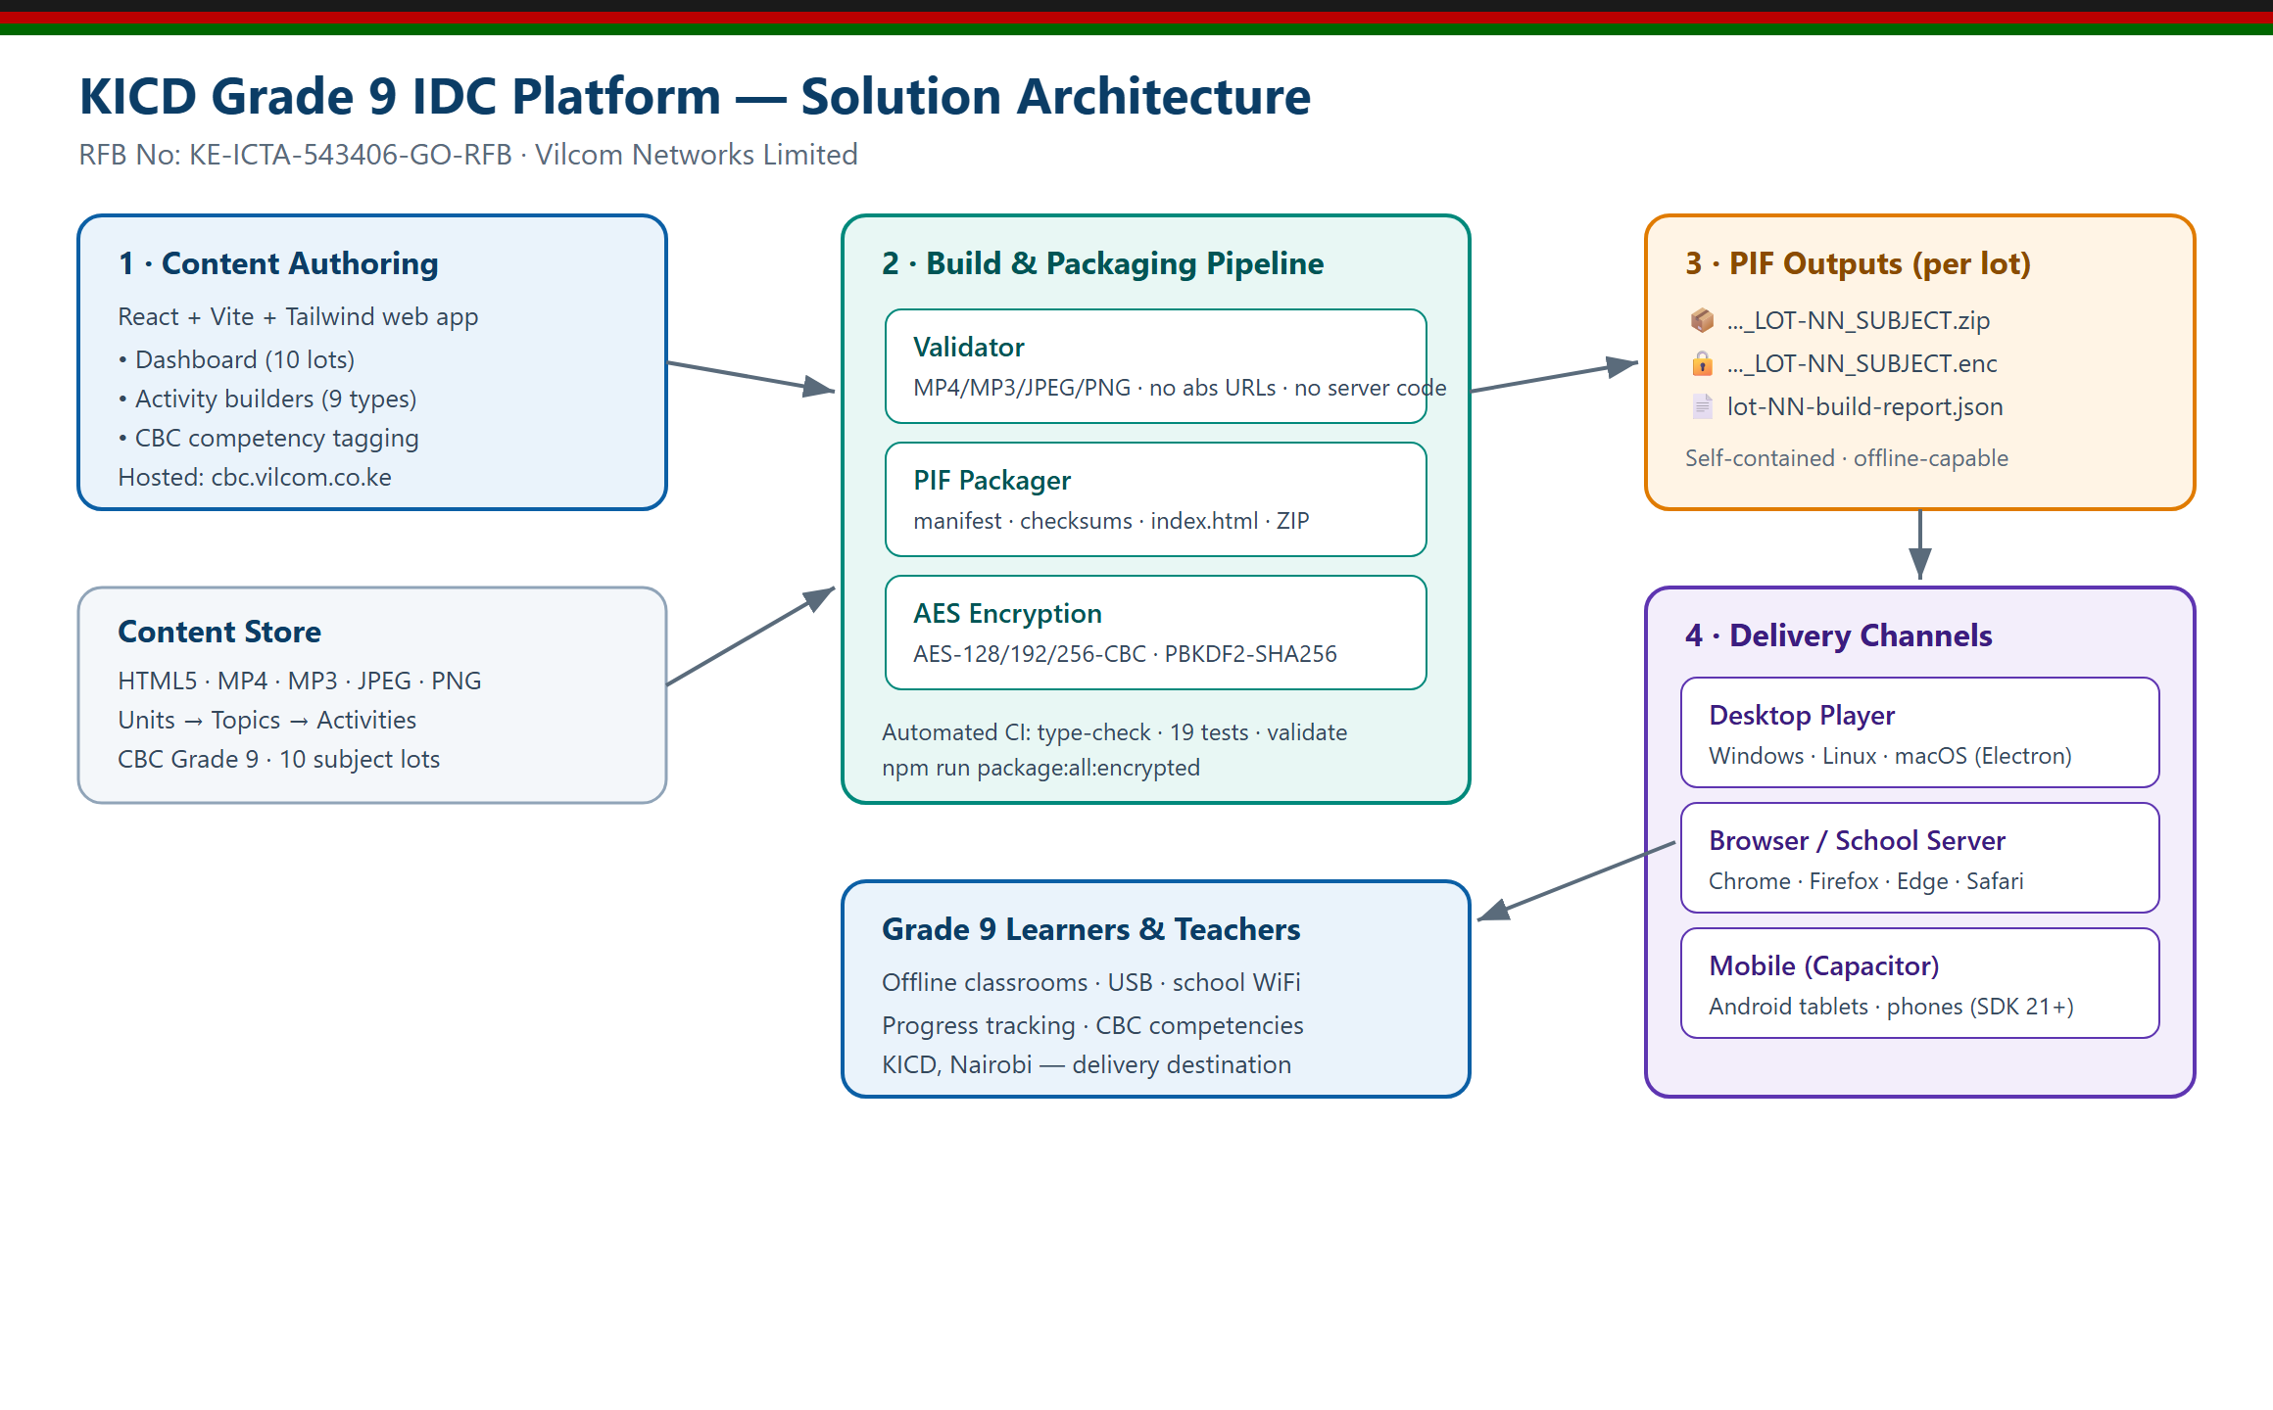
Figure 2 — End-to-end architecture: authoring studio → validation & packaging pipeline → PIF / encrypted outputs → multi-platform offline delivery.

2.1 Design principles
- Self-contained by construction — the learner package contains everything it needs — no external URLs, no server, no internet. This is enforced by the validator, not left to discipline.
- One model, one render — the same content model renders to the author’s live preview and to the HTML5 that ships inside the package, so what the author sees is what the learner gets.
- Low-end friendly — packages run on Atom-class hardware and in any modern browser; the studio is a lightweight single-page application.
- Sovereign by default — the AI assistant runs on an on-premise LLM; content and prompts never leave the country.

3. The Content Model
All content lives in a single typed hierarchy: a Project holds the ten subject Lots; each Lot has Units (strands); each Unit has Topics (sub-strands); each Topic holds interactive Activities. Every unit opens with an overview and key terms so the learner knows what they are about to study, and every activity is tagged to a CBC core competency — a requirement for KICD approval.
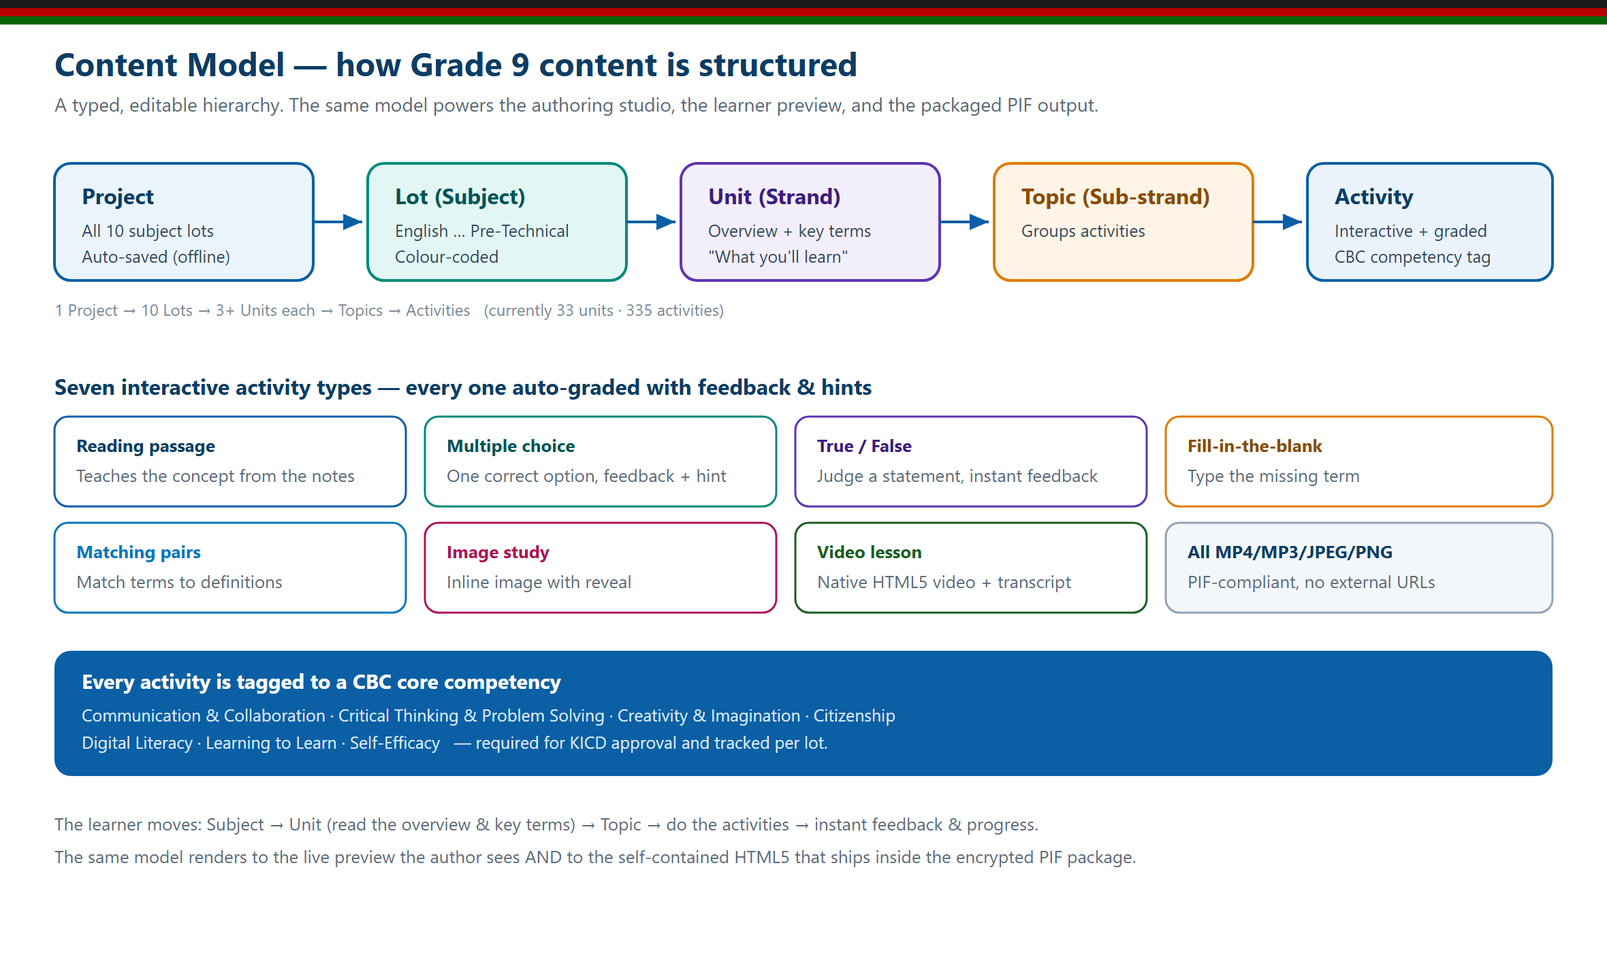
Figure 3 — The content model and its interactive activity types (now eleven — including audio lessons, virtual labs, games and animations). The same model powers authoring, preview and the packaged output.
Because the model is typed and validated, content is consistent across all ten subjects and can be checked automatically for completeness and correctness before packaging.

4. Content Coverage
The platform carries 2,344 interactive activities across 51 units and 112 lessons — every one of the ten Grade 9 lots is fully populated, and every unit has an overview and key-term glossary. The media layer spans all six interaction types required by §1.2: text (112 reading passages), 112 video lessons (subtitles on by default), 112 audio lessons (offline “Listen” narration), 28 animated process diagrams, 100 playable, auto-scored games, and JPEG/PNG image studies — plus 16 interactive PhET virtual labs and 1,740 auto-graded assessment questions with feedback. Every subject has video, audio, games and questions in every lesson; every text lesson can be read aloud by a built-in “Listen” narration that also works offline; and lessons carry attributed key terms and a learner-facing AI “Dive deeper” helper. All ten lots are authored from the official KICD Grade 9 source notes and independently fact-checked for every formula, fact and answer key.
Lot — Subject | Units | Lessons | Activities | Media coverage (all source-grounded ★)
1 — English | 5 | 10 | 230 | 10 video · 10 audio · 9 games · 180 Qs
2 — Kiswahili | 5 | 11 | 216 | 11 video · 11 audio · 10 games · 1 anim · 160 Qs
3 — Mathematics | 5 | 15 | 320 | 15 video · 15 audio · 13 games · 3 labs · 2 anim · 240 Qs
4 — Integrated Science | 5 | 11 | 235 | 11 video · 11 audio · 6 labs · 9 anim · 165 Qs
5 — Agriculture | 4 | 8 | 192 | 8 video · 8 audio · 7 games · 4 labs · 4 anim · 144 Qs
6 — Creative Arts & Sports | 4 | 11 | 215 | 11 video · 11 audio · 10 games · 2 labs · 156 Qs
7 — Christian Religious Education | 5 | 10 | 193 | 10 video · 10 audio · 9 games · 142 Qs
8 — Islamic Religious Education | 6 | 12 | 252 | 12 video · 12 audio · 11 games · 192 Qs
9 — Hindu Religious Education | 6 | 10 | 204 | 10 video · 10 audio · 9 games · 4 anim · 150 Qs
10 — Social Studies & Pre-Technical | 6 | 14 | 287 | 14 video · 14 audio · 13 games · 1 lab · 5 anim · 211 Qs
TOTAL | 51 | 112 | 2,344

★ Source-grounded lots are authored directly from the official KICD Grade 9 notes and independently fact-checked for every formula, fact and answer key.

4.1 Authored content in the studio
Each subject opens into a full content tree — units, topics and activities — with a live preview of exactly what the learner will see. Below are two source-grounded lots as they appear in the studio.
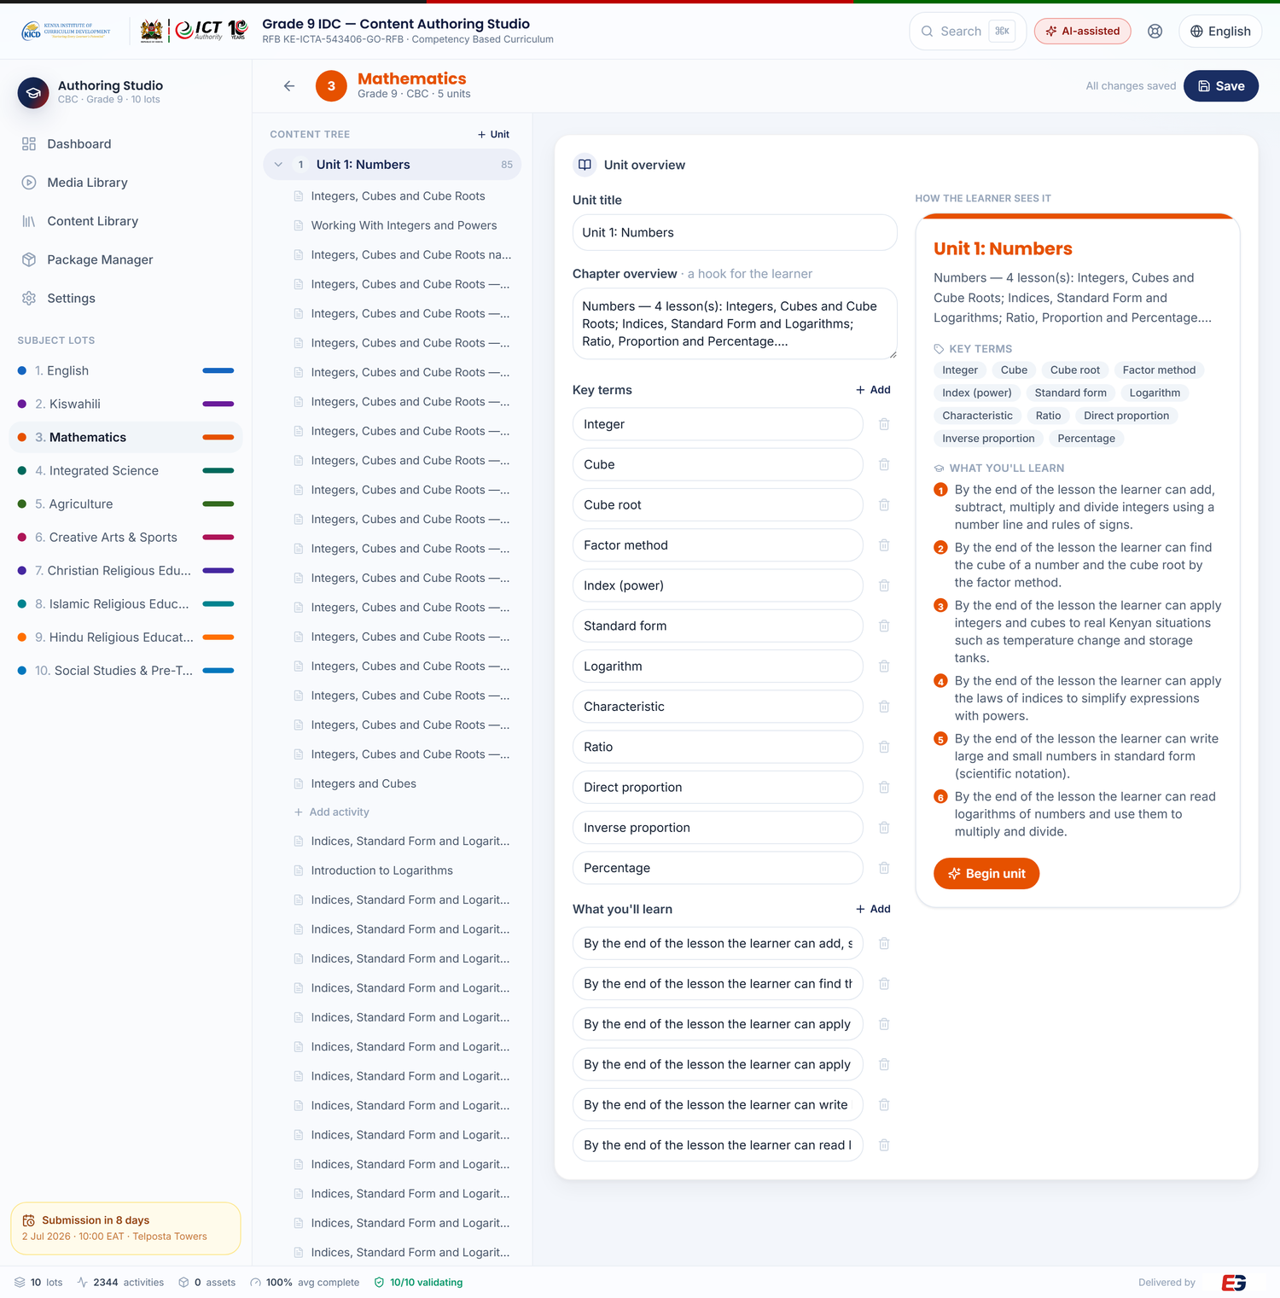
Figure 4 — Mathematics lot: units and topics grounded in the official Grade 9 notes, with the learner preview of an activity.
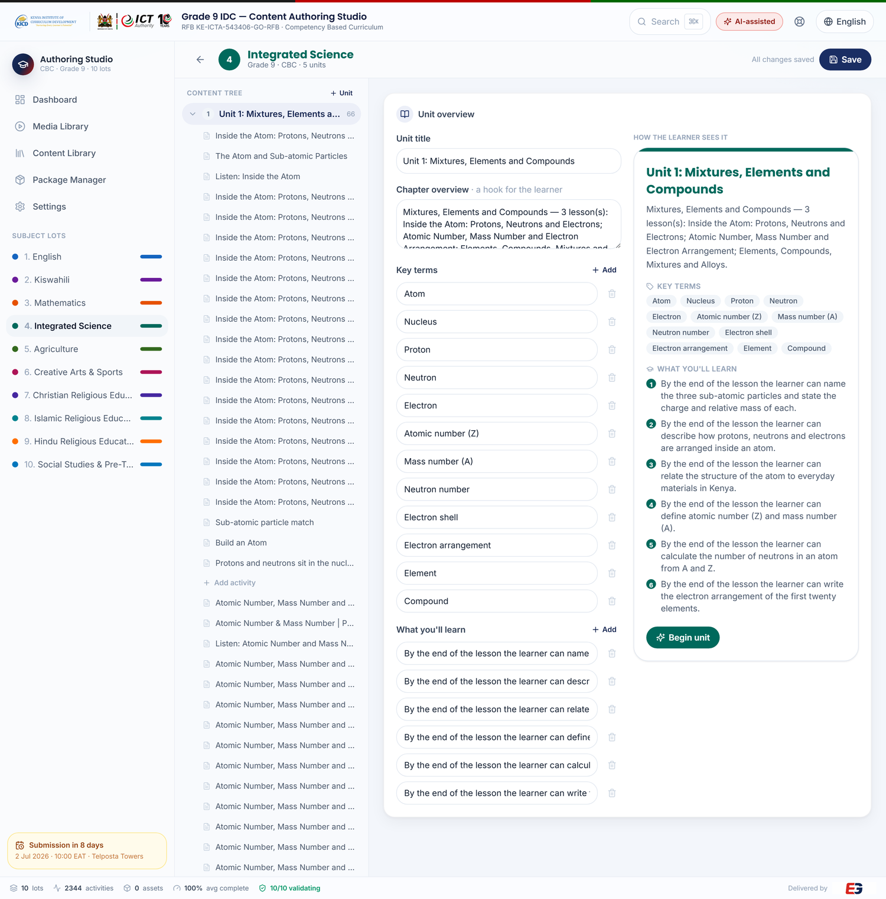
Figure 5 — Integrated Science lot in the authoring studio.

5. The Authoring Studio
The studio is a modern, browser-based workspace built for curriculum developers — not engineers. It works offline, auto-saves as you type, supports light and dark themes, English/Kiswahili interface, a command palette (⌘K) for fast navigation, and import/export of the whole project as a single file for back-up and hand-over.

5.1 Readiness, validation & packaging
The Package Manager gives a real, per-lot readiness view: how many activities each lot has, how many are competency-tagged, and whether the lot is ready, before anything is validated, packaged or encrypted. Packaging is a single command from the project root.
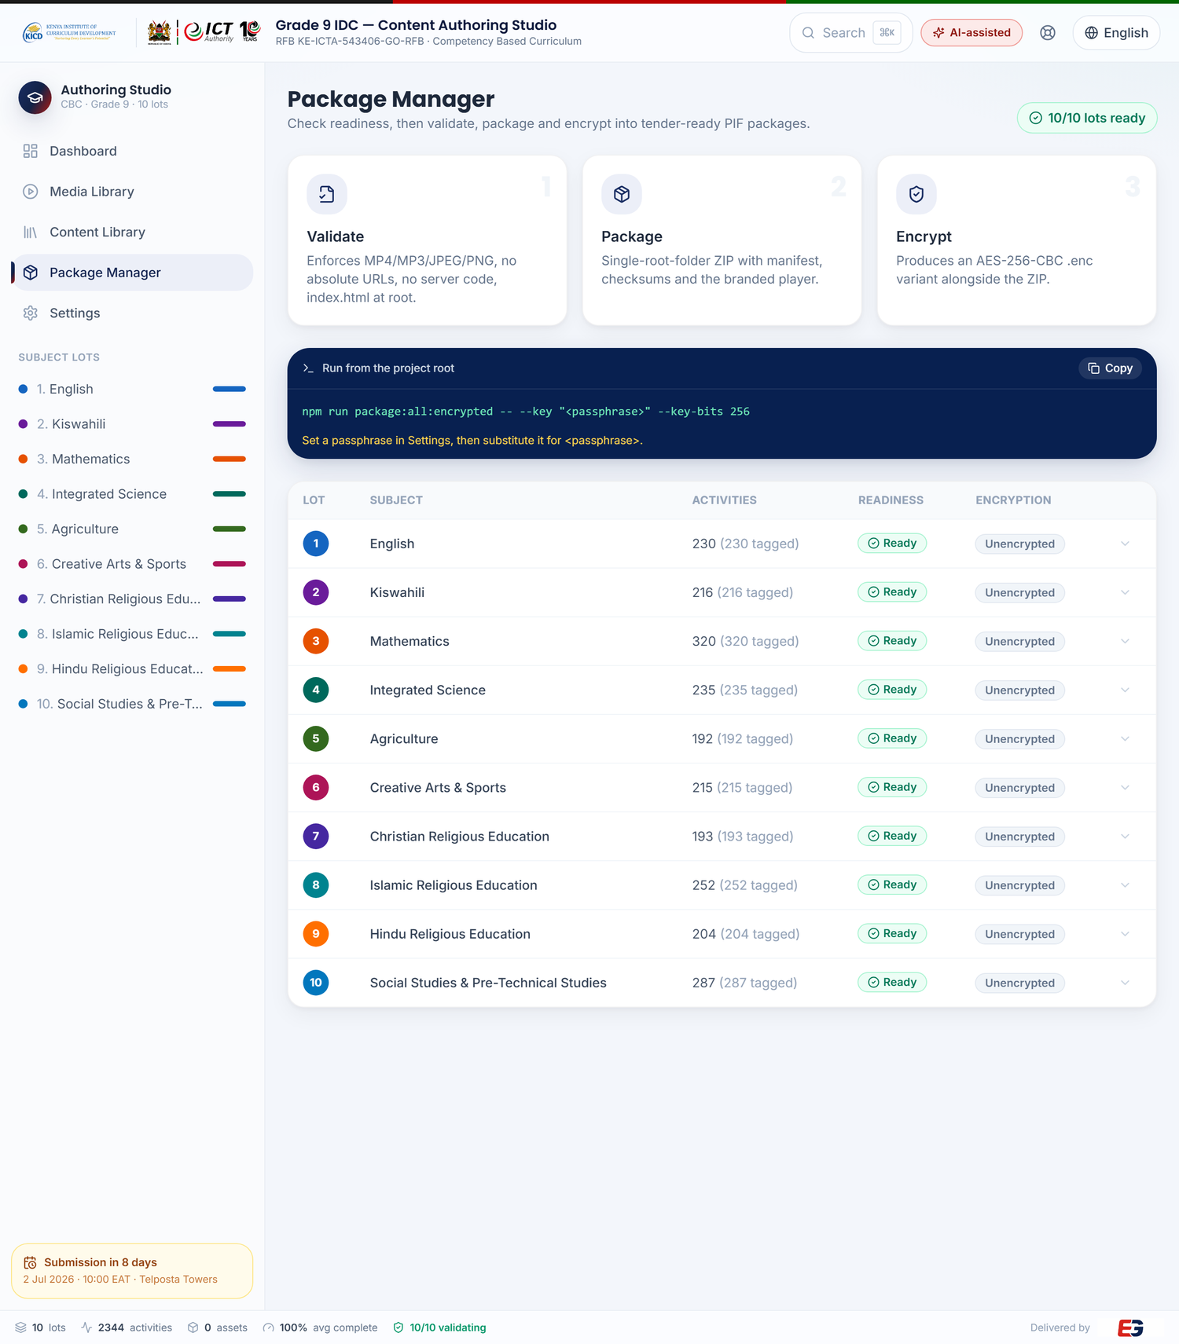
Figure 6 — Package Manager: validate → package → encrypt, with live per-lot readiness across all ten lots.
The three stages map directly to the tender’s structural and security requirements:
- Validate — enforces MP4/MP3/JPEG/PNG-only assets, no absolute URLs, no server code, and index.html at the package root.
- Package — produces a single self-contained folder ZIP with manifest, per-file checksums and the branded offline player.
- Encrypt — produces an AES-256-CBC encrypted .enc variant alongside the ZIP for delivery on physical media.

6. Interactive Activity Types
The platform supports eleven interactive activity types — reading, multiple-choice, true/false, fill-in-the-blank, matching pairs, image study, video lesson, audio/podcast, virtual lab, learning game and animation — most auto-graded with instant feedback and hints. The screenshots below are rendered from real Grade 9 content — exactly what a learner sees. Every type is built from PIF-compliant HTML5; the delivered package uses only MP4/MP3/JPEG/PNG media with no external URLs.

6.1 Reading passage
Teaches the concept directly from the official notes, in clear, learner-friendly language with worked, locally-relevant examples.
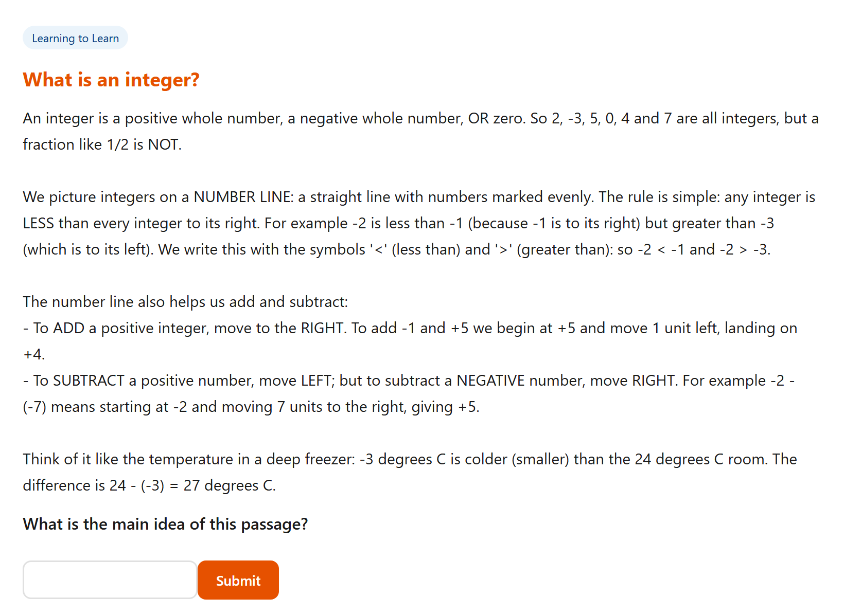
Figure 7 — A reading activity from the Mathematics lot: “What is an integer?”

6.2 Multiple choice
A single correct option with feedback and a hint. Questions use Kenyan contexts to make the mathematics concrete.
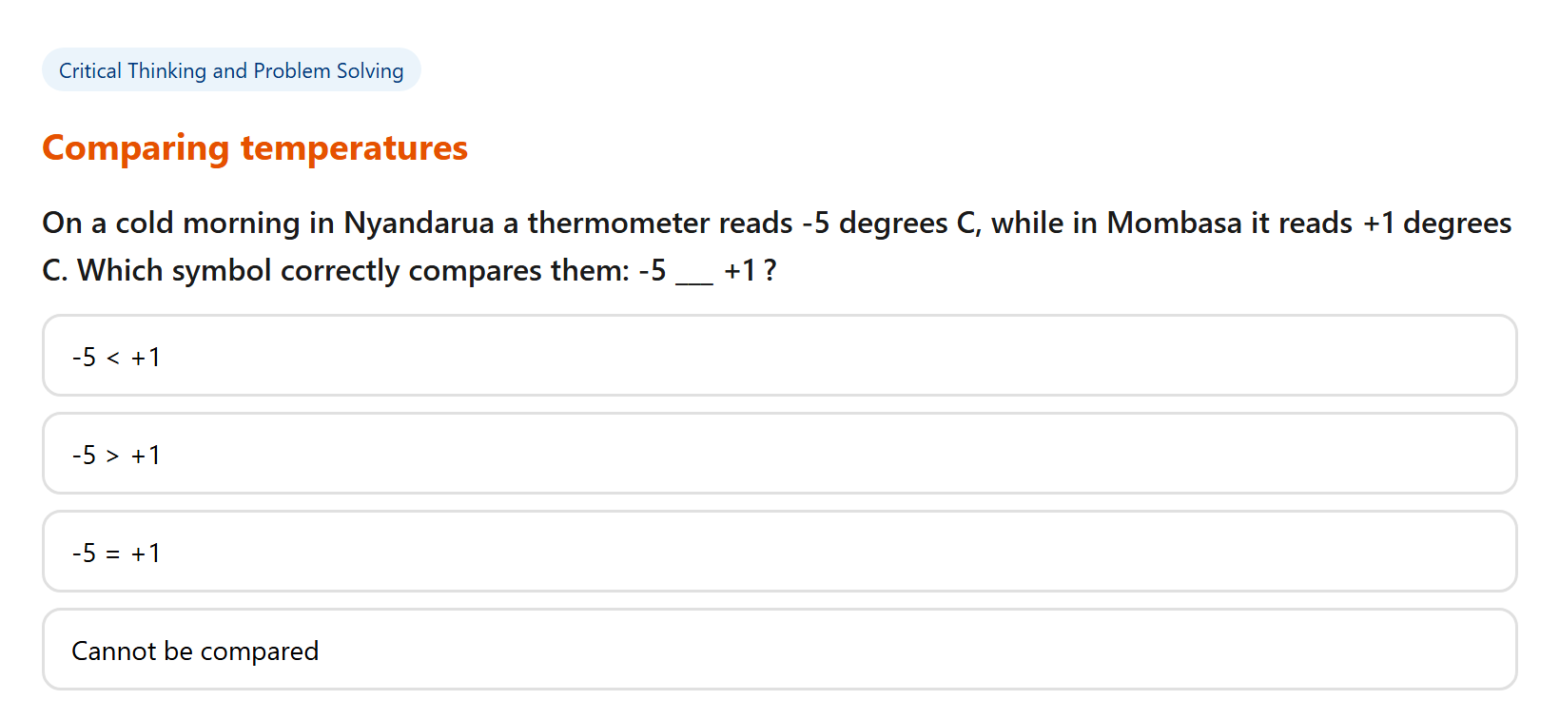
Figure 8 — Multiple-choice: comparing temperatures in Nyandarua and Mombasa (integers).

6.3 Matching pairs
Learners match terms to definitions or operations to results — strong for vocabulary, formulae and classification.
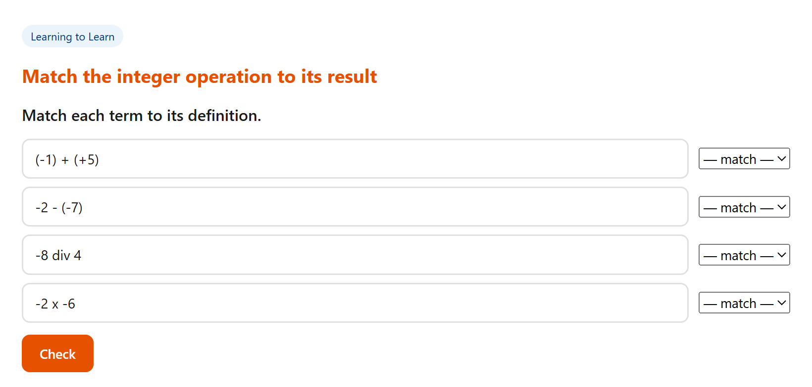
Figure 9 — Matching pairs: integer operations to their results.

6.4 Fill-in-the-blank
The learner types the missing term; the answer is checked instantly. Used widely for key terminology and definitions.
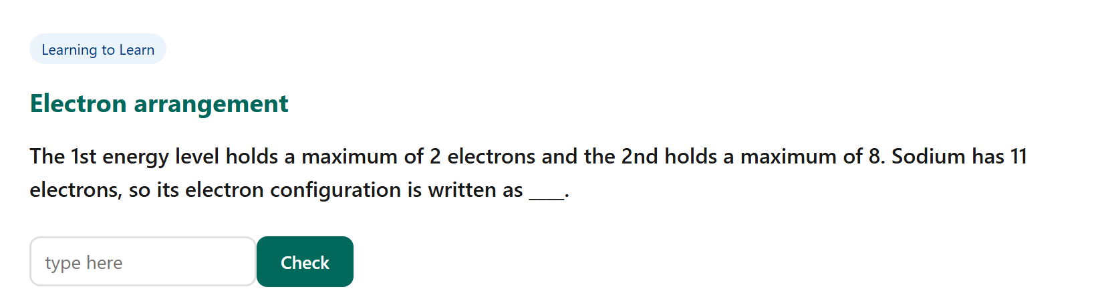
Figure 10 — Fill-in-the-blank: electron arrangement (Integrated Science).

6.5 True / false
A quick judgement on a statement, with immediate feedback that reinforces the underlying idea.
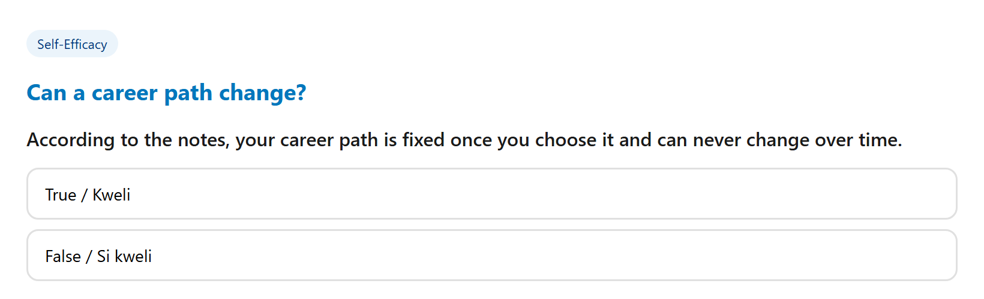
Figure 11 — True/False: “Can a career path change?” (Social Studies & Pre-Technical).

6.6 Rich media — video, audio, animation & image study
Beyond text-based interaction, activities embed native HTML5 video lessons (with transcript), audio lessons, lightweight animations and image-study (hotspot) activities — all using only the permitted media formats and bundled inside the package.
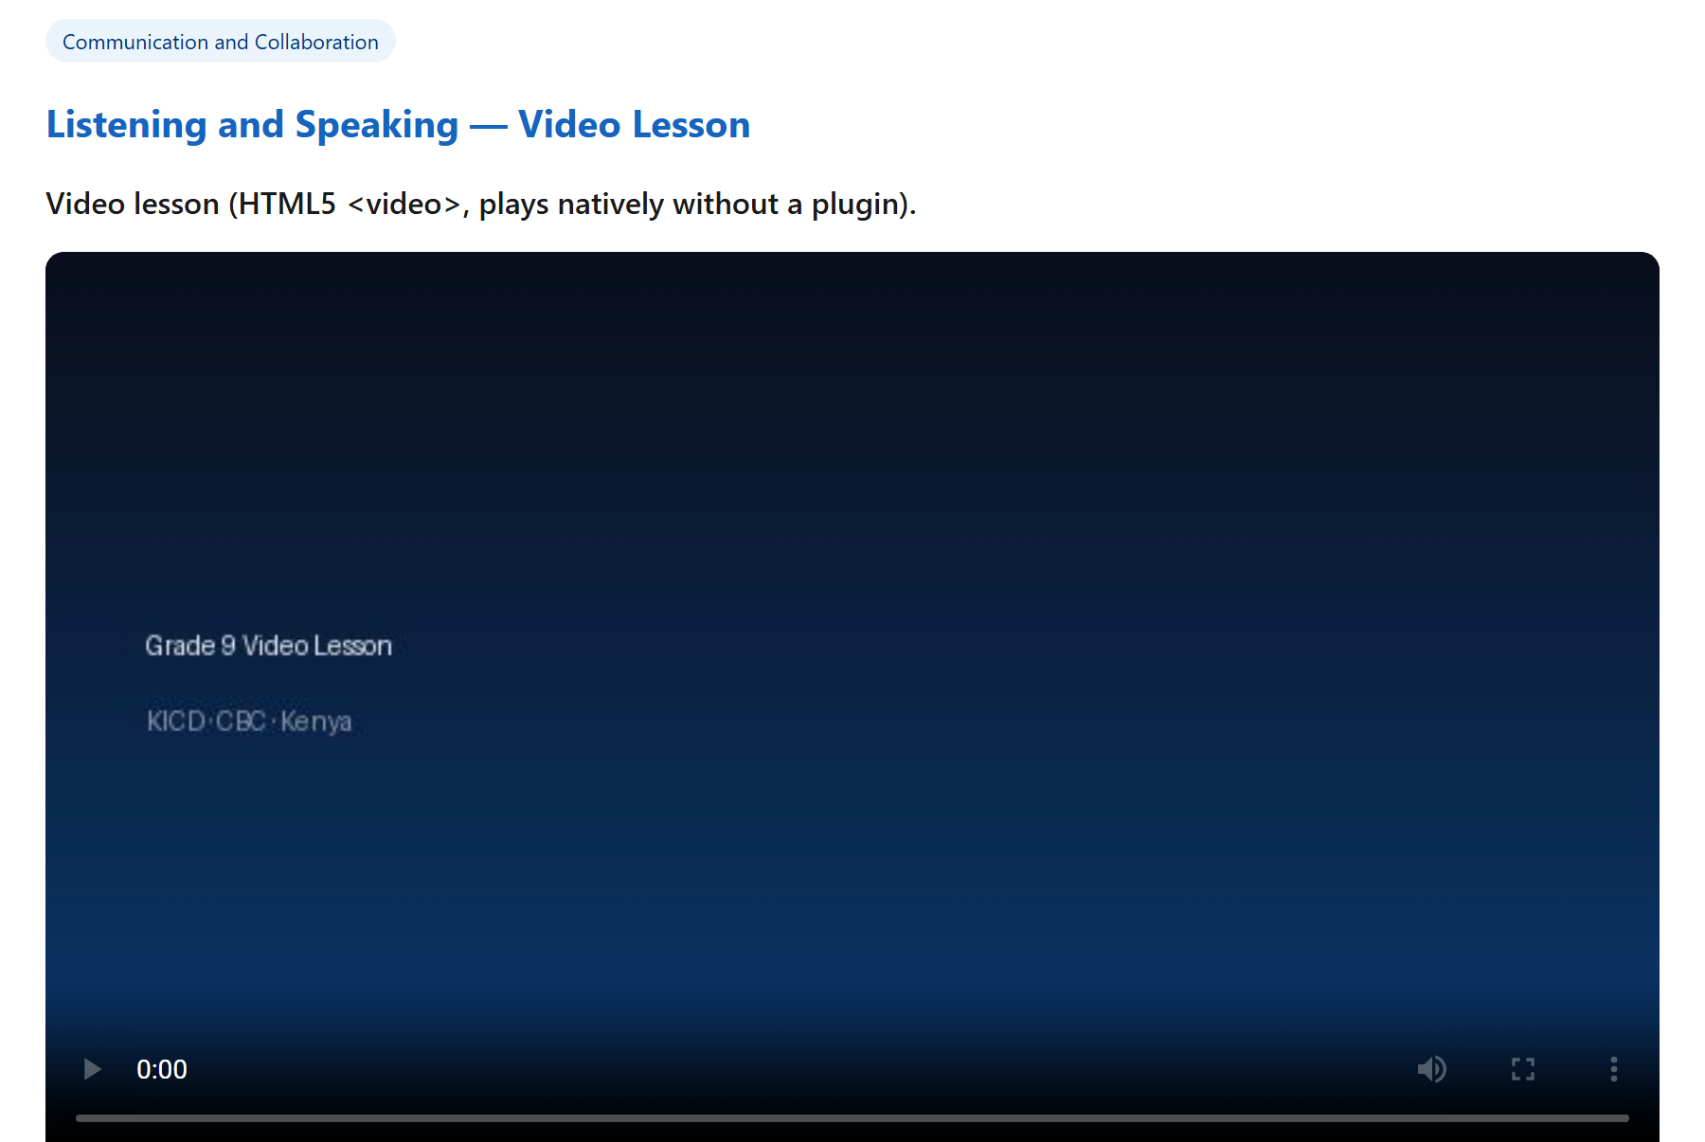
Figure 12 — A native HTML5 video-lesson activity with transcript.
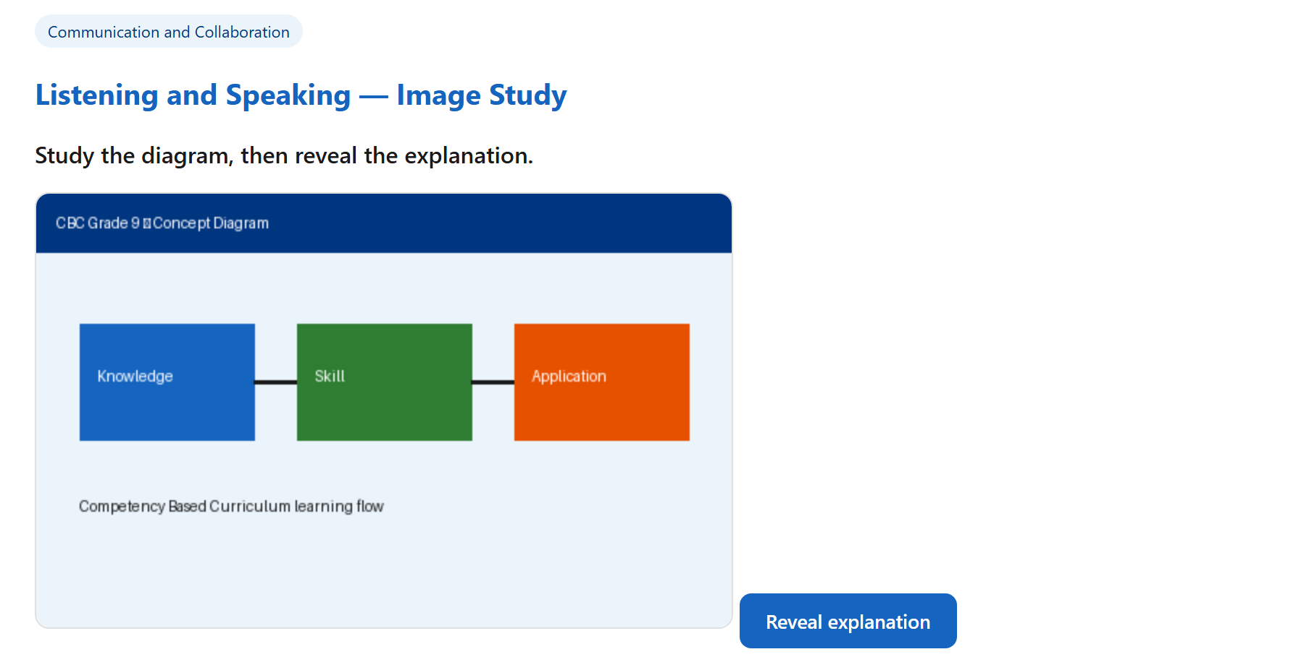
Figure 13 — An image-study (hotspot) activity.

6.7 Streamed video lessons — transcript, key points & lyrics
To make the live platform genuinely engaging, every lesson carries its own video — 112 in all — streaming curated, subject-matched videos from reputable educational channels (Khan Academy, Math Antics, CrashCourse, BibleProject, AsapSCIENCE and others), with every video link independently verified. Each is wrapped with key points, a written transcript and — for songs — the lyrics, and subtitles (closed captions) are switched on by default. This is the rich online experience the Evaluation Committee sees on the live demo at cbc.evergain.co.ke. In the delivered offline PIF package the same lesson plays from a bundled MP4 with its transcript, so packages remain self-contained with no external URLs (§1.10).
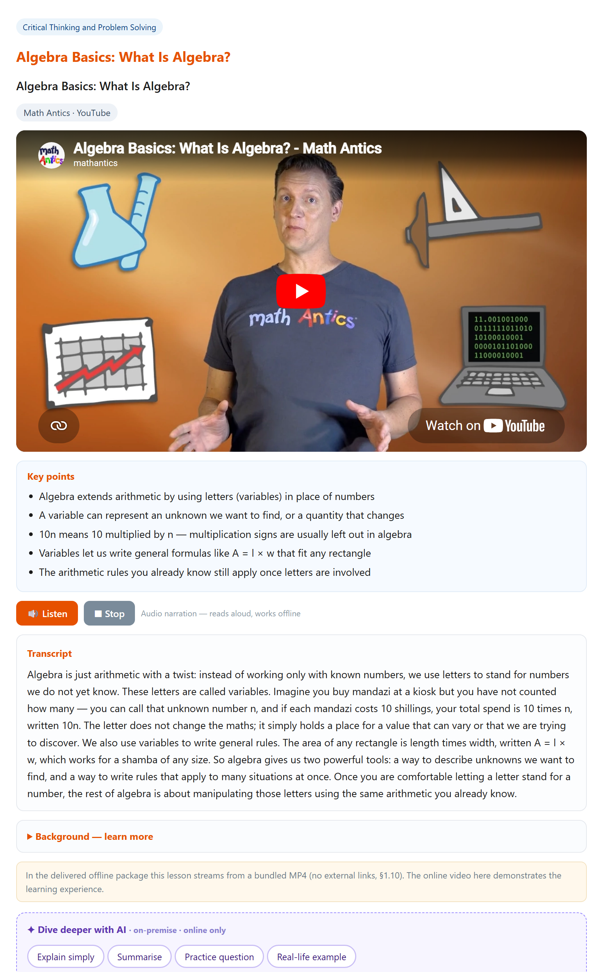
Figure 13a — A streamed video lesson (Math Antics, “What Is Algebra?”) with key points, transcript and the offline-package note.
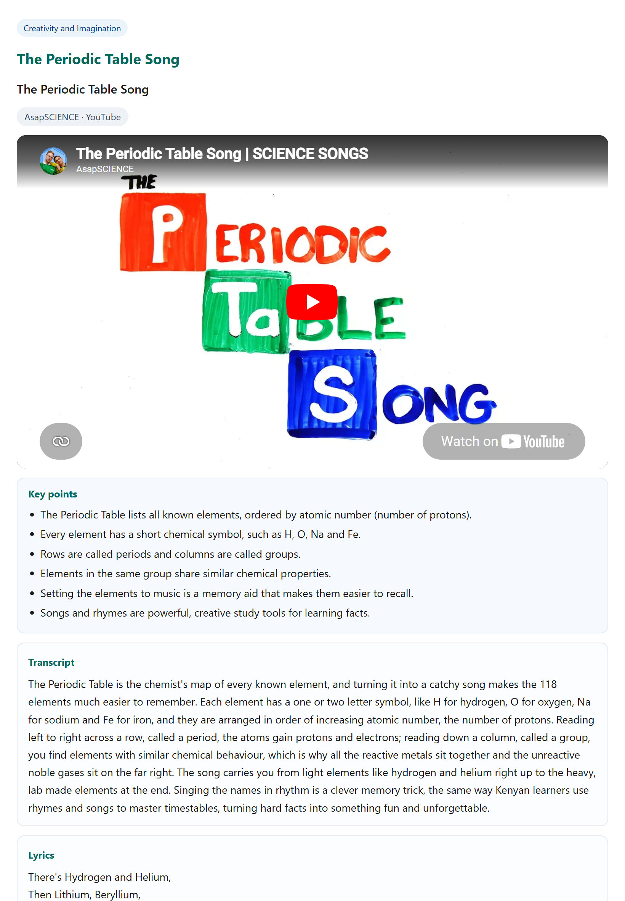
Figure 13b — A science video carrying both a transcript and lyrics (AsapSCIENCE, “The Periodic Table Song”).
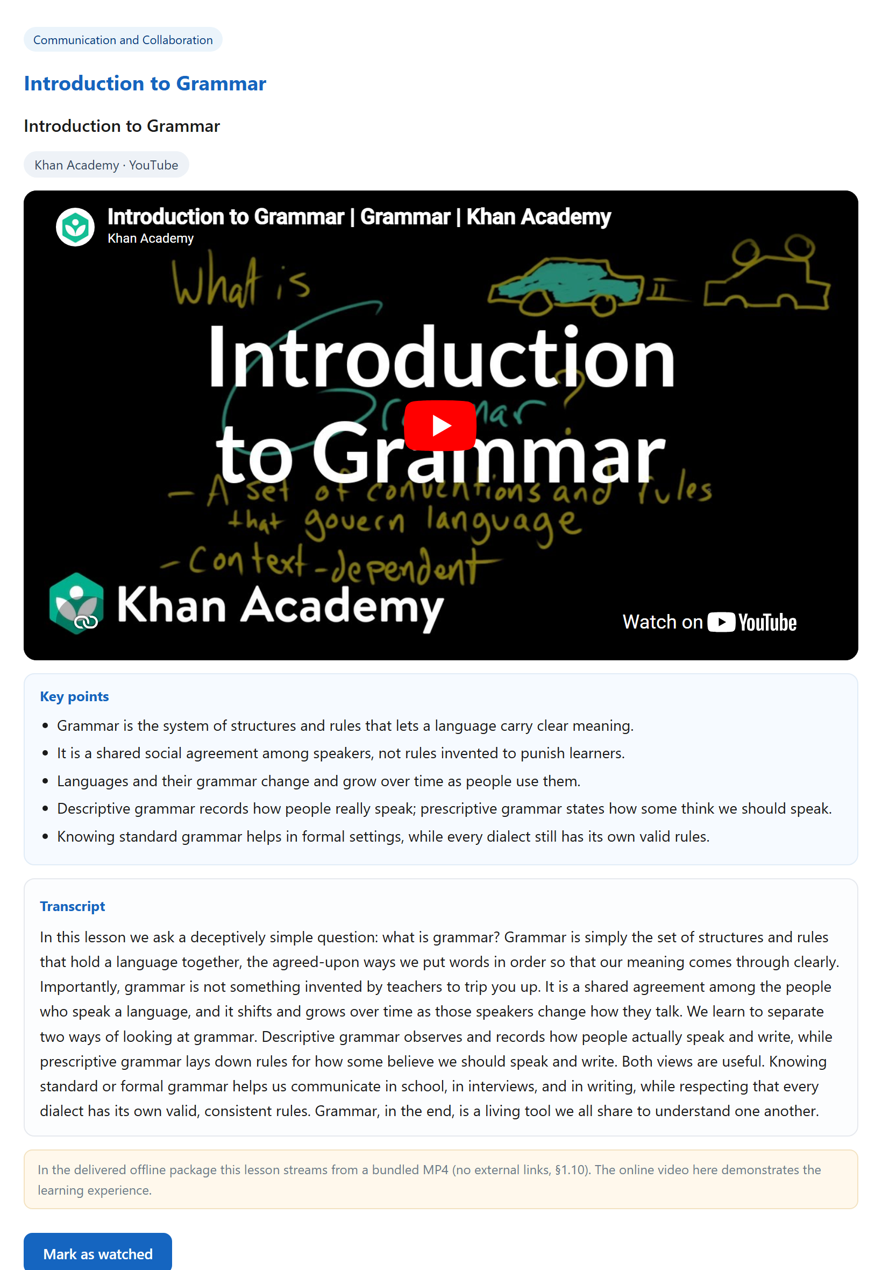
Figure 13c — Every subject has a video: English grammar (Khan Academy) with key points and transcript.

6.8 Worked example — Algebra, end to end
Mathematics carries a flagship “Algebra — from symbols to solutions” track that walks the learner end-to-end: variables and expressions, collecting like terms, substitution, solving one- and two-step equations, forming equations from Kenyan word problems, factorising, expanding brackets, and finally solving a quadratic by factorisation. Each step pairs a short video with auto-graded practice questions set in local contexts (shillings, matatu fares, shamba dimensions) — and every answer key is independently fact-checked.
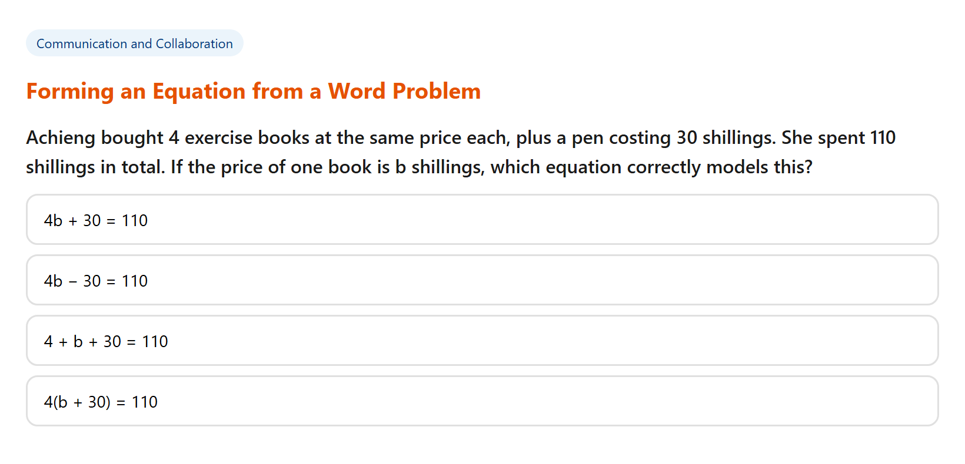
Figure 13d — An Algebra practice question: forming an equation from a Kenyan word problem.

6.9 Audio lessons, podcasts & “Listen” narration
Every subject has an audio lesson, and every text lesson can be read aloud by a built-in “Listen” button that uses the device’s own speech engine — so it narrates even with no internet and no media file. Where a podcast fits the topic, the platform embeds it too (streamed in the demo; a bundled MP3 excerpt ships in the package). All audio carries a full transcript and key points.
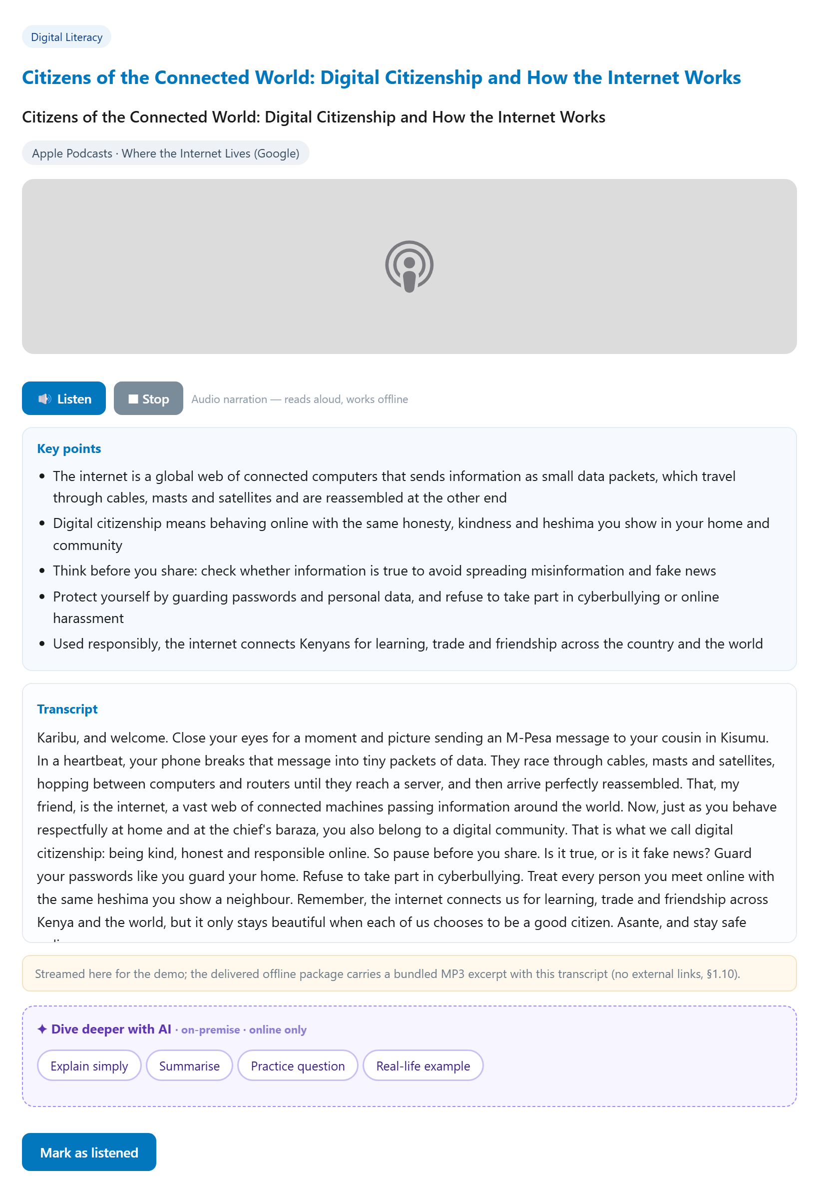
Figure 13e — An audio lesson with an embedded podcast (Apple Podcasts), a “Listen” narration, transcript, a “Background” panel and the AI “Dive deeper” helper.

6.10 Interactive virtual labs (PhET)
Five subjects — Mathematics, Integrated Science, Agriculture, Creative Arts & Sports, and Social Studies & Pre-Technical — include 16 hands-on virtual labs built on PhET Interactive Simulations (University of Colorado Boulder). Because PhET sims are self-contained HTML5, they are embedded in the live demo AND can be bundled inside the offline package — so the lab runs fully offline, with no external links (§1.10). Each lab pairs a short science background, a guided step-by-step task, and key points.
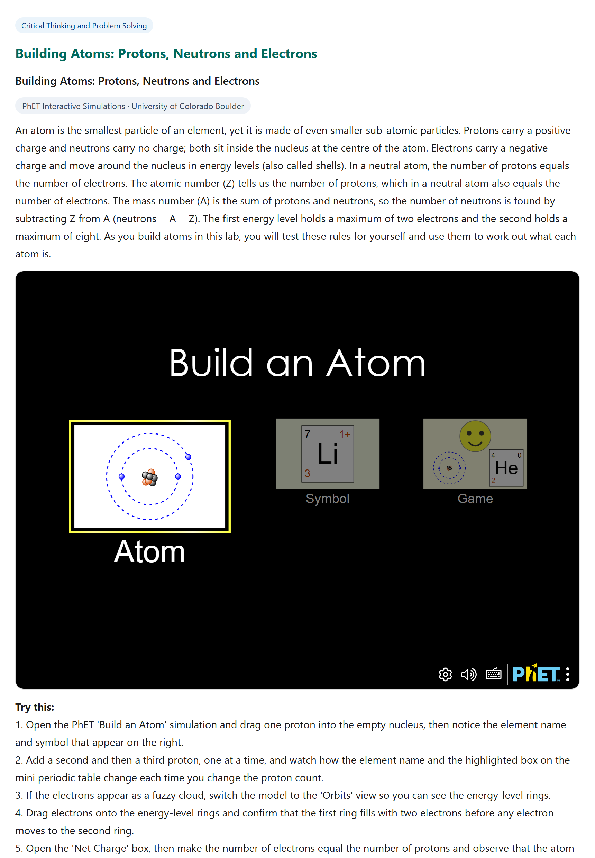
Figure 13f — A virtual lab: “Build an Atom” (PhET) with a science background and a guided “Try this” task.

6.11 “Dive deeper with AI”, “Background — learn more”, and the compliance boundary
Two enrichments run across lessons. A learner-facing “Dive deeper with AI” helper (Explain simply · Summarise · Practice question · Real-life example) calls the on-premise LLM — content never leaves Kenya — to help a stuck learner on demand. A “Background — learn more” panel adds a short, attributed encyclopedic extract (e.g. Wikipedia, CC BY-SA), bundled as plain text. Both respect the tender’s self-contained rule: streamed video and podcasts, the live AI helper, and the online encyclopedia enrich the LIVE platform, while the delivered PIF package carries bundled MP4/MP3, the offline “Listen” narration, the offline-capable PhET lab and the bundled background text — with no external URLs and no server-side code (§1.7–§1.10). The mandatory learning content always works fully offline; the online features are additive.

6.12 Media Library — everything discoverable in one place
All video, audio, podcast and virtual-lab lessons are gathered in a dedicated Media Library, filterable by media type and by subject and searchable — so a teacher or learner finds the right media in seconds.
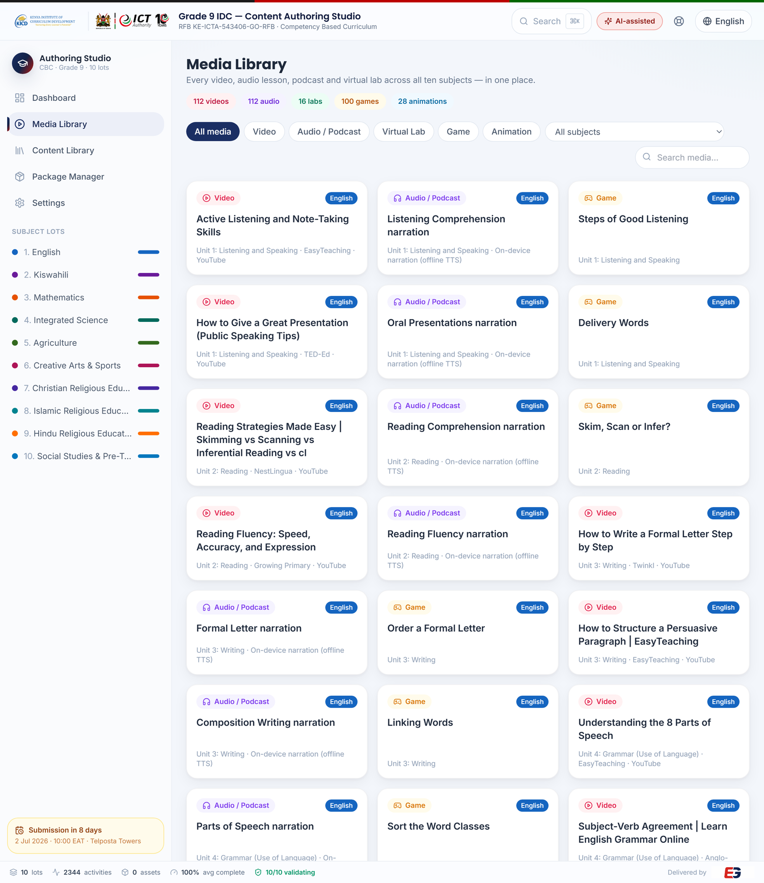
Figure 13g — The Media Library: every video, audio lesson, podcast, virtual lab, game and animation across all ten subjects, filterable and searchable.

6.13 Learning games & animations — and the full §1.2 media set
The platform now carries 100 playable, auto-scored learning games — across three formats: drag-to-categorise (sort), put-in-order (sequence) and memory match — plus 12 tap-the-gap fill-in activities. A further 28 lessons carry an animated diagram of a key process (water cycle, photosynthesis, electric circuit, plant growth, the atom and more). All are built in pure HTML5/CSS/JavaScript with no asset files at all, so they are fully self-contained and run offline inside the package.
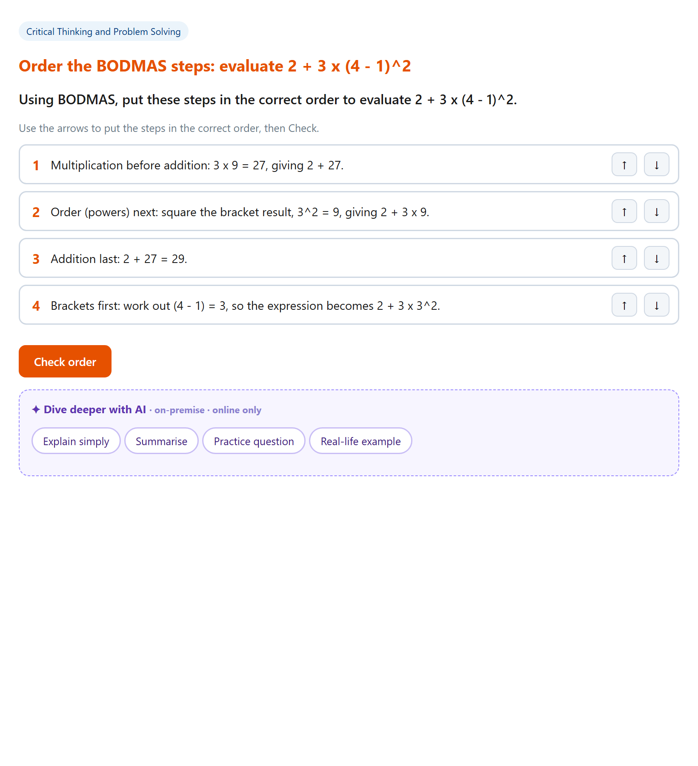
Figure 13h — A “put the steps in order” game: applying BODMAS to evaluate an expression (auto-scored).
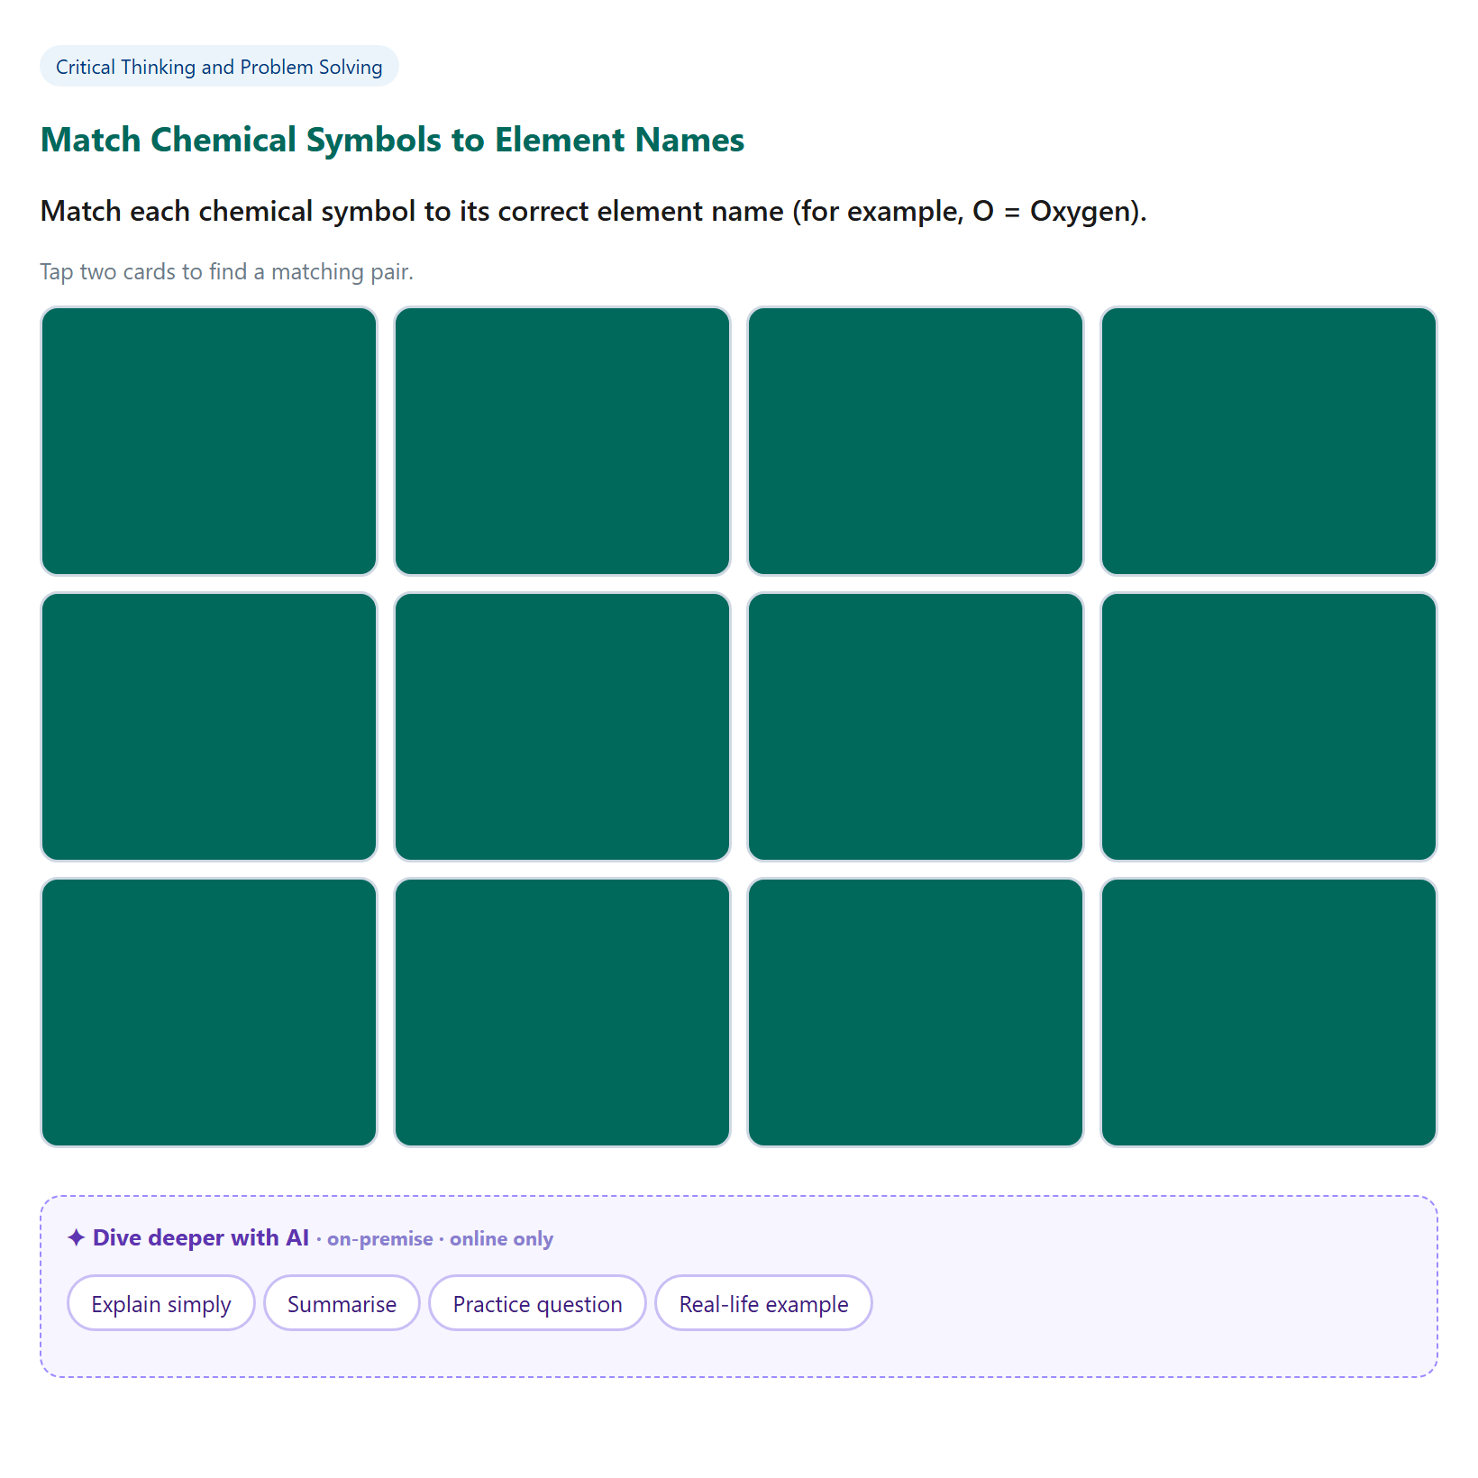
Figure 13i — A memory-match game: pairing chemical symbols with their element names (auto-scored).
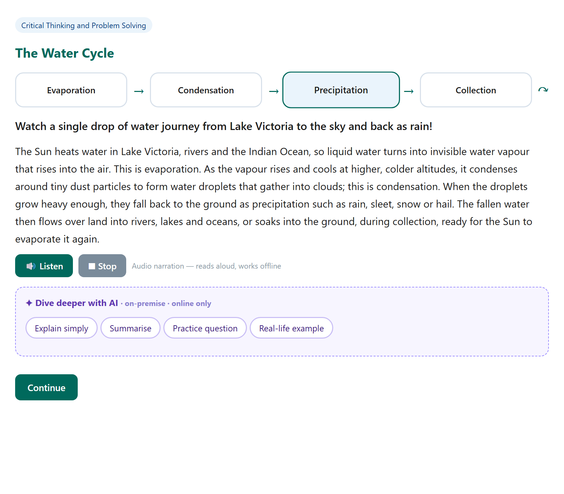
Figure 13j — An animated diagram: the water cycle, the active stage highlighted as the animation loops, with narration.
Taken together, the platform demonstrates every interaction type required by Section VII §1.2, as real activities in the live content — using only the permitted formats (§1.7) with no external URLs (§1.10):
§1.2 media type | On the platform | Delivered format
Text | 112 reading passages + 1,740 questions, fill-in-the-blank, matching | HTML5 text
Video | 112 video lessons — captions + transcript | Bundled MP4
Audio | 112 audio lessons + offline “Listen” narration | Bundled MP3
Animation | 28 animated CSS process diagrams | HTML5 / CSS — no asset file
Games | 100 playable, auto-scored games | HTML5 / JS — no asset file
Images | Image-study activities | JPEG / PNG

All six types are present as real activities in the live content — not just as samples — and every one packages into the self-contained PIF with only MP4/MP3/JPEG/PNG assets, no server-side code and no external URLs.

7. On-Premise AI-Assisted Authoring
To accelerate authoring without compromising data sovereignty, the studio embeds an AI Authoring Assistant powered by an on-premise large language model hosted inside Kenya. A curriculum developer picks a subject, topic and activity type and gets a high-quality starting draft in seconds — which is then reviewed and edited by a subject-matter expert, with all content prepared for KICD review and approval as a required step of the delivery process before final acceptance.
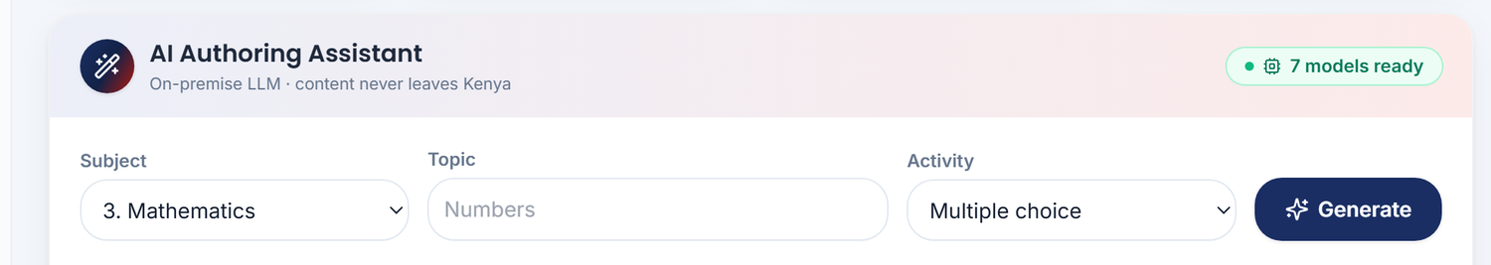
Figure 14 — The AI Authoring Assistant on the dashboard: “On-premise LLM · content never leaves Kenya · 7 models ready.”

7.1 How the assistant fits the pipeline
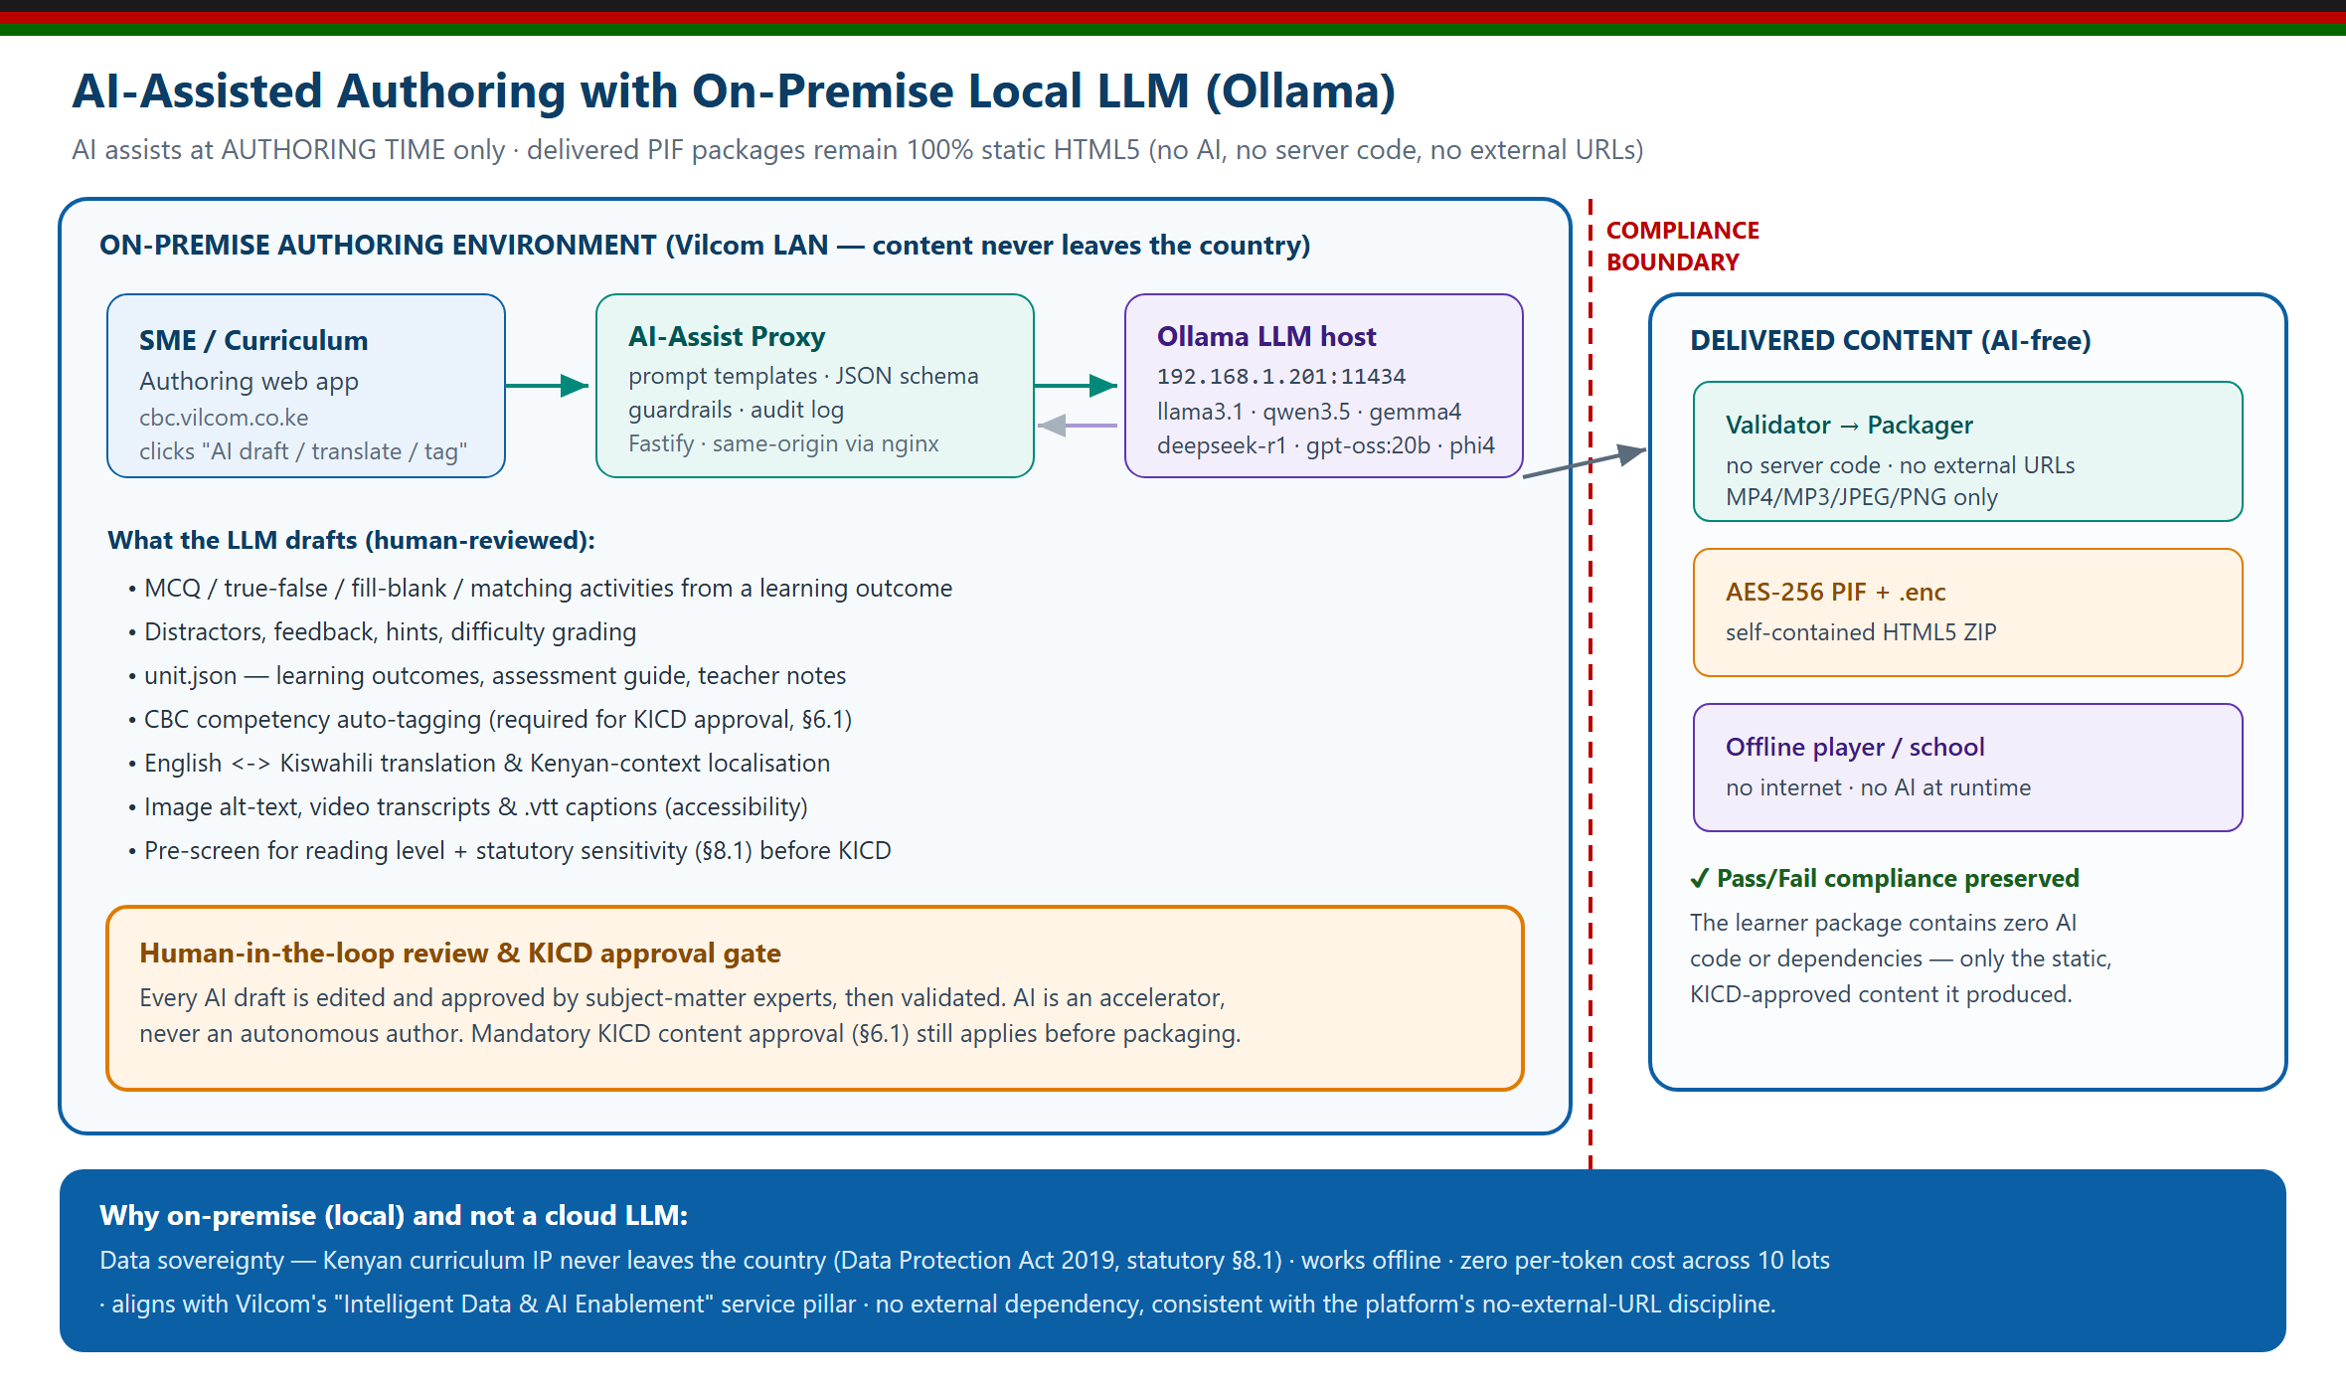
Figure 15 — The assistant drafts; subject-matter experts review and the content is then submitted for KICD approval. The AI never has the final say.
- Data sovereignty — the LLM runs on Evergain infrastructure inside Kenya; no content or prompt is sent to any external cloud service.
- Human-in-the-loop — the AI produces a starting draft only; every activity is reviewed and corrected by experts and submitted for KICD approval (§6.1).
- Faster authoring — it removes the blank-page problem and standardises structure, so authors spend their time on pedagogy and accuracy.

8. Content Provenance & Quality Assurance
The content on this platform is not invented — it is grounded in the official KICD Grade 9 source notes, drafted with assistance, then adversarially fact-checked before a subject-matter expert reviews it and it is submitted to KICD for content approval. Every formula, fact and answer key in the source-grounded lots is verified against the source material.
All content is authored to conform to the Content Standards for Digital Complementary Content for CBC and is built against the KICD-approved curriculum support materials referenced on the Kenya Education Cloud (lms.kec.ac.ke). At this stage the content is authored to KICD standards and is prepared for submission to KICD for content approval; KICD approval is a required downstream step in delivery, not a status already obtained.
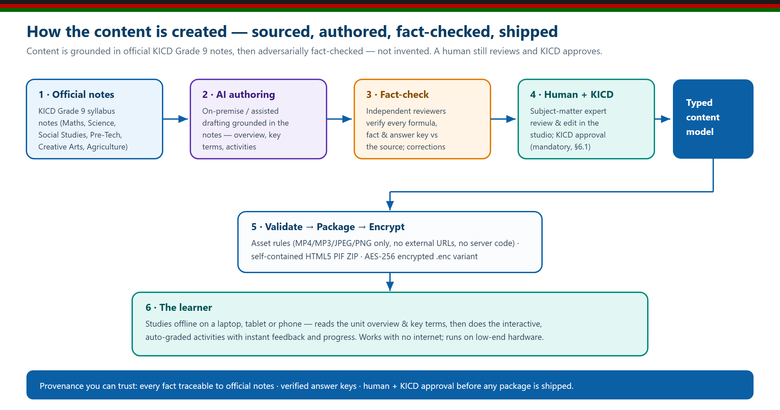
Figure 16 — Content provenance: KICD-approved materials (Kenya Education Cloud) → AI-assisted drafting → independent fact-check → expert review → submission for KICD approval → validate, package, encrypt → the learner.

8.1 What this guarantees
- Traceable — content traces back to KICD-approved Grade 9 materials referenced on the Kenya Education Cloud (lms.kec.ac.ke) — not to a generic web source.
- Independently verified — a separate fact-checking pass verified every multiple-choice key, formula and stated fact.
- Structurally validated — all multiple-choice items have exactly one correct option; all fill-in-the-blank items have a defined answer; all units have an overview and key terms; zero invalid competency tags.

9. Packaging & Security
Each lot is delivered as a Package Interchange File (PIF): a single ZIP whose root contains one folder with index.html, a content manifest, per-file checksums, the offline player and all units, activities and assets. This satisfies the structural rules of Section VII §1.3–§1.10.
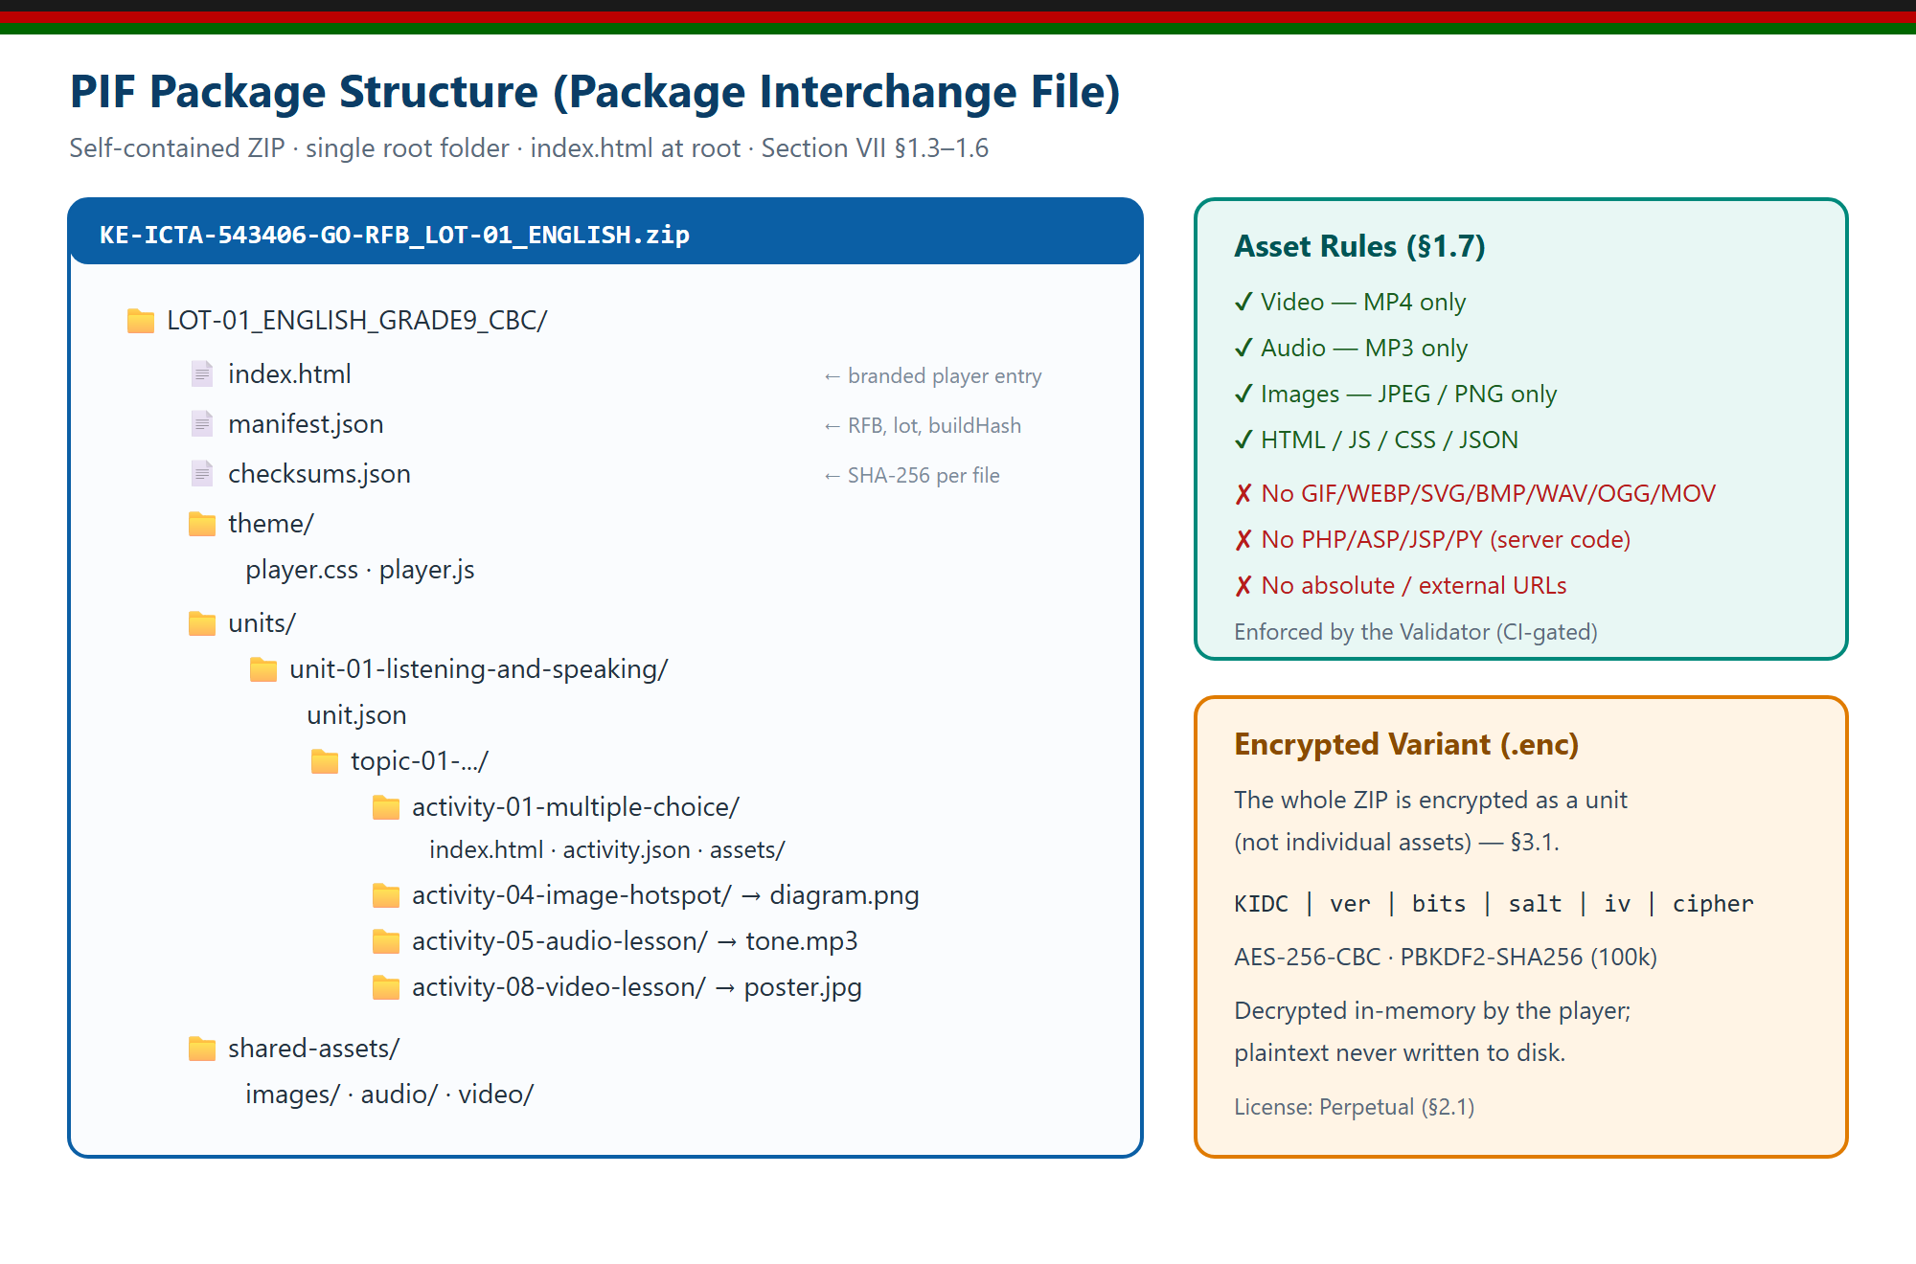
Figure 17 — PIF package structure, asset rules and the encrypted (.enc) variant.

9.1 AES encryption of the delivery package
Alongside the plain PIF ZIP, the pipeline produces an AES-encrypted .enc variant (128 / 192 / 256-bit, configurable) for delivery on physical media, meeting the encryption requirement of §3.1. The package is decrypted by the authorised player at the school; the content is never exposed in transit.
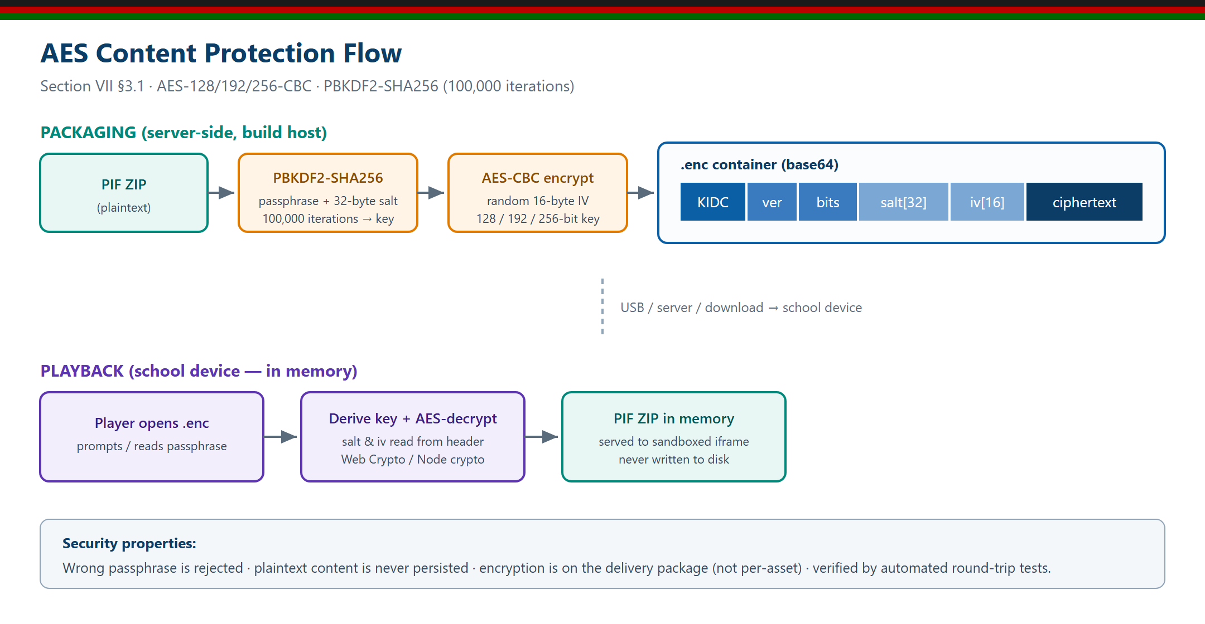
Figure 18 — AES encryption / decryption flow for the delivery package.

10. Deployment Topologies
The same package runs unchanged across the three environments described in the tender. No internet connection is required for any of them at learning time.
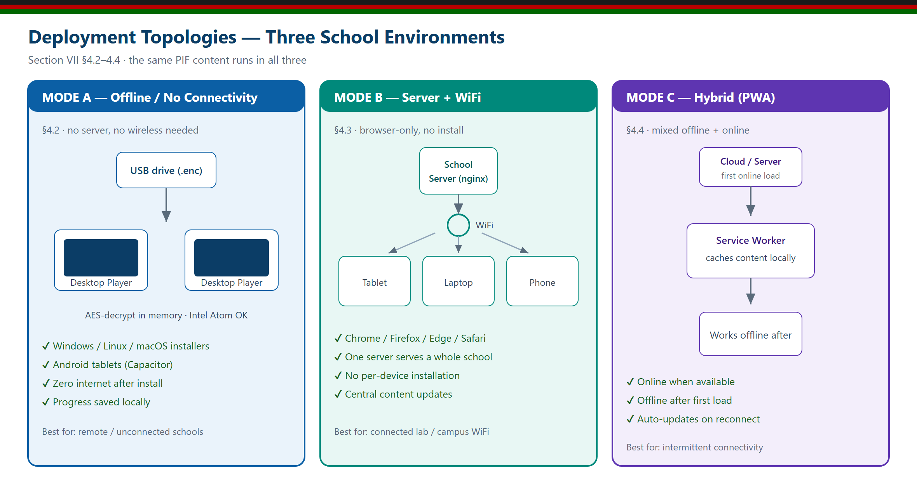
Figure 19 — The three deployment topologies: standalone offline, school-server + WiFi, and hybrid.
- Standalone offline — the PIF runs directly on a learner’s Windows / Linux / macOS laptop or Android device via the offline player. Ideal for take-home and low-connectivity schools.
- Server + WiFi — the package is hosted on a low-cost school server and served over the local WiFi to browsers on student devices — no public internet needed.
- Hybrid — a mix of both, with optional central management for content distribution and updates.

11. How the Platform Compares
Existing Grade 9 offerings are largely online Moodle-style course sites: they need the internet, store content on a central server, and present mostly static pages or PDFs. The Evergain platform is purpose-built for the tender’s offline, encrypted, self-contained delivery model.
Capability | Typical online Grade 9 site | Evergain IDC Studio
Works fully offline | No — needs internet/server | Yes — self-contained PIF
Delivery security | Open web content | AES-256 encrypted package
Interactive, auto-graded activities | Limited / mostly static | 7 types, instant feedback
Content provenance | Mixed web sources | Official KICD notes + fact-check
CBC competency tagging | Rare | Every activity tagged
AI authoring | None / external cloud | On-premise, data stays in Kenya
Runs on low-end hardware | Depends on server | Yes — Atom-class, any browser
Multi-platform player | Browser only | Windows/Linux/macOS/Android

12. Technology Stack
The platform is built on a modern, well-supported, open technology stack, chosen for offline robustness, low resource use and long-term maintainability.
Layer | Technology
Authoring studio | React 18 + Vite 6 + TypeScript, TailwindCSS, Zustand state — a fast single-page app
Offline persistence | Browser-side storage with auto-save; whole-project export/import as a single file
Validation & packaging | Node.js command-line tools: asset validator + PIF packager (self-contained HTML5 ZIP)
Encryption | AES-128 / 192 / 256-CBC encryption of the delivery package (.enc)
Offline player | Cross-platform desktop player (Windows / Linux / macOS) and Android; runs any PIF
AI assist | On-premise LLM (Ollama) + a zero-dependency Node proxy (systemd service) behind nginx
Hosting & security | Ubuntu + nginx + Let’s Encrypt TLS; live at cbc.evergain.co.ke

13. Conclusion
The Evergain Grade 9 Interactive Digital Content Studio is not a concept — it is a working, deployed platform that already authors, validates, encrypts and packages KICD-aligned interactive content across all ten Grade 9 lots, with 2,344 interactive activities spanning 112 lessons — including 1,740 auto-graded assessment questions, 112 video lessons, 112 audio lessons, 100 playable games, 28 animated process diagrams and 16 interactive virtual labs, with an offline “Listen” narration on every text lesson and a learner-facing AI helper — all in place, and an on-premise AI assistant accelerating authoring while keeping all content inside Kenya.
It is engineered around exactly what this tender requires: self-contained, offline, encrypted, multi-platform content authored to conform to the Content Standards for Digital Complementary Content for CBC and prepared for KICD content approval — produced through a transparent, fact-checked, human-reviewed pipeline structured for KICD approval. We invite the Evaluation Committee to view the live platform at cbc.evergain.co.ke and look forward to delivering it for Grade 9 classrooms across Kenya.

Evergain Limited · cbc.evergain.co.ke

Learner Access, Read-Only Delivery and Per-Learning-Area Packaging
This section records how the Grade 9 Interactive Digital Content is delivered following the KICD content review, and confirms the two matters raised in that review.
1. One independent package per learning area
The content is NOT delivered as a single combined learning-management platform. Each of the ten learning areas is supplied as its own independent, self-contained package with its own launcher (index.html), its own units, activities and media, and no dependency on any other learning area. Each package may be installed, distributed, evaluated and awarded entirely on its own.
Lot | Learning area | Units | Activities | Questions | Learner access link
1 | English | 8 | 255 | 195 | https://cbc.evergain.co.ke/subjects/english/
2 | Kiswahili | 6 | 224 | 165 | https://cbc.evergain.co.ke/subjects/kiswahili/
3 | Mathematics | 8 | 350 | 256 | https://cbc.evergain.co.ke/subjects/mathematics/
4 | Integrated Science | 8 | 262 | 180 | https://cbc.evergain.co.ke/subjects/integrated-science/
5 | Agriculture | 5 | 201 | 150 | https://cbc.evergain.co.ke/subjects/agriculture/
6 | Creative Arts & Sports | 7 | 237 | 168 | https://cbc.evergain.co.ke/subjects/creative-arts-sports/
7 | Christian Religious Education | 8 | 219 | 157 | https://cbc.evergain.co.ke/subjects/christian-re/
8 | Islamic Religious Education | 9 | 273 | 204 | https://cbc.evergain.co.ke/subjects/islamic-re/
9 | Hindu Religious Education | 9 | 229 | 165 | https://cbc.evergain.co.ke/subjects/hindu-re/
10 | Social Studies & Pre-Technical Studies | 9 | 311 | 225 | https://cbc.evergain.co.ke/subjects/social-studies-pretechnical/

2. Read-only learner edition — learners cannot edit content
The packages supplied to learners are a READ-ONLY learner edition. They contain no editing, authoring, content-management or administrative controls of any kind. A learner can read, watch, listen, play and answer questions; a learner cannot add, change, delete or re-order any content.
- No authoring functions are present in the learner build (no add, update, delete or move-activity operations).
- No editable regions are present (no contenteditable elements).
- No editor, administrator, Save or Manage routes or controls are present.
- Each package contains exactly one learning area.
- Packages make no external resource requests and operate fully offline.
3. Content authoring is restricted to authorised staff
Content authoring is performed only by authorised Evergain personnel in the Evergain Content Studio, which is hosted separately from the learner content and protected by authentication. It is not reachable from the learner packages or from the public learner site, and it is never distributed with learner content.
4. Verification
Every delivered package was checked programmatically before release. Across all ten packages the audit returned zero authoring operations, zero editable regions, zero administrative routes, exactly one learning area per package, and zero external resource loads. Each package additionally carries SHA-256 integrity checksums and is available in an AES-256-CBC encrypted variant.

